[Launch player](https://www.rnz.co.nz/audio/player)

17 Aug 2023

**Crown vs Cow: The inside story of how we failed to regulate our worst climate polluter**

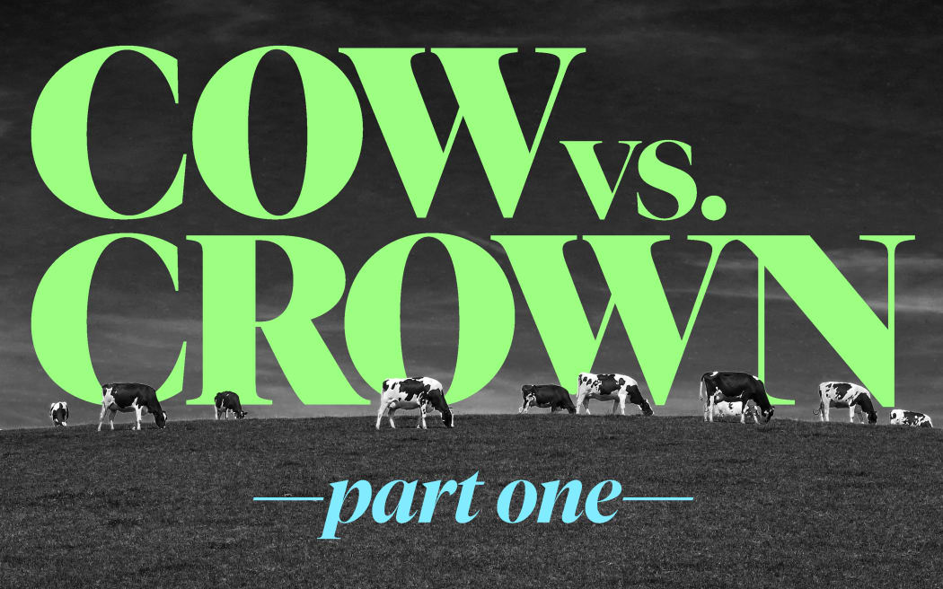

From [**In Depth Special Projects**](https://www.rnz.co.nz/programmes/in-depth-special-projects), 5:00 am on 17 August 2023

Share this

* [Share on Twitter](https://twitter.com/intent/tweet?text=%20Deny%2C%20deny%2C%20delay%3A%20How%20agriculture%20lobbied%20Labour%20into%20putting%20off%20a%20climate%20tax%2C%20again.&url=https://www.rnz.co.nz/programmes/in-depth-special-projects/story/2018902262/crown-vs-cow-the-inside-story-of-how-we-failed-to-regulate-our-worst-climate-polluter)
* [Share on Facebook](https://www.facebook.com/sharer/sharer.php?u=https%3A%2F%2Fwww.rnz.co.nz%2Fprogrammes%2Fin-depth-special-projects%2Fstory%2F2018902262%2Fcrown-vs-cow-the-inside-story-of-how-we-failed-to-regulate-our-worst-climate-polluter)
* [Share via email](mailto:%20?subject=%20Deny%2C%20deny%2C%20delay%3A%20How%20agriculture%20lobbied%20Labour%20into%20putting%20off%20a%20climate%20tax%2C%20again.&body=I%20thought%20you%20might%20be%20interested%20in%20this%20page%20https%3A%2F%2Fwww.rnz.co.nz%2Fprogrammes%2Fin-depth-special-projects%2Fstory%2F2018902262%2Fcrown-vs-cow-the-inside-story-of-how-we-failed-to-regulate-our-worst-climate-polluter%20from%20RNZ.)
* [Share on Reddit](https://www.reddit.com/submit?url=https://www.rnz.co.nz/programmes/in-depth-special-projects/story/2018902262/crown-vs-cow-the-inside-story-of-how-we-failed-to-regulate-our-worst-climate-polluter)
* [Share on Linked In](https://www.linkedin.com/shareArticle?mini=true&url=https://www.rnz.co.nz/programmes/in-depth-special-projects/story/2018902262/crown-vs-cow-the-inside-story-of-how-we-failed-to-regulate-our-worst-climate-polluter)



[**Kirsty Johnston**](https://www.rnz.co.nz/authors/kirsty-johnston)

**Agriculture contributes more to global warming than any other industry in Aotearoa. Yet attempts to rein in the sector’s emissions have fallen short once more. In a three-part series, Crown vs Cow, In Depth reporter Kirsty Johnston investigates how a “world-leading plan” was born, and how it fell apart. This is**

**part one: Deny, deny, delay.**

On a typically foggy Waikato morning in the winter of 2019, Prime Minister Jacinda Ardern pulled on a pair of sturdy boots and began her visit to the most important farming event of the year, the Fieldays.

To the casual observer, the trip looked like little more than a public relations exercise. Ardern cut a ribbon to open the expo, and she spoke about the strength of the primary industries and its importance to New Zealand. Then she began a tour of the stands, posing for pictures with the local rugby team, a group of midwives, and anyone else bold enough to ask for a selfie. Ardern was still a new leader then, and a new mother, and her popularity was at its pre-Covid high, even among farmers. The crowds were clearly delighted to see her, enjoying a day out, just like them.

But Ardern hadn’t come to Fieldays simply to gild her reputation among the farming community. While farmers and their families were inspecting Swanndris and testing tractors out the front, out the back, Ardern was holding a meeting with agriculture’s most powerful people, working to finally close a secret deal on climate change after months, and months, of talk.

That day, Ardern and 11 sector leaders from farming industry groups agreed they would work together to come up with a way to price climate change pollution from agriculture. It would be a world first, they said. But there was a kicker: instead of the agriculture industry paying for its emissions immediately, as Labour had proposed in its election campaign, farmers would get a five-year reprieve before pricing came in.

The plan’s announcement, when it came four months later, would prove a shock among farmers, environmental groups, and even government supporters. Farmers felt they were being sold down the road by their own leaders. Environmentalists were incredulous that agriculture had managed to delay regulation once again, and that a Labour government, of all people, had let them. And those who voted for Ardern were left wondering: What happened to the climate change action they were promised?

This RNZ investigation uses background interviews with industry insiders, officials, and experts, as well as documents obtained under the Official Information Act, such as cabinet papers, government reports and ministers’ diary entries to tell the full story of how the agriculture industry lobbied its way out of paying a climate tax, again.

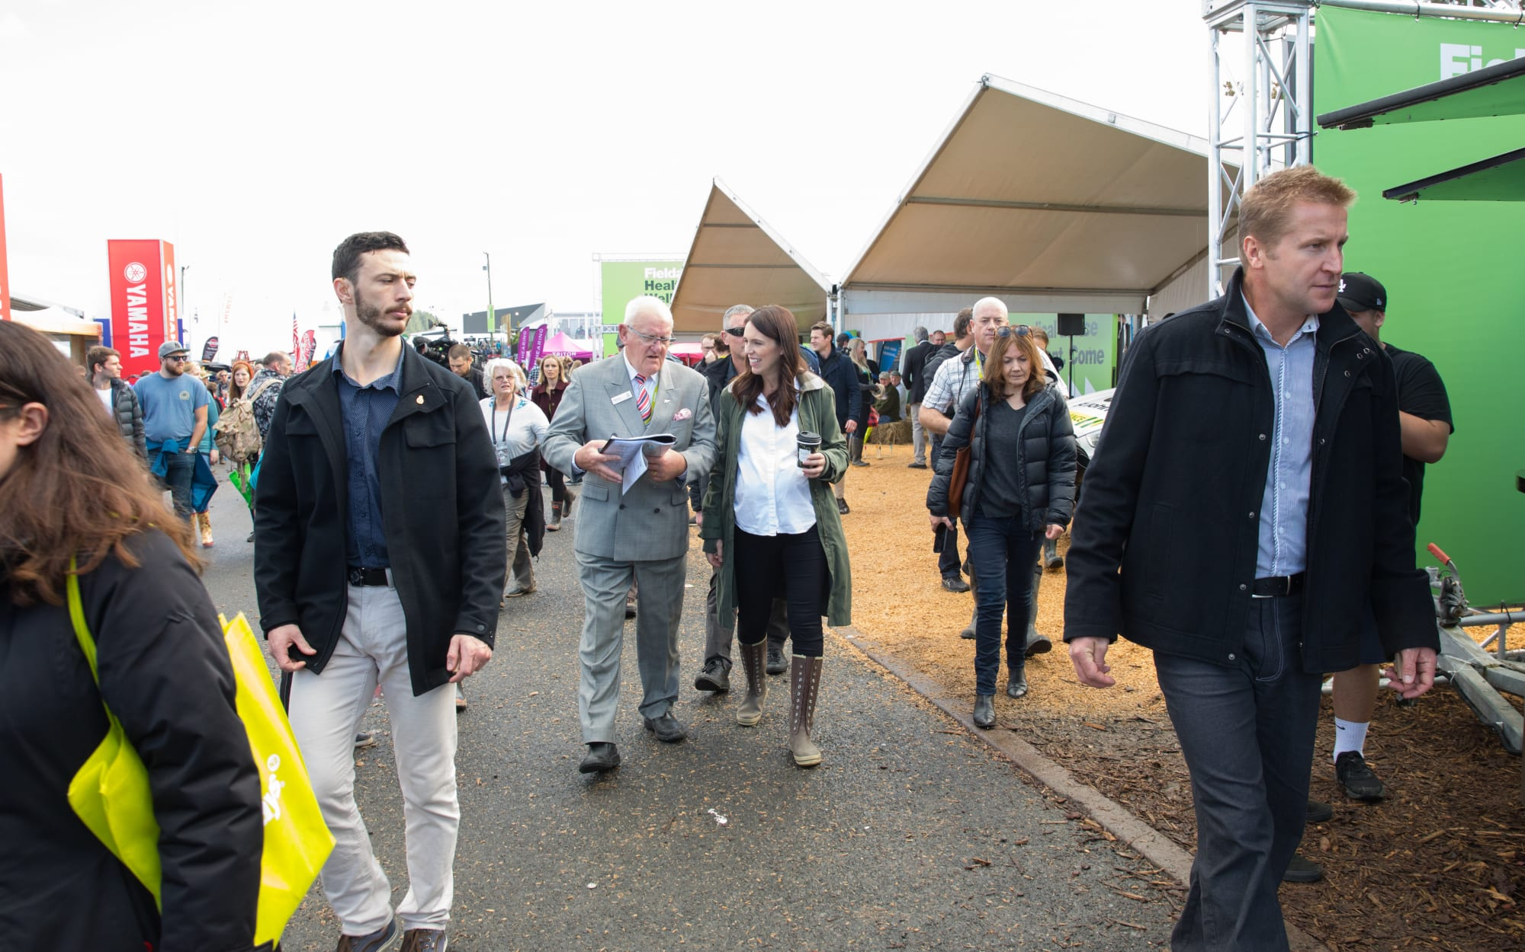

Jacinda Ardern at the 2018 Fieldays event.  Photo: RNZ / Cole Eastham-Farrelly

It was late 2017 when concerns about climate change regulation first began to circulate among farming industry leaders. The Labour party had just swept to power in the September election, with new Prime Minister Jacinda Ardern vowing New Zealand would be carbon net-zero by 2050, and naming climate change as her generation’s “nuclear free moment".

Among her campaign promises, Ardern had said Labour would bring agriculture into the Emissions Trading Scheme, making it subject to the market price for greenhouse gas credits. Twice before, agriculture had lobbied against its inclusion, and won, making it the only industry that did not pay for its climate pollution.

Labour’s coalition partner New Zealand First hadn’t wanted agriculture to face a climate tax, but during negotiations, the two parties had compromised. If the newly-formed Climate Change Commission recommended it, they said, agriculture would still be subject to the ETS, but would only pay for 5 percent of its emissions, and all revenue raised from farming would be recycled back into the industry to encourage innovation.

Despite those extremely generous terms, the idea of going into the Emissions Trading Scheme sent shivers through the farming sector. No industry ever wants more regulation, but the agribusiness’ opposition to emissions pricing was especially deep-seated: paying for pollution meant admitting there was pollution, and who knew where that might end up.

The industry decided it needed to challenge the pricing idea, and the best way to do that was to present a united front. So in November 2017 eleven peak industry bodies - including Federated Farmers, Beef+Lamb, Dairy NZ, Horticulture NZ and the Federation of Māori Authorities, together with an independent chair, agribusiness leader Mike Petersen -  formed a new entity under the banner of the “Farming Leaders Group”.

The group met first with the new minister of agriculture, Damien O’Connor, and then in February 2018 O’Connor arranged the group’s introduction to the Prime Minister at Parliament, at a high-powered meeting which also included environment minister David Parker, finance minister Grant Robertson, and forestry minister Shane Jones. Throughout that year the Farming Leaders’ Group would meet with Ardern and the group of ministers - together with climate change minister James Shaw -  three more times. Ardern also had three separate meetings with the dairy co-op Fonterra, New Zealand’s single largest climate change polluter.

During that same time period, Ardern met only once with the heads of the country’s environment groups, diary entries show. But that imbalance was nothing new, even for a centre-left government. Agriculture has always had a special place when it comes to environment policy in New Zealand. Since at least the 1990s, successive governments have eschewed regulation in favour of voluntary industry agreements, and direct negotiation with industry when necessary. Partly, this is a product of culture, a nod to our beginning as a pastoral nation, where farming was seen as the most important use of land. Partly, it’s economic. In 2022, food and fibre made up 80 percent of exports, bringing in a record $52.2 billion.

[**A Flourish chart**](https://flourish.studio/visualisations/line-bar-pie-charts/?utm_source=showcase&utm_campaign=visualisation/14699330)

As 2018 wore on, however, it became obvious that agriculture’s vaunted position might not be able to save it from a new tax. The government was clearly serious about upholding its promises, and had commissioned a series of reports on climate change and agriculture to give its argument weight. As each came back, the case for regulating emissions grew more urgent - not less.

The first of those, in July, saw the Prime Minister’s Science Advisor Peter Gluckman lay bare the stark facts of agriculture’s emissions footprint. Gluckman found biological emissions from agriculture made up nearly half Aotearoa’s total greenhouse gas emissions. Three-quarters of those were methane from ruminant livestock -  the burps from sheep, cows and deer. The rest was nitrous oxide, from animal urine and manure, and synthetic fertiliser use, including on crops like kiwifruit.

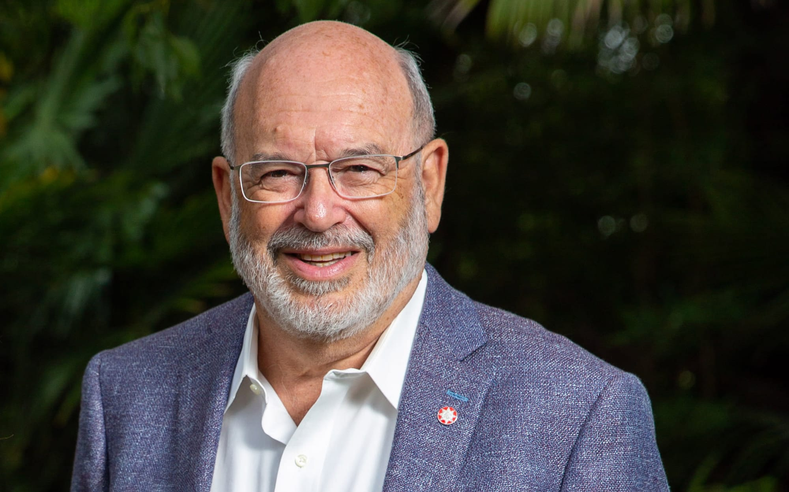

Sir Peter Gluckman Photo: Supplied / University of Auckland

Worse, since 1990, agricultural emissions had risen by 12 percent, Gluckman said. The growth of intensive farming, particularly the expansion of industrial dairy, had seen farmers applying more synthetic nitrogen fertiliser (to make more grass), and using more imported, high-energy feed. That in turn drove higher emissions, both directly from the fertiliser application itself, but also because methane production is proportional to an animal’s energy intake. And even though farming grew more efficient as it intensified - with higher carcass weights in the sheep and beef sector, and more milk per cow in dairy, for example - that wasn’t enough to offset the increase in the sheer amount of feed the animals were consuming, and the associated growth in meat and milk production.

"Maintaining agriculture’s central role in our export economy will require the sector to be increasingly sympathetic to the environment,” Gluckman warned. “Part of that must include reducing its contributions to greenhouse gas production.”

Gluckman’s report was not good news for agribusiness, but worse was yet to come. In August, an advice paper from the Productivity Commission looked to answer one of the most contentious questions in the agriculture space: whether biological emissions of methane and nitrous oxide should be treated the same as carbon, and therefore whether they should go in the ETS.

For years, arguments had swirled about how much nations needed to reduce methane emissions - and in some cases, whether they should bother to focus on methane at all. Unlike carbon dioxide and nitrous oxide, which are long-lived gases, methane is what scientists call “short-lived”. This means it does not linger in the atmosphere for hundreds of years, but instead dissipates after about a decade. Therefore, some people argue, treating it the same as carbon is unfair. In fact, some farming proponents argue that to “do their part” for climate change, all the industry should do is hold their methane levels steady, to show they weren’t causing any “extra” warming on top of that caused by fossil fuels.

Most climate experts disagree. Firstly, they say, methane has contributed most of New Zealand’s warming so far - more than twice as much as carbon. Secondly, although methane leaves the atmosphere quickly, it is a very potent warming agent in the short term, and therefore reducing it means we can reduce warming rapidly too.

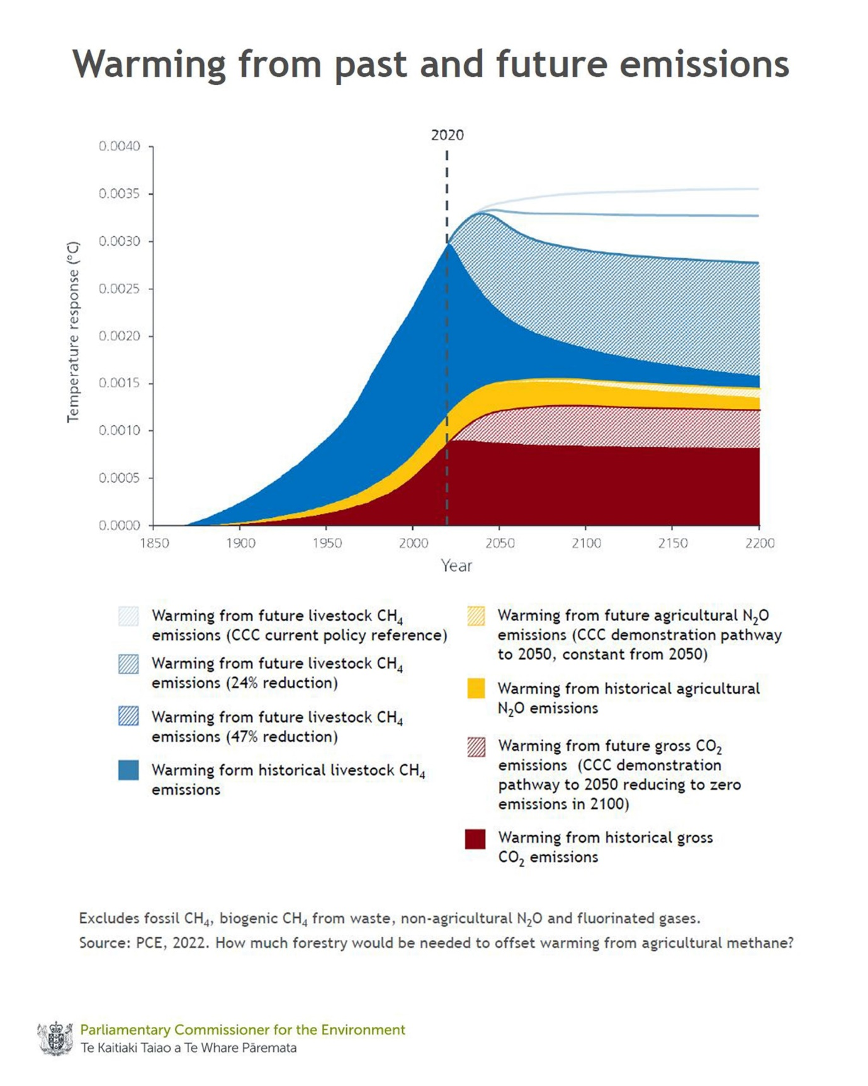

Photo: RNZ

In its report, the Productivity Commission resolved the argument in two parts. Firstly, it said that methane should be reduced. However, it said, to ensure fairness, New Zealand could have separate emissions reductions targets for both short and long-lived gases, with nitrous oxide going in the ETS with carbon, while methane, from both agriculture and waste, would have its own system.

The commission’s report was another shot across agriculture’s bow. Not only did the government now have the justification for regulation, but a way to implement its policy.

But the worst blow for farming came in December, this time in a study co-authored by government experts with the agriculture sector itself. The report from the Biological Emissions Reference Group (BERG) cut across one of the most widely-held views of New Zealand’s farming sector: that because our ruminant farmers were already “the most efficient in the world”, further emissions reductions were nigh-on impossible, unless stock numbers were culled.

While New Zealand farmers were efficient, the report found, there were several main strategies that farmers could use to reduce warming by up to 10 percent, while remaining profitable. The strategies included reducing nitrogen use and stocking rates, while upping animal productivity - for example, a dairy farmer might have fewer cows, but ensuring each cow produced more milk. The strategies weren’t theoretical, the report said, many farmers had already implemented such changes on-farm, and in some cases had seen their profits increase.

(There were also ways to achieve emissions reductions of more than 10 percent, such as planting trees on steep or low-quality land, or switching dairy or sheep and beef pasture to lower emissions farming systems like horticulture, crops, pigs or poultry. After that, further reductions would rely on the use of technology such as methane vaccines, methane and nitrogen inhibitors, or genetically modified ryegrass, which were not yet commercially available.)

The report said the bigger question was why, if it was profitable, had so few farmers chosen to switch to low emissions systems. Its answer was varied, but a major barrier was a farmer’s expertise. A balanced farm system with fewer inputs took skill, and not all farmers had the ability to implement such changes without impacting their bottom line. Farmers’ mindset, their land type, debt levels, appetite for risk, and worldview were also important. The paper noted there was a “degree of paradox” in farmers’ attitude towards the environment. For example, while farmers said they felt responsible for the environment, they were unwilling to accept their practices had environmental implications.

Equally, farmers were sceptical about the importance of their role in influencing climate change, but acknowledged the importance of changes they had made to lessen the impact of future droughts.

The report was a bad look: effectively, it said farmers weren’t doing enough, while also implying some farmers were low-skilled or lacked climate knowledge.

Fortunately for the Farming Leaders Group, by the time the report was released, they had a plan. They decided to propose a voluntary accord with the government instead, in which the sector would lead emissions reductions. But when it became obvious during the Interim Climate Change Committee (ICCC) consultation process that the idea wasn’t going to cut it, industry quickly changed tack. They instead proposed an interim accord. Rather than facing costs straight away, the industry was asking for a five year amnesty, while they prepared for a pricing system.

To climate change advocates, the industry’s tactics seemed obvious - they were simply seeking to once again delay emissions pricing. But the idea caught on: as early as April, the industry’s interim option began to circulate in internal ministry briefings to ministers.

When the ICCC reported back, it found unequivocally that emissions should be priced. Rather than the blunt tool of the ETS, however, the ICCC recommended the government should implement a separate scheme to levy emissions from every farm. A farm-level scheme would instead give individual farmers more autonomy over reducing their emissions, and reward them for taking positive action. Farmers would get 95% of their levy refunded to offset the impact of pricing, as per the coalition agreement, and what money was collected would go back to mitigating on-farm emissions. Getting the work done on time would be a large task, the ICCC said, but the plan didn’t have to be perfect at first.

“New Zealand needs to get started on a genuine transition to meet its climate change objectives. Policy can be adapted and improved as we learn more,” the ICCC said.

In the five years before the pricing scheme came in, the ICCC recommended farming go into the ETS at a factory level - meaning meatworks and dairy companies would face a tax. But, it said, there was another option - the industry proposal to work together, and delay any pricing for five years. The ICCC said it was possible, however it created a significant risk in implementing the pricing scheme on time in 2025.

When the report was made public, the Farming Leaders Group saw its opportunity. Immediately, they kicked their lobbying up a gear. During May, they held two more meetings with Ardern, Shaw and O’Connor. By the end of the month, the industry had yet another new proposal. This time, they suggested as well as the five-year reprieve from pricing, they would work on a farm-level emissions pricing system with the government, together.

Initially, the Ministry for the Environment was not impressed with the proposition at all. If it did go ahead, officials said, there needed to be strict bottom lines. The group would need to participate “constructively” in any development of a pricing scheme.

But despite the ministry’s misgivings, the group had the ear of the Prime Minister, thanks to their meetings on the eighth floor of the Beehive. So over the next two weeks, the Farming Leaders Group, the ministers, and officials began negotiating the terms of a deal. The group was asked to revise its proposal multiple times, after officials complained it was “too vague”. Specifically, the group was asked to commit to a pricing mechanism from 2025; to agree to all farmers having a climate change management plan by then; and to help fund a five-year programme to build an emissions reduction scheme at a cost of $47 million. The negotiations might have dragged out for longer, but in mid-June, Ardern decided to travel to that pivotal gathering at the Fieldays.

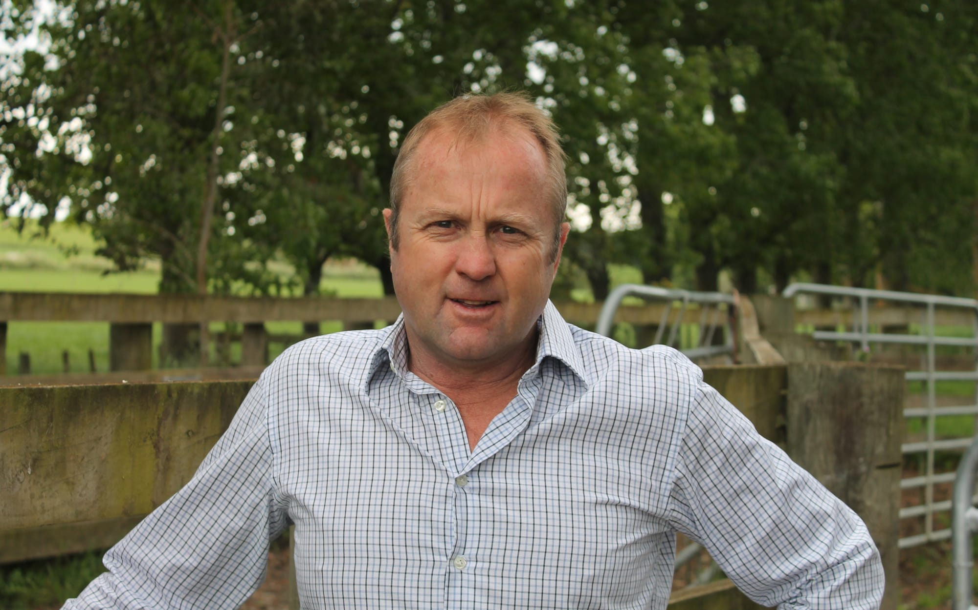

Mike Petersen Photo: supplied

From her first meeting back in 2017, Ardern had formed a constructive relationship with the farming leaders, and particularly with chair Mike Petersen. At that first meeting, the group brought an agenda to discuss, but Ardern set it aside, instead asking each of the 11 leaders to outline their vision for the sector. The answers were largely the same: more sustainable food production, reduced environmental footprint and impact; thriving rural communities; integrity and pride and belief in farming. Ardern listened to them talk, then told the group she wanted to support something that would work for farmers and growers. The leaders were happy - someone was listening to them. And Ardern herself was clearly enamoured with the idea of having the industry on board, rather than enduring endless accusations that Labour “hated farmers.”

At Fieldays, Ardern reiterated her point of view. It worked. After the meeting, there was a sudden “shift” in the key details of the proposal, particularly on the pricing and funding issues, a briefing document said. Subsequently, on June 18, the final proposal was included in a Cabinet discussion document. A briefing to Damien O’Connor revealed just how closely officials and industry were working together - a draft of the Cabinet paper had been shared with the Leaders Group chair, Mike Petersen, before it was seen by ministers and approved on July 1.

Shortly afterwards, the Farming Leaders Group released its proposal publicly. It was called “He Waka Eke Noa,” meaning “we are all in this together”. The document drew an extremely delicate balance. It promised to contribute to global efforts towards the Paris Agreement target, whilst maintaining food production. It would adapt to climate change, while remaining competitive in international markets. And any reductions would be made while preserving profitability.

Nonetheless, the compact was a huge step forward for the industry. Just five years earlier Federated Farmers had refused to even acknowledge that agriculture was contributing to climate change.

But back in Wellington climate change minister James Shaw was still unhappy with the proposal being adopted as law. Draft Cabinet papers show Shaw, an environmentalist with an economics background, strongly believed agriculture should go in the ETS as an interim measure. The agriculture industry’s proposal had uncertain outcomes, he wrote. A regulatory impact assessment concurred. Choosing the industry proposal would delay addressing equity issues between agriculture and other industries, who were already paying for their pollution, it said.

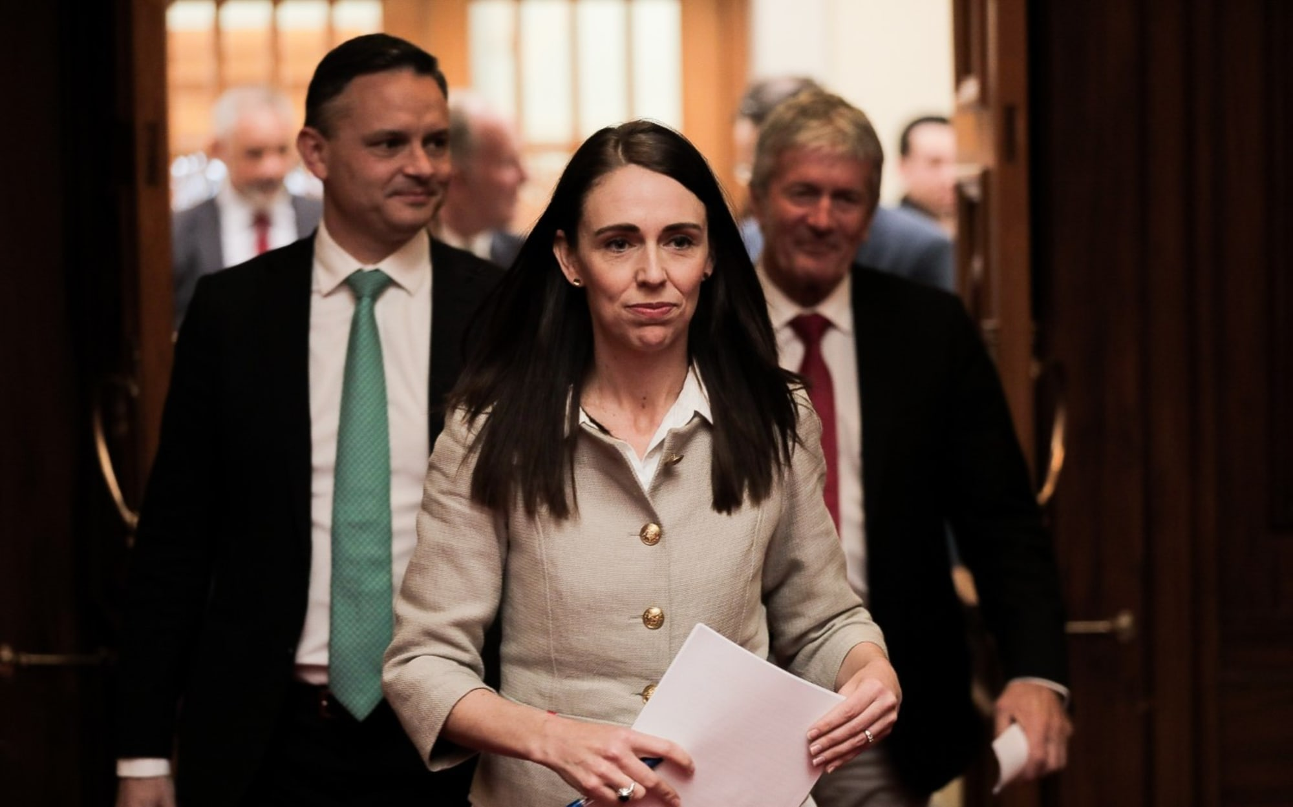

Ardern, Shaw and O'Connor (right), about to announce a plan to create a pricing system for agricultural emissions, which would be designed with the farming industry. Photo: RNZ / Dom Thomas

In late September, however, Shaw and the officials were overruled by Cabinet. On October 24, Ardern stood at a lecturn next to Dairy NZ chief executive Tim Mackle at Parliament, and announced that the government would work together with the agriculture industry to design a “world first” pricing system by 2025. To strengthen the agreement the government had included a backstop: If the group failed to make enough progress, agriculture could still be brought into the ETS.

"I'm proud that we have a world-first agreement as part of our plan to tackle the long-term challenge of climate change and we've done that by reaching an historic consensus with our primary sector," Ardern said.

Shaw, standing behind Ardern, gave no indication of his earlier opposition to the plan. “This will help keep our planet safe for future generations,” he said in a statement.

Prior to the launch, the farming leaders had been welcomed into the Prime Minister’s office for a brief catch-up. The environment lobby, however, was offered no such hospitality, and had no warning the plan was coming.

Greenpeace accused the government of “caving” to industry pressure. While the Government had its ETS backstop, Greenpeace said, there were two elections before any potential pricing might come into play, presenting plenty of opportunity to delay plans yet again. Privately, some government ministers held the same concerns, but equally, believed that if anyone could succeed at corralling farmers, it would be Ardern.

More worrying for the government, then, was the reception from the farmers themselves. It was the first most had heard of such a plan, and they were extremely sceptical - particularly of what an editorial in Rural News called the “lovey-dovey” rhetoric surrounding the launch.

“This deal has the appearance of an arranged marriage, rather than one born out of unrequited love,” the editorial read. “Despite all the spin, uncertainty and a lack of confidence remain in the agriculture sector.”

That lack of confidence would later prove a key ingredient in the plan’s downfall. But back then, before things fell apart, Ardern remained confident the government had done the right thing in striking a deal.

 "My goal is that we never again have to debate the path that we need to be on as a nation, that we never again see tractors roll up the front steps of Parliament,” she said. “This agreement will stick and it means instead of debating what we do, we get on with doing it.”

***\* Part two is published on Friday:  Devil in the detail - How agriculture and government fell out, and the climate lost***

[live stream](https://www.rnz.co.nz/audio/live/national)

[live stream](https://www.rnz.co.nz/audio/live/concert)

[live stream](https://www.rnz.co.nz/audio/live/international)

18 Aug 2023

**Crown vs Cow part two: How agriculture and government fell out, and the climate lost**

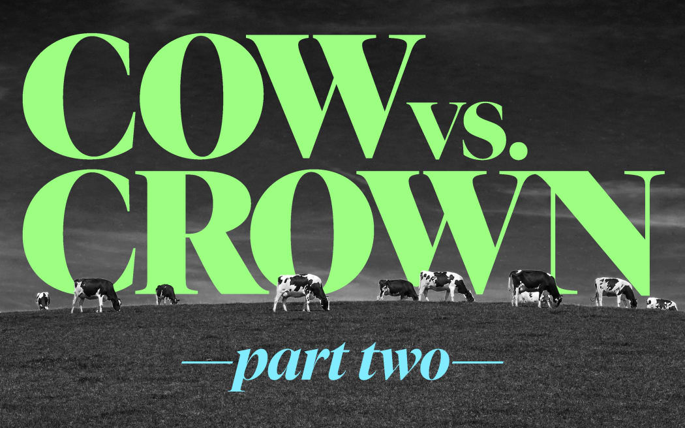

From [**In Depth Special Projects**](https://www.rnz.co.nz/programmes/in-depth-special-projects), 5:00 am on 18 August 2023

Share this



[**Kirsty Johnston**](https://www.rnz.co.nz/authors/kirsty-johnston)

**Agriculture contributes more to global warming than any other industry in Aotearoa. Yet attempts to rein in the sector’s emissions have fallen short once more. In Depth reporter Kirsty Johnston investigates how a “world-leading plan” was born, and how it died. This is part two: Devil in the Detail. How agriculture and government fell out, and the climate lost.**

It took nearly three years before cracks in the shiny veneer of the Labour government’s partnership with the agriculture industry on climate change began to appear, and then just three months for the plan to crumble almost completely.

The ‘He Waka Eke Noa’ deal had been launched as an “historic consensus” by Prime Minister Jacinda Ardern in late 2019, where the two parties would stand “shoulder-to-shoulder” on a programme to reduce emissions.

“For too long politicians have passed the buck and caused uncertainty for everyone while the need for climate action was clear,” Ardern said.

The “world leading” plan was that industry, with help from government agencies, would draw up a system to price and reduce agriculture’s climate pollution - the greenhouse gases created from farming cows, sheep and deer, which make up half of all New Zealand’s planet-warming emissions.

In those first years, it had seemed like the two parties were making progress, despite the huge task before them. Industry representatives spent hours on Zoom or in boardrooms with officials, trialing options and modelling impacts, trying to find the best solution. And by mid-2022, industry had launched its plan.

But to the industry’s apparent surprise, ministers didn’t immediately accept their proposal. Soon, there were two competing plans, with industry distancing itself from the government version. By December, most of the farming industry had reneged on at least part of their commitment, and were urging everyday farmers to follow their lead and submit against the proposal they had helped create.

In short: the love affair was over. But what killed the consensus? If the proposal came from a partnership, why were politicians so unhappy with the result? And more importantly - what about the climate?

This RNZ investigation uses background interviews with industry insiders, officials, and experts, as well as documents obtained under the Official Information Act, such as cabinet papers, government reports and ministers’ diary entries to tell the inside story of how a once-promising idea fell apart. You are reading part two - you can [go back to part one here](https://www.rnz.co.nz/programmes/in-depth-special-projects/story/2018902262/crown-vs-cow-the-inside-story-of-how-we-failed-to-regulate-our-worst-climate-polluter).

A protest convey of the Groundswell group, moving through central Auckland in July 2021. Photo: Newsroom / Matthew Scott

The task before the He Waka Eke Noa partnership was never going to be easy. The 11 industries involved were extremely diverse: from beekeepers to deer farmers; horticulture to dairy; beef, lamb, Māori agriculture, and then the government officials.

The group had two main tasks. First, they had to upskill farmers, and rapidly. At that point, in early 2020, very few farmers knew their farms greenhouse gas emissions, with most underestimating farming’s pollution by half. Secondly, they had to find a way to price emissions that would be agreeable to everyone. By far the most difficult part, the partnership believed, was the pricing element.

The rationale behind a pricing system for emissions is simple: if polluters have to pay for the cost of their emissions, emissions will reduce, because every tonne of emission reduced is one they don’t have to pay for. Ideally, because pricing rewards those who take positive action, it would also encourage innovation.

Most emissions pricing policies are made of two parts: First, the price for the pollution, and second the mitigation against that price, like a discount. In this case, that discount would likely be in the form of “free allocation” of pollution, which would help farmers and rural communities adjust to the increased costs imposed on them, and to aid the transition to low-emissions agriculture. Because the initial discount was set at 95 percent, by the coalition agreement, agriculture would only pay for 5 percent of the gases it emitted.

The partnership had a raft of choices to make. They already knew they wanted the price to apply at individual farm level, so farmers had more control over their emissions. They wanted a split gas levy - so that methane had a separate price from nitrous oxide and carbon. And in terms of mitigation, they wanted not only to provide financial assistance via free allocation, but practical assistance to help farmers transition, such as upskilling, or access to low-emissions technology.

The difficulty came in trying to distribute the free allocation at a farm-level in a way that was fair, but also achieved the emissions reductions required. There were multiple methods considered by the partnership, all which posed their own particular problems.

For example, one method, known as “grandparenting”, saw free allocation determined by a farmer’s historic emissions level. Farmers would individually get their 95% free allocation based on that level, meaning if they reduced emissions subsequently, they could save or even make money. But the partnership didn’t like that method, as they felt it penalised those who had already made emissions gains, while rewarding polluters.

Another example, recommended by the Climate Change Commission, had two similar systems called “output-based allocation” and “land-based allocation”. In an output-based system, a farm’s allocation would be based on its annual output, for example of milk solids for dairy, or stock numbers for drystock farming. If the farm’s output was above the average amount of emissions for that “output”, the farmer would pay a levy. If it was below, it would receive a rebate, encouraging emissions efficiency. Similarly with a land-based system, if a farmer’s emissions were above or below the average for their land’s “productive capacity” per hectare, they would be either penalised or rewarded. Both systems put pressure on high-emitting farmers to reduce emissions, or face financial consequences.

The partnership’s problem with the output and land-based methods, however, was that each one favoured a particular sector. Generally, land-based allocation would benefit farms with lower stocking rates and lower emissions per hectare, like sheep and beef farms. Output-based favoured the more intensive systems used by dairy.

Inside the steering group’s room, the committee members went around and around on which one would be better, commissioning modelling and charting impacts, then taking updates back to their industry groups, who would inevitably push back if their particular sector was at a disadvantage. In the end, even though some of the partners wanted the land-based or output-based options, the argument came down to a struggle between the two loudest voices: the dairy industry and the meat industry, who simply would not agree to a scheme that left their members worse off.

Groundswell protestors on the streets of Christchurch Photo: RNZ / Conan Young

While the partners were locked away discussing their plans, the mood outside was changing, rapidly. A newly-formed farming lobby group named Groundswell began to organise protests over what they saw as various “attacks” on farmers by the government, including new freshwater rules, the so-called “ute tax”, and of course, climate regulation. “The unworkable elements of climate-change policy which are crucifying farmers and growers must be withdrawn,” Groundswell declared. The growing disquiet saw hundreds of tractors and trucks descend on the country’s main cities, with furious farmers waving signs proclaiming “No Farms No Food” and “Change The Politics, Not The Climate.”

The partnership released its draft report into this seething melee, in November 2021. The document revealed that the group had never managed to agree on an allocation policy. Instead, the partnership had put aside a traditional rebate scheme and settled on something else entirely: a proportional discount, where the levy amount itself was simply discounted by 95% at each farm, no matter what reductions a farmer made.

At the price rate the partnership suggested, 11c/kg methane, farmers would pay anywhere from 1.4 per cent to 6.0 percent of their operating profit in levies, with some farm types hit harder than others. For example, while an average Waikato dairy farmer would pay $6195 a year, a Canterbury dairy farmer would pay $12,966. A South Island hill country sheep farmer would pay $11,195.

[**A Flourish chart**](https://flourish.studio/visualisations/line-bar-pie-charts/?utm_source=showcase&utm_campaign=visualisation/14746813)

To help offset those costs, and to boost emissions reductions, the partnership had thrown in some sweeteners. If farmers lowered emissions, either by growing vegetation to absorb carbon (a process known as sequestration), or by using certain emissions reduction technologies, they would be paid for their emissions savings - at a rate up to ten times the amount of the levy. With such generous terms, some farmers would be able to offset their entire emissions bill, or even be paid a credit. The incentives were to be paid from the levy money raised, meaning all revenue was recycled back into agriculture, and didn’t end up in the government coffers.

HWEN programme director Kelly Forster called the draft a “huge milestone”, forged in challenging circumstances. “You’ve got very diverse views sitting on that group,” Forster told Newsroom.

Critics did not agree, saying the plan was a waste of time.

"He Waka Eke Noa had one job, to come up with an emissions reduction plan for agriculture that would cut emissions. They have completely failed,” said Forest & Bird Climate Advocate Geoff Keey.

Environmentalists made two points. First, they said, the low methane price meant farmers remained insulated from the cost of their pollution. And secondly, although the government's new methane targets required a 10% reduction by 2030, the partnership’s modelling showed that its pricing system would reduce emissions by less than 1% from 2017 levels. Any further reduction relied on technology that had not yet been proven at scale. It was an outcome the Interim Climate Change Commission (ICCC) had warned against in its earlier report, saying that a proportional discount “would not retain the full incentive to reduce emissions that is required to reach the desired outcomes.” It appeared that in their drive for consensus and fairness, the partnership had foregone the entire point of the exercise: to combat global warming.

Climate Change Minister James Shaw openly expressed his own disappointment. “There is clearly more work to be done on those proposals before final decisions in March,” Shaw said. (Shaw was in fact so unhappy that he asked the partnership to go back and re-visit an option initially suggested by the ICCC - a hard limit on the total emissions, also known as a cap. But the partnership again discarded the idea, saying it was too complex.)

James Shaw Photo: RNZ / Cole Eastham-Farrelly

In early 2022, the partnership began a consultation tour. While some meetings were held locally, most were forced online due to Covid-19, alienating many already-disgruntled farmers further. Groundswell added to the sense of agitation, accusing the partnership members of being the government’s “pet lobby groups”. But the partnership and its supporters remained adamant: farmers should get on board, because their option was better than being subject to the Emissions Trading Scheme (ETS).

In June, the final He Waka Eke Noa partnership proposal was released. This time, the partnership anticipated the blowback on its emissions reductions, and presented a calculation showing their proposal would cut methane by 4-5.5% from 2017 levels by 2030. When added to contributions from the waste sector and freshwater regulators, that meant it would achieve the 10% target in the Zero Carbon act by 2030. Meanwhile, nitrous oxide output would drop by between 2.9 and 3.2% by the end of the decade.

The figures made for a shiny headline, but modelling released with the report revealed the predictions still relied heavily on unproven technology that might not work in New Zealand. Modelling showed once those kinds of forecast technology improvements were taken out, the levy itself would only achieve a 0.8% emissions reduction by 2030.

A week after the proposal was made public, officials drafted a briefing with their initial feedback for ministers. The plan had some flaws, they said, the first one being the methane price wasn’t high enough to force change. It was also expensive - more than $100 million a year to implement - and a high burden on farmers.

The aspect of the plan that caused most immediate concern, however, was sequestration. The sequestration payments were the partnership’s solution to a difficult problem: its scheme would otherwise be inequitable, placing a much higher burden on sheep and beef farmers. Unlike dairy, the dry stock sector was less likely to have cost-effective mitigation technology that would help them avoid the cost of the levy. (Sheep and beef are also less profitable generally, whereas dairying can be more lucrative). On the other hand, however, many dry stock farms had large tracts of native bush, or scrappy land that they could plant out if they were allowed to claim credit for them. The officials’ dilemma, however, was that the sequestration payments created another kind of equity issue. It would mean farmers were being paid for vegetation, such as long-established native bush, riparian planting and shelterbelts, where other, non-farming landowners such as council or iwi were not. There was also a question over how much carbon would actually be removed from the climate from small patches of trees, and whether that would officially count towards New Zealand’s emissions targets. Plus, sequestration was already part of the ETS. Because of the complexity, officials recommended deferring the inclusion of sequestration, or risk missing the 2025 target.

Climate Change Commission chair Rod Carr Photo: RNZ / Dom Thomas

In its advice in late June, the Climate Change Commission recommended that if the plan was to go ahead the Government make “several substantive changes”. Sequestration was one of those. It should not be part of the pricing model, but instead the government should begin work on a separate system that recognised vegetation that was not currently included in the ETS, the commission said. There also needed to be more consultation with Māori, as their farms - many in sheep and beef - would be affected. The commission also recommended that fertiliser should go into the ETS, not the farm-level system.

As the proposal stood it would be “infeasible to implement” by 2025, as neither the government nor the farming sector was prepared enough for the level of detailed emissions capture it required, the commission said. But it warned against delaying pricing. Instead, it recommended starting with a basic farm-level levy and continuing to develop the pricing system further - particularly so that it could enable emissions prices to increase, as in a more traditional marginal pricing system. Using revenue to fund mitigation was a good first step, it said, “but we do not consider this will be an effective and enduring model in the long term to meet targets.” It said a pricing system using an output-based or other allocation model, should be “rapidly pursued.”

The commission’s advice caused an obvious headache for officials. They were on deadline, and timelines were clearly too tight to come up with a second system. In a briefing from Ministry for Primary Industries (MPI) staff to Agriculture Minister Damien O’Connor, officials pointed out that while the commission preferred an allocation system, it hadn’t given any practical solutions for how to do that, or how to transition from one system to another. Officials instead advised ministers that they supported the partnership's proposal to use recycled revenue to incentivise emissions reductions.

Over the next three months, ministers and the officials worked at making the He Waka Eke Noa proposal “more credible and workable”. One major issue was deciding how the methane price was set. In their proposal, the partners wanted methane prices to have a three-year price-ceiling of 11c/kg methane to “earn farmers trust”. Officials disagreed with that cap, saying it might “constrain the ability of the pricing system to drive emission reductions”. The partners also wanted input on methane prices in the future, by way of an oversight board, made up of sector members, who gave advice to ministers on the levy rate. Officials said that process lacked independence and transparency, opening the door for “constant debate” (read: lobbying) on the levy price. The Treasury, when it gave advice on the plan, held the same concerns. "The governance approach proposed by the partnership may risk regulatory capture, given their recommendations to have industry representatives on a governing board responsible for recommending levy prices,” it said.

The Treasury’s report strongly advised against the He Waka Eke Noa scheme as a whole. It was not based on sound economic principles, it said. The Treasury too was concerned that the pricing system would not actually lower emissions. It recommended, rather than using generous payments for emissions reductions, that the government should impose a higher levy price and then, if there was evidence of hardship, provide targeted financial support to affected farms. But, officials said, the government should not intervene to prevent every single farm from failing.

**"We expect to see structural change across land-based primary industries because of pricing, given the historic lack of incentives addressing the sector’s emissions and the implicit subsidy that it has received to date. In some places there are likely to be existing land uses that are no longer viable when facing the full costs of their production,” said Treasury.**

In September, the government’s proposed version of the He Waka Eke Noa plan went to Cabinet for approval. The paper revealed that - just like with the partners’ model - the two most powerful people tasked with designing the government’s system had been unable to agree. While Agriculture Minister Damien O’Connor supported an amended version of the farm-level pricing system, Climate Change Minister James Shaw did not. He still had concerns regarding “uncapped emissions, a low marginal price, and the risk of emissions reduction targets being traded off against other considerations when prices are set.” Shaw instead recommended his preferred version: a cap and trade system.

Once again, Shaw’s proposal was rejected by Labour ministers.

Climate Change Minister and Green Party co-leader James Shaw (left), with Labour's Agriculture Minister Damien O'Connor, then-Prime Minister Jacinda Ardern and MP for Wairarapa Kieran McAnulty at the announcement of a proposed agricultural emissions pricing scheme in October 2022. Photo: RNZ / Angus Dreaver

On 11 October 2022, Jacinda Ardern donned a new pair of gumboots and travelled to the Wairarapa. At a local dairy farm, surrounded by cameras, she announced the government’s proposed pricing scheme, alongside an extra $485 million in subsidies to help agriculture reduce its emissions.

The plan the government proposed was largely identical to that put forward by industry, except for changes to the sequestration policy, and the way the levy price was set.  In the government version, sequestration would be recognised, but through a separate system, with only riparian planting and indigenous vegetation to be included from 2025. In the long term, Cabinet agreed to consult on working towards including new categories of vegetation in the ETS. Meanwhile, the sector’s plan to help set the levy price was wholly rejected. Instead, the price would be tied to emissions reductions targets, and would likely start around 11c/kg methane.

“This is a pragmatic solution that helps us meet our targets, be the first in the world to do so and can be implemented quickly,” Ardern said, in launching the proposal. “All of those things are material if New Zealand is to start making a difference on its agricultural emissions reductions.”

Bryce McKenzie of Groundswell Photo: RNZ / Angus Dreaver

The backlash from the farming sector was brutal. Groundswell’s Bryce McKenzie called the plan an "assault on food production and rural communities". Beef+Lamb NZ chair Andrew Morrison was more measured, saying he supported the bulk of the proposal but the changes to the sequestration policy, which meant smaller lots of trees would not attract a reward, was unfair. Federated Farmers president Andrew Hoggard said the proposal was disappointing. "We didn't sign up for this. It's gut-wrenching to think we now have this proposal from the government which rips the heart out of the work we did.”

Hoggard had attended an advance briefing on the government proposal ten days earlier. He’d picked out some key figures: modelling commissioned by the government showed no matter how the pricing system was designed, meat and dairy farming would be negatively impacted by emissions pricing: profits would drop, some farmers would switch to horticulture, plant trees or sell up to foresters. But some scenarios were worse than others. The partnership’s proposal, for example, saw sheep and beef farmland shrink by at least 8%. But under the system proposed by the government, there would be a roughly 21% reduction in lamb and wool, and a 36% drop in beef, [the modelling found.](https://www.beehive.govt.nz/sites/default/files/2022-10/Impacts%20of%20CC%20mitigation%20policies%20on%20the%20primary%20sector_FINAL.PDF)The impact on dairy was much lower, with a 5% drop in milk solids.

“Say Goodbye Small Town New Zealand,” Hoggard wrote in a Federated Farmers press release. "Our plan was to keep farmers farming. Now they’ll be selling up so fast you won’t even hear the dogs barking on the back of the ute as they drive off.”

The irony to the public backlash was that government modelling had found that with land use change included, even considering the very low methane price, it would be enough to meet New Zealand’s emissions goals. Methane emissions would drop 15%, and nitrous oxide would fall by nearly 13% by 2030. However, that benefit wasn’t one of Federated Farmers talking points. Instead, the debate switched to a new narrative about the government causing “emissions leakage” - where other countries who were less emissions efficient would fill the gap caused by New Zealand’s drop in production, meaning international emissions could actually increase as a result of the policy. This was picked up as a talking point by Dairy NZ, and subsequently the National Party.

National pointed to modelling which estimated as much as 65 percent of reductions here could be "leaked" by countries offshore. O’Connor was quick to push back, saying the figures in the report were “assumptions.” [Other commentators](https://www.newsroom.co.nz/farmings-big-warming-impact-needs-a-fair-price#:~:text=The%20global%201.5C%20target,over%20the%20past%20two%20centuries.) raised the spectre of leakage as a false flag, citing the Climate Commission report, which found multiple analyses could not agree on how much leakage there would be, because the international landscape was changing so rapidly.

In early November 2022, the leaders of Federated Farmers, Beef+LambNZ and Dairy NZ announced to farmers that they had decided to pull their support for the government’s methane reduction target of 10 percent by 2030. Shortly afterwards, the full He Waka Eke Noa partnership issued a submission on the government’s plan, recommending it change its pricing proposal back to the original version, except this time with an even lower levy rate, of 5c/kg of methane, with no increase for five years. Federated Farmers’ own submission went further, saying it would only support a pricing system if methane targets were based on “no additional warming”, and if no leakage or reductions in food production occurred.

Publicly, the industry-government partnership had splintered. Behind-the-scenes, however, the lobbying continued. Dairy NZ met with officials to raise its concerns about the government plan. The meeting exposed a gap in thinking between the two groups. Dairy NZ was adamant that the purpose of the pricing scheme was only to raise enough money to pay for mitigation on-farm, and nothing else - particularly not offshore carbon offsets. Officials admitted their point exposed an “ambiguity” in the emissions plan. “Is the purpose of the pricing system to raise funds for incentives and research or is it a price to discourage emissions?”

Climate change commentator Rod Oram said it was deeply concerning that the two groups appeared to be on different pages at such a late stage. “I believe everyone has been talking past each other on this issue - politicians included,” Oram said.

At the end of November, in a last-ditch attempt to keep consensus, Ardern again met with the He Waka Eke Noa partners at Fieldays. During the meeting, the government backed down on its sequestration proposal, instead agreeing it would include sequestration as part of the farm-level pricing system from 2025, as an interim move while it reformed the ETS.

A month later, right before Christmas, government released its final plan. It had conceded something on almost all of the industry’s points, even on price-setting. While government would set the levy, it would be on advice from a board of farming representatives and the Climate Change Commission. They would be directed to find the “lowest possible price” that could conceivably allow New Zealand to meet its emissions reduction targets. That price would be set for five years. It also agreed that all money raised by the scheme would go back to farming, not to the government coffers.

Some of the He Waka Eke Noa partners were at the press conference at Parliament. Dairy NZ chair Jim van der Poel said the changes showed the government and industry could find a way forward together.

“There have been important changes, for the way the price will be set, farmers’ ability to manage and report their emissions, and the recognition farmers will get from the planting on their farms. We’ve made good progress,” he said.​

But despite the supposed show of unity, the government had lost the sector’s backing and they knew it. As 2022 turned to 2023, no further mention was made of agricultural emissions pricing.

In January, Ardern resigned, costing the scheme its most powerful champion. As of June 2023, there is still no emissions pricing plan. The government, once confident, and motivated to make real climate action, has instead run out of time.

Share this

**RECENT STORIES FROM IN DEPTH SPECIAL PROJECTS**

* [Crown vs Cow part three: Why farming reneged on its deal to cut emissions](https://www.rnz.co.nz/programmes/in-depth-special-projects/story/2018903090/crown-vs-cow-part-three-why-farming-reneged-on-its-deal-to-cut-emissions)
* [Crown vs Cow: The inside story of how we failed to regulate our worst climate polluter](https://www.rnz.co.nz/programmes/in-depth-special-projects/story/2018902262/crown-vs-cow-the-inside-story-of-how-we-failed-to-regulate-our-worst-climate-polluter)
* [Something Evil](https://www.rnz.co.nz/programmes/in-depth-special-projects/story/2018901718/something-evil)
* [THIS ONE'S REAL: The Loafers Lodge Fire](https://www.rnz.co.nz/programmes/in-depth-special-projects/story/2018890914/this-one-s-real-the-loafers-lodge-fire)
* [The Deadline](https://www.rnz.co.nz/programmes/in-depth-special-projects/story/2018885956/the-deadline)

**Get the RNZ app**

for easy access to all your favourite programmes



**RNZ STATIONS**

* [National](https://www.rnz.co.nz/national)
* [Concert](https://www.rnz.co.nz/concert)
* [RNZ Pacific](https://www.rnz.co.nz/international)
* [Parliament - live stream](https://www.rnz.co.nz/parliament)

**LATEST & POPULAR**

* [Latest audio](https://www.rnz.co.nz/audio)
* [Popular audio](https://www.rnz.co.nz/audio/popular)
* [Latest video](https://www.rnz.co.nz/video)

**HOW TO WATCH & LISTEN**

* [Audio help](https://www.rnz.co.nz/listen/audiohelp)
* [Radio](https://www.rnz.co.nz/listen/amfm)
* [Follow our podcasts](https://www.rnz.co.nz/listen/podcasts)
* [Sky, Freeview & Satellite](https://www.rnz.co.nz/listen/sky)
* [YouTube](https://www.youtube.com/user/radionz)
* [RNZ apps for iPhone and Android](https://www.rnz.co.nz/listen/app)
* [RNZ Flash Briefing for Amazon Alexa](https://www.rnz.co.nz/listen/alexa)
* [RNZ News for Google Assistant](https://www.rnz.co.nz/listen/google)

**ABOUT RNZ**

* [About](https://www.rnz.co.nz/about)
* [Contact](https://www.rnz.co.nz/about/contact)
* [Formal Complaints](https://www.rnz.co.nz/about/formalcomplaints)
* [Media Releases](https://www.rnz.co.nz/media)
* [Awards](https://www.rnz.co.nz/awards)
* [Jobs](https://www.rnz.co.nz/jobs)
* [RNZ Your Media Matters](https://www.rnz.co.nz/yourmediamatters)
* [Local Democracy Reporting](https://www.rnz.co.nz/ldr)
* [RNZ Commissioning](https://www.rnz.co.nz/commissioning)

**JOIN & FOLLOW RNZ**

* [RNZ on Facebook](https://www.facebook.com/RadioNewZealand)

* [RNZ on Twitter](https://twitter.com/radionz)

* [RNZ on Youtube](https://www.youtube.com/user/radionz)

* [RNZ on Instagram](https://www.instagram.com/radionewzealand)
* [**Sign up to RNZ Newsletters**](https://www.rnz.co.nz/about/newsletters)

shielded

* [Terms of use](https://www.rnz.co.nz/about/legal)

© Copyright Radio New Zealand 2023

9 Aug 2023

**Crown vs Cow part three: Why farming reneged on its deal to cut emissions**

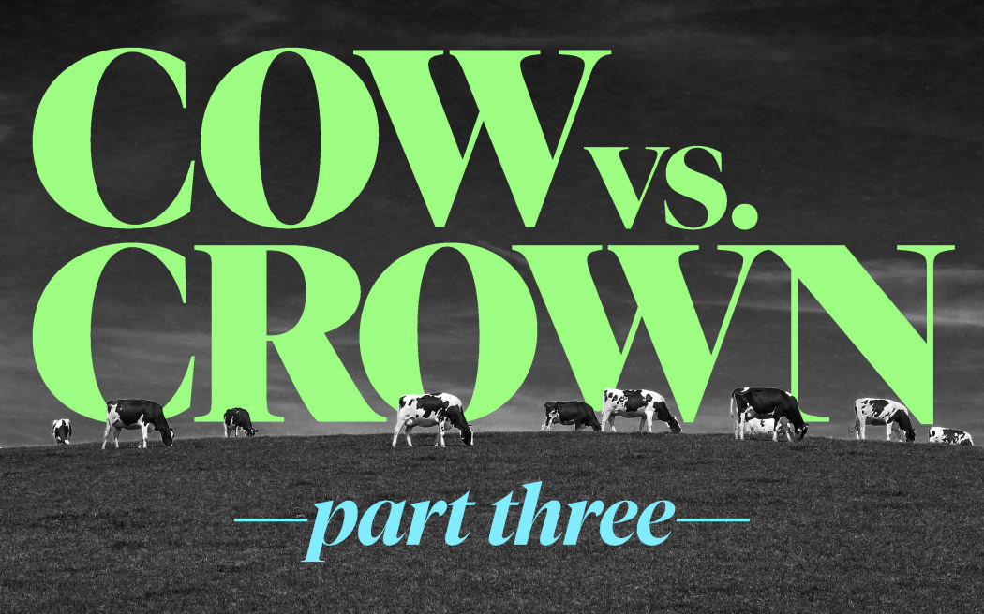

From [**In Depth Special Projects**](https://www.rnz.co.nz/programmes/in-depth-special-projects), 5:00 am on 19 August 2023

Share this

* [Share on Twitter](https://twitter.com/intent/tweet?text=Crown%20vs%20Cow%3A%20The%20plan%20for%20pricing%20agricultural%20emissions%20is%20effectively%20dead%20-%20what%20killed%20it%3F&url=https://www.rnz.co.nz/programmes/in-depth-special-projects/story/2018903090/crown-vs-cow-part-three-why-farming-reneged-on-its-deal-to-cut-emissions)
* [Share on Facebook](https://www.facebook.com/sharer/sharer.php?u=https%3A%2F%2Fwww.rnz.co.nz%2Fprogrammes%2Fin-depth-special-projects%2Fstory%2F2018903090%2Fcrown-vs-cow-part-three-why-farming-reneged-on-its-deal-to-cut-emissions)
* [Share via email](mailto:%20?subject=Crown%20vs%20Cow%3A%20The%20plan%20for%20pricing%20agricultural%20emissions%20is%20effectively%20dead%20-%20what%20killed%20it%3F&body=I%20thought%20you%20might%20be%20interested%20in%20this%20page%20https%3A%2F%2Fwww.rnz.co.nz%2Fprogrammes%2Fin-depth-special-projects%2Fstory%2F2018903090%2Fcrown-vs-cow-part-three-why-farming-reneged-on-its-deal-to-cut-emissions%20from%20RNZ.)
* [Share on Reddit](https://www.reddit.com/submit?url=https://www.rnz.co.nz/programmes/in-depth-special-projects/story/2018903090/crown-vs-cow-part-three-why-farming-reneged-on-its-deal-to-cut-emissions)
* [Share on Linked In](https://www.linkedin.com/shareArticle?mini=true&url=https://www.rnz.co.nz/programmes/in-depth-special-projects/story/2018903090/crown-vs-cow-part-three-why-farming-reneged-on-its-deal-to-cut-emissions)



[**Kirsty Johnston**](https://www.rnz.co.nz/authors/kirsty-johnston)

**Agriculture contributes more to global warming than any other industry in Aotearoa. Yet attempts to rein in the sector’s emissions have repeatedly fallen short. Kirsty Johnston investigates how a “world-leading plan” was born, and how it fell apart. This is part three: Backtrack. Why farming reneged on its deal to cut emissions.**

When it came time to launch the New Zealand farming sector’s scheme to combat global warming in June 2022, the industry’s plan was to present a strong, united front at a celebratory event in Wellington.

A group of leaders from industry groups, the farming lobby, and Māori agriculture would sit in a row of stools on stage, facing the audience, and proudly announce that after nearly three years’ work they had created a “robust and credible” system to price farming’s greenhouse gas emissions.

It was a big deal, a “world first”, they would say, and most importantly, everyone - even the staunch farmers’ lobby group, Federated Farmers - had signed in agreement on the report’s recommendations.

But on the day of the launch, things didn’t go to plan. The Federated Farmers logo was on the big screen, but its president, Andrew Hoggard, was not on stage. Hoggard, a dairy farmer from Manawatū, instead sat in the crowd as the launch played out, arms folded, only reluctantly leaving his seat to answer questions from media about whether Federated Farmers fully supported the proposal.

“We’ve signed up to it,” Hoggard said. “I don’t think it’s quite perfect just yet. I think the bones are there. There’s more work that’s needed.”

“Obviously, we would love that there wasn’t a price at all, but here we are.”

Later, it turned out that Hoggard hadn’t wanted to sign the final report at all. At the time, the Federated Farmers board overruled him, confident the industry plan would be better than the alternative, which was for farmers to be put in the Emissions Trading Scheme (ETS) alongside other polluting industries, and be subject to the market price for greenhouse gas credits.

The more progressive members of that board also argued that taking responsibility for their part in causing climate change was the right thing to do, and that it was up to them to show leadership, in the hope they could bring farmers along with them.

Then-Prime Minister Jacinda Ardern shared that hope. She believed that an industry-led plan would be more likely that a government-imposed one to get the support needed to reduce agricultural emissions, which make up half of New Zealand’s greenhouse gas pollution. Ardern was determined to get a deal done, and for a time it seemed she would, even if it was through sheer force of will alone.

Looking back, however, Hoggard’s passive protest stands out as a giant red flag - a kind of man-sized portent. As a farmer, Hoggard was not on board with the plan, and as it turned out, neither were many of his farming peers. When the scheme’s recommendations were not immediately accepted by the government - which instead drew up its own version of the plan - Federated Farmers reneged on its commitment, swiftly followed by the rest of the industry partners.

A year on from that launch, the agricultural emissions pricing plan exists in name only, its future tenuous, at best. Environmentalists are despondent. Farmers are furious, both with regulators and the sector leaders who worked on the plan. Industry goodwill towards the government has largely been replaced with hostility and suspicion. And agricultural emissions are once again political grist for the electoral mill, with further delays likely, even as experts warn we don’t have time to waste.

The plan’s failure marks the third time in 20 years that an attempt to regulate farming’s contribution to climate change has faltered. What went wrong? Were farmers ever on board at all? Was the Government simply naive to believe they would ever agree to regulation?

This RNZ investigation uses background interviews with industry insiders, officials, and experts, as well as documents obtained under the Official Information Act, such as cabinet papers, government reports and ministers’ diary entries to tell the inside story of how a once-promising idea fell apart. You are reading part three - you can [go back to part one here](https://www.rnz.co.nz/programmes/in-depth-special-projects/story/2018902262/crown-vs-cow-the-inside-story-of-how-we-failed-to-regulate-our-worst-climate-polluter) and [part two here](https://www.rnz.co.nz/programmes/in-depth-special-projects/story/2018902908/crown-vs-cow-part-two-how-agriculture-and-government-fell-out-and-the-climate-lost).

Beef+Lamb backed out of He Waka Eke Noa immediately after its chair Andrew Morrison was voted out of the role. Photo: RNZ / Richard Tindiller

This is the way the government’s climate change deal with the agriculture industry fell apart: not with a bang, but with a press release. It was April 2023, and for the preceding four months, the pan-agriculture climate change group He Waka Eke Noa had heard almost nothing from Parliament about its plan to introduce farm emissions pricing. In contrast with the previous five years, when the group’s chair Mike Petersen had enjoyed direct access to then-Prime Minister Jacinda Ardern, the new prime minister, Chris Hipkins, did not seem engaged, particularly after two cyclones caused widespread damage across the North Island that summer.

Just the previous December, the government had launched its final plan to reduce pricing, a modified version of industry’s own proposal. After intense backlash from its “partners” in industry, Ardern had eventually backed down on most of the changes it had made, and instead offered agriculture a very generous deal that would see farmers pay the lowest price possible and have access to incentive payments for technology and planting trees. Despite the concessions, industry groups remained dissatisfied, and continued to argue for more lenient conditions, and more financial support.

Farmers, in turn, were unhappy with their industry leaders for, seemingly, even considering a pricing plan. They began to take action against those they felt were responsible. In April 2023, one of the most committed leaders in the He Waka Eke Noa partnership, Beef+Lamb chair Andrew Morrison, lost his role after being voted out. He was replaced by Southland farmer Geoffrey Young, who vowed to stand up for the “disenfranchised and unheard farmers”. Young, unlike Morrision, was supported by the lobby groups Groundswell and Southland Federated Farmers, both vehement anti-pricing proponents.

After Morrison’s exit, on 18 April, Beef+Lamb issued a press release saying it was effectively backing out of the emissions deal. It said it wanted a “staged implementation” of the pricing framework, rather than the legislated 2025 implementation it and the other parties had agreed to five years earlier. With Beef+Lamb’s announcement, the government-industry partnership, already flailing, was now effectively dead in the water.

Rumours began to surface that the government, knowing it was out of time to introduce pricing legislation, was considering introducing a fertiliser tax instead. The National Party seized its opportunity, saying it no longer backed emissions pricing, despite earlier pledging bipartisan support. A few weeks later, at Fieldays, National announced its own farming emissions policy: farmers would not face a price until 2030, and if elected, National would review the targets for reducing methane. National’s climate spokesman Simon Watts said the party would look to meet emissions targets by targeting transport and energy creation, rather than agriculture.

PM Chris Hipkins speaking at the opening of Fieldays in June. Photo: RNZ / Angus Dreaver

Prime Minister Chris Hipkins immediately accused National of “treating the climate with contempt.” Hipkins also made an appearance at Fieldays, where ruled out a fertiliser tax. After meeting with farming leaders, Hipkins said Labour would rather continue working with the He Waka Eke Noa partnership instead.

"I think we can get a way forward, I don't think we're that far apart,” Hipkins said. Subsequently, a statement from the partnership said they were still negotiating on “equity, timing and price levels.”

On Friday 18 August, Agriculture Minister Damian O’Connor outlined what he was calling the government’s “final plan” to reduce emissions from the sector. The plan was largely unchanged from the version outlined in December 2022, with the government once again committing to price emissions at “the lowest possible level”. Farms would have to start reporting their emissions from October 2024 and paying for them from October 2025, with new legislation needed to account for the further delay.

The most significant difference in O’Connor’s latest plan was that this time, Climate Change Minister James Shaw was in open disagreement. The Green Party, which Shaw co-leads, would clearly not support what was being proposed. The only chance, then, for O’Connor’s proposal actually coming to pass was if Labour won a renewed absolute majority in Parliament. An extremely unlikely scenario.

Immediately after the announcement, Federated Farmers said it didn’t support the plan either. Neither did Beef + Lamb, nor Dairy NZ.

Andrew Hoggard, the former president of Federated Farmers, is now a candidate for the Act Party. Photo: RNZ / Angus Dreaver

Depending who you ask, the failure to get the pricing plan over the line prior to the election is the fault of industry, or government, or both.

Some of the He Waka Eke Noa partners say it was the introduction of methane targets in the Climate Response Act as early as 2019 that saw the industry trust in government begin to fray. Federated Farmers, in particular, vehemently opposed the idea that emissions should be reduced by 10 percent by 2030, and began to push back about their inclusion in any industry plan as soon as the law was passed.

Others say the turning point came when officials who had been working with the group for nearly three years told partners that neither the Ministry for the Environment nor Primary Industries would be signatories to the proposal. Until that point, some partners say, they believed the partnership was exactly that - a three-way deal with industry, Māori and government - and the recommendations put forward would be accepted whole. “If we’d known the government wasn’t going to sign - would we really have them in there the whole time?” says Hoggard, who recently stepped down from his role with Federated Farmers to run as a candidate for the Act Party. “Maybe instead we would have had the spinal fluid to put something forward that we thought would work, regardless of whether we thought the government would agree to it.”

Many farmers - whether they’re the industry representatives or the people on the ground - say it was the government’s version of the plan that tipped the balance, particularly the clumsy rejection of the sequestration payments. In their view, Ardern had something unprecedented “gifted” to her by the entire agriculture industry, and she turned it down. “The government didn’t understand how finely balanced that proposal was, that every line had been gone over,” says farming commentator Andy Thompson. Most farmers saw the system like a ledger, Thompson says, with emissions created on one hand, and absorbed on the other. “When you took that sequestration away, farmers said: ‘This is nothing more than a tax’. And that’s when they lost the room.”

Others have a slightly more cynical view, arguing that, all along, Federated Farmers had one foot in, and one foot out of the partners’ tent. When the sequestration payments didn’t go their way, it simply provided an obvious chance to renege on their commitments - an easy way out.

Regardless, almost everyone agrees the final nail in the coffin was when the government’s own modelling of the impacts proved that concerns raised by the sector were based on data. The modelling showed there would be a roughly 21% reduction in lamb and wool production, and a 36% drop in beef. The impact on dairy was lower but still significant, with a 5% drop in milk solids. Effectively, it made it untenable for industry bodies, particularly for Beef+Lamb, to continue to support the pricing plan, because it meant signing up to financial losses for their own members.

“We never would have supported a proposal that would do that,” says former Beef+Lamb chair Andrew Morrison. “We had already modelled those figures ourselves and that’s why we said the sequestration and the right emissions price was so important, because otherwise it wouldn’t work for us.”

Environmentalists, however, say they don’t believe that agribusiness ever had any intention of agreeing to emissions pricing, and the notion of “finding consensus” was simply another delay tactic employed by industry, which the government naively fell for.

“Why would these industries agree to pricing?” Greenpeace chief executive Russel Norman says. Agreeing to pricing was to cede control to a regulator, and therefore to admit there was pollution they were not paying for, Norman says. “The best thing for them is that things continue as they are, where everyone else cuts emissions, and they don’t have to.”

Ecologist Mike Joy says for the dairy industry in particular, low emissions farming would require a total shift in mindset. “For 30 years dairy has run a system optimised for maximising production volumes - one that requires as much milk as possible. Ironically, that system was incentivised by the government, who are now saying it’s the wrong approach.” For companies like Fonterra, reducing production posed a business risk, including the possibility of stranded assets, like milk processing factories, and a possible drop in profit if the industry was unable to sell lower emissions milk at a higher rate.

Ecologist Mike Joy Photo: supplied

And even if industry leaders were genuine about implementing a price, the notion of a sector-wide “consensus” was something of a pipe dream, briefing documents show. In mid-2022, officials warned ministers there was disagreement across the agriculture sector on the “need, urgency and quantity of emission reductions” and how to achieve these. Research from the Climate Commission had found that while half of farmers surveyed agreed they should reduce on-farm emissions, the other half disagreed. When asked what measures they could take, some respondents gave genuine answers, like improving efficiency or changing stocking ratios. But in the comments, the anger from others was visceral. “This is just a government driven way of taxing farmers to please the UN. No real science behind it,” one comment read. “I will not agree with any form of tax,” said another. “I honestly believe the whole idea is rubbish.” Others wrote that instead of choosing mitigation, they would retire, or move off the land: “My farm is for sale, I've had a gutsfull of all this shit.” Other comments were more reasonable, but spoke to the complete lack of assistance farmers had received to get their heads around the changes. “At 65 some of these things are way out of our expertise range. We are just farmers, not computers or technical people.”

Many of the partners agree that in hindsight, they could have done more to help farmers and growers understand why reducing emissions was so important. “Doing a tour of Aotearoa would have helped people understand what the proposal meant for them,” says Traci Houpapa, chair of FOMA, the Federation of Māori Authorities. “Consultation works best when people have a good base understanding, and that's where the partnership could have done better.” Instead, industry groups largely relied on selling the He Waka Eke Noa proposal as the lesser of two evils. Repeatedly, the message was: “It’s better than going in the ETS.”

Equally, however, critics say the government could have done a better job of selling its plan - not just to farmers, but to the public generally. Although Treasury advice suggested some farms would have to be allowed to fail, the government was never going to let that happen at scale. It did not want to encourage widespread, rapid change in land use. And the tax wasn’t going to drastically increase the price of food - in fact a *Newsroom* analysis found that the impact of the pricing scheme would come to [$0.14 per kilo of beef, $0.09 per kilo of lamb and half a cent per litre of milk by 2030](https://www.newsroom.co.nz/sustainable-future/farming-groups-want-methane-ambition-halved). In fact, the scheme wasn’t going to “cost” the country at all. According to a cost-benefit analysis, under the partnership model there was a net benefit of $175 million to New Zealand. And then there were the flow-on effects - better water quality, enriched biodiversity from more planting, improved animal health, and in some cases, higher profits.

“We are very good at talking about the cost, but people forget there is also a benefit to not polluting,” says climate change commentator Rod Oram. “Instead, we just end up with this dialogue where farmers think townies are after them. To me, there was a chronic breakdown in what should have been a national conversation about how we make our economy more productive with higher environmental benefits.”

Part of the difficulty, however, in having such a conversation is that many of the facts are politically unpalatable, particularly in an election year. Neither politicians, nor industry, want to say publicly “we have some bad farmers,” even if they admit it to themselves in private. No one wants to make the argument that perhaps, if those farmers can’t afford to pay for their pollution, then they shouldn’t be in business. Further, no one seems ready to consider that if we want to meaningfully cut emissions, barring a technological breakthrough, New Zealand will have to reduce meat and milk production at some point, and to farm other things instead. Because to acknowledge that would be to concede that our main export industry is bad for the planet, and we don’t have a back up plan.

National's climate spokesman Simon Watts Photo: RNZ / Samuel Rillstone

For now, the emissions pricing scheme remains in a holding pattern. Each party will take a different version of the policy to the October 2023 election - National with its five-year delay, the Greens with a cap-and-trade scheme, to ensure more certainty around emissions reductions. Act wants to match our emissions targets to our five closest trading partners. And Labour says it would have its rather generous pricing plan in place by the end of 2025, if only it could get re-elected with an absolute majority. (As far back as the 2011 election, Labour’s policy was to include agricultural emissions in the ETS within two years.)

Meanwhile, there is growing concern that New Zealand has missed its window to capitalise on being first in the world to regulate farming emissions reductions. In the six years since Labour was first elected, the global picture has shifted rapidly. Other farming nations have brought in ambitious climate targets on agriculture, including Ireland and the Netherlands. At the same time, the commercial market has shifted, with companies like Nestle, Mars and Danone, which buy significant quantities of New Zealand milk powder, announcing they will only buy from suppliers who achieve significant emissions cuts. Their policies are driven by consumer preferences, as more customers demand lower emissions food. Offshore supermarkets, like British multinational Tesco, also have emissions targets.

For progressive farmers, watching their industry leaders cause further delays on global warming has proved extremely frustrating. Like any profession, farming is a broad church, and there are at least as many innovative farmers as there are laggards - but the laggards also tend to make the most noise. In the meantime, the more innovative farmers are quietly getting on with making changes where they can. Some local companies, such as meat processor Silver Fern Farms, or milk company Synlait, have employed their own programmes to encourage the switch to low emissions. Silver Fern chief executive Simon Limmer says the transition to a low carbon economy is an opportunity to create “new forms of value” and to position farmers as climate innovators. It has incentivised sequestration, and invested in methane reduction technology.  “Our consumers are our North Star, and we see a need to continue empowering our farmers to keep pace with increasing customer expectations for more sustainably produced, and processed, red meat,” Limmer says.

Still, questions remain over whether change will happen fast enough to retain New Zealand’s “world-leading” claim on climate efficiency. In a recent interview, Climate Commissioner Rod Carr warned against complacency, saying while New Zealand was once the most efficient, other countries, who have different farming practices (ie animals in barns) are quickly catching up. “We may be best in class, but in a class that is rapidly changing,” Carr said.

There are still signs of climate denialism firmly rooted in parts of the sector. Last month, while Prime Minister Chris Hipkins was meeting with the He Waka Eke Noa partners at Fieldays, Groundswell was holding its own meetings, with American scientist Tom Sheahan, who falsely claims methane and nitrous oxide are “irrelevant” gases and not responsible for global warming. A flyer announcing his visit read: “There is no climate emergency.”

Fifth generation farmer and freshwater ecologist Alison Dewes says that kind of messaging is deeply unhelpful. Better to follow the lead of numerous innovative farmers who are already well on the way to having profitable, resilient, lower emissions businesses, she says.

“Climate volatility is going to hit farmers hardest. Look at Cyclones Hale and Gabrielle - how they've scarred the heart of rural businesses,” Dewes says. “That was a wake up call. Change has got to happen, and it's time to stop scrapping. It's time to get on with it together.”

The free trade agreement Damian O'Connor signed with the European Union could force the matter on agricultural emissions. Photo: RNZ / Samuel Rillstone

The somewhat unexpected post-script to the emissions pricing story will come later this year, when the government moves to introduce into legislation its Free Trade Agreement with the European Union (EU).

The deal, signed by O’Connor in July, was the first of its kind for the two parties, in that it commits both to their climate commitments under the Paris Agreement. That means if New Zealand can’t reduce its greenhouse gases by 30 percent by 2030 - a very real possibility at this point given its current trajectory - it could be sanctioned, or cut off by the EU. Among those most impacted would be the farmers who export meat and dairy to Europe.

Journalist and commentator Bernard Hickey, who spied the climate targets hidden in the dense text of the trade document, described the deal as a kind of “back door” climate policy. “It’s handcuffing farmers to climate targets in a way they weren’t expecting,” Hickey said. “And I don’t know if anyone has really realised what it could mean yet.”

It’s unclear if Parliament will actually legislate for the trade deal before the election. If it doesn’t pass in time, a National-led government could try to revisit the climate targets in the deal. That would assuage the parts of the industry staunchly opposed to cutting emissions. But it might risk access to a significant trading partner, and take away one more claim to being the best in the world.