1. [national](https://www.stuff.co.nz/national)

Log in

ADVERTISEMENT

[*Advertise with Stuff*](https://advertise.stuff.co.nz/)

**What place for the anonymous in political funding?**

05:00, Dec 08 2021

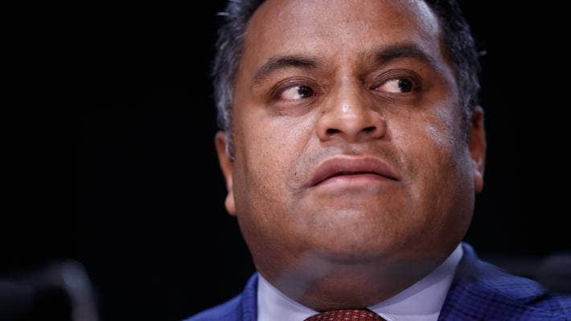

ROBERT KITCHIN/STUFF

Justice Minister Kris Faafoi:

**EDITORIAL:** A proposed [ban on anonymous political donations](https://www.stuff.co.nz/national/politics/127196717/ban-of-anonymous-political-donations-among-electoral-law-reform-options)will likely hold instant appeal to the large group of people who have no intention of donating to any of those outfits but wouldn’t mind knowing who else is.

It’s one of the options upon which the Government is consulting in the name of improving the transparency and accountability of the electoral process.

In less high-minded terms, it’s an acknowledgement that our existing political funding system is a hot mess.

ADVERTISING

It’s been besmirched by a series of unedifying high-profile cases leading to Serious Fraud Office prosecutions centred around donations for Labour, National and NZ First.

**READ MORE:  
\***[**The slipperiness of hate speech**](https://www.stuff.co.nz/national/politics/125560332/the-slipperiness-of-hate-speech?rm=a) **\***[**The Detail: The secrecy around political donations**](https://www.stuff.co.nz/national/the-detail/300334925/the-detail-the-secrecy-around-political-donations?rm=a) **\***[**How political donations could be reformed to reduce potential influence**](https://www.stuff.co.nz/national/politics/108241335/how-political-donations-could-be-reformed-to-reduce-potential-influence?rm=a)

There’s good reason to strengthen rules for disclosure, particularly to confront sly means of breaking up large donations from potentially influential players into amounts that don’t trigger existing disclosure requirements.

ADVERTISEMENT

[*Advertise with Stuff*](https://advertise.stuff.co.nz/)

We already have rules against that, but they’re part of a complex system that’s ripe for clarification as well as toughening.

So yes, it does appear sensible to knock the threshold for political parties to disclose donors from $15,000 to $1500, which would make cheating far harder to get away with.

But stripping all anonymity provisions? A step too far.

Elsewhere in our electoral system, anonymity is rightly cherished.

One small example: after the 1990 general election, a small, light-hearted story arose from Southland. Who voted Labour in Scotts Gap?

Polling booth records showed that somebody - just the one - had, from the very midst of National Party heartland territory, declined to join the stampede of support that carried local lad Bill English to Parliament.

It wasn’t a story about a witch hunt. The consensus at Scotts Gap was shrugging acceptance that every community has its eccentrics. But editorial writers the length of the country seized upon it as a chance to highlight the need for anonymity in the electoral process.

What if that person had wanted to make a donation without inviting neighbourhood commentary? Or, as Otago University law professor Andrew Geddis plausibly predicts, didn’t want to face the prospect of being diligently nagged from that point onwards for further donations.

Anonymity at this level is hardly sinister but the shadows lengthen when the sums are large enough to raise the prospect, or even the suspicion, of significant political gratitude.

Other proposals for the public to mull over include introducing a requirement on political parties to publicly disclose their financial statements, to increase the frequency of donations reporting, and - why isn’t this already a requirement? - to publicly report on candidate loans.

ADVERTISEMENT

[*Advertise with Stuff*](https://advertise.stuff.co.nz/)

The practice of in-kind donations does require squinted scrutiny. Giving your expertise for free? Giving goods and services? Can this safely be treated as nobody else’s business but yours and the party’s? Is it simply volunteerism?

Views on such matters will reasonably diverge among individuals, as they have among parties. ACT sees constitutional issues arising and, in any case, would have us identify this as a Labour initiative founded on the belief, rightly or wrongly, that it will hit the pockets of Labour’s opponents harder than it will them.

The Greens want lower disclosure thresholds but no full ban on anonymous donations.

Incidentally, in announcing the public consultation process for these changes, the Ministry of Justice has included an assurance that responses will be anonymised.

And then it adds that, even so, if a request is made “we may need to release your information under the Official Information Act’’, but it does have some discretion to withhold it, so if that’s what people want, they should say so, and why, in their submissions.

From which we might conclude that anonymity is a state that sometimes requires scrutiny, sometimes defence.