STUFF

Justice Minister Kris Faafoi announces a major review of New Zealand's electoral law is being launched by the Government.

A ban of anonymous political donations is among the possible changes to electoral law being considered by the Government.

Justice Minister Kris Faafoi in October announced the Government would embark on a [major overhaul of how elections are run](https://www.stuff.co.nz/national/politics/126581083/government-launches-major-review-of-electoral-law-to-include-voting-age-and-party-funding), with specific "targeted changes" on how donations are disclosed and the Māori general roll set to come into force for the 2023 election.

The Ministry of Justice on Friday published a consultation document about possible changes to political donations it wants public feedback on.

ADVERTISING

A ban on anonymous political donations is among the proposed changes. The document also proposed lowering the threshold for political parties to disclose donors from $15,000 to $1500, and requiring political parties to make public their annual financial statements.

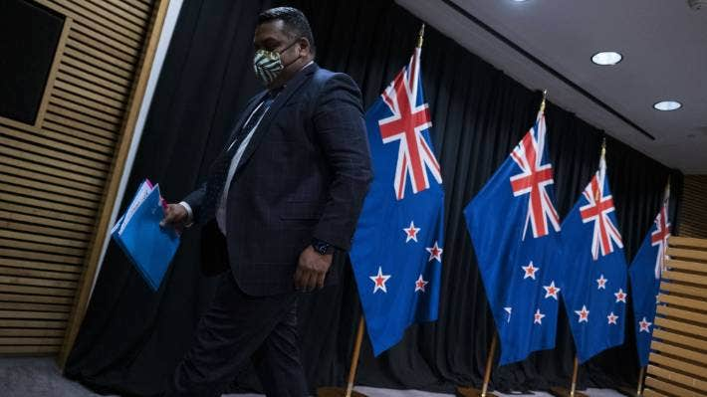

ROBERT KITCHIN/STUFF

Justice Minister Kris Faafoi is shepherding through a reform of electoral law.

**READ MORE:  
\***[**Man's four-year wait for trial one of nearly 6000 cases to be heard**](https://www.stuff.co.nz/national/crime/127044273/mans-fouryear-wait-for-trial-one-of-nearly-6000-cases-to-be-heard?rm=a) **\***[**Government launches major review of electoral law, to include voting age and party funding**](https://www.stuff.co.nz/national/politics/126581083/government-launches-major-review-of-electoral-law-to-include-voting-age-and-party-funding?rm=a) **\***[**Government struggles to explain proposed 'hate speech' laws amid mounting opposition**](https://www.stuff.co.nz/national/politics/125579536/government-struggles-to-explain-proposed-hate-speech-laws-amid-mounting-opposition?rm=a)

The ACT Party has called the possible changes “constitutionally dangerous”, while the Green Party has thrown its support behind the changes to curb what it alleged to be undue influence from big money donors.

ADVERTISEMENT

[*Advertise with Stuff*](https://advertise.stuff.co.nz/)

The Ministry of Justice, in briefing documents, said there was “a clear public interest in understanding the potential financial influences on key participants in our democratic system”.

“Recent high-profile incidents involving donations to major political parties or candidates have raised public concerns about the level of transparency in, and complexity of, our donations regime.

“Each incident has been different in nature and this suggests there may be a number of vulnerabilities in the current settings that warrant further attention.”

Otago University law professor Andrew Geddis said there were reasons for allowing anonymous, small donations that were not “nefarious”, including that a donor may not wish for the party to chase them down for more money in the future.

"Our system isn't going to get corrupted by having people give $200 or $300, anonymously, or even $1,000,” he said.

[[](https://my.stuff.co.nz/register/newsletter?type=politicallyCorrect&cid=politicallyCorrect:editorial:pointer)](https://my.stuff.co.nz/register/newsletter?type=politicallyCorrect&cid=politicallyCorrect:editorial:pointer" \t "_top)

**[Politically Correct](https://my.stuff.co.nz/register/newsletter?type=politicallyCorrect&cid=politicallyCorrect:editorial:pointer" \t "_top)**[Independent, expert political analysis delivered to your inbox.](https://my.stuff.co.nz/register/newsletter?type=politicallyCorrect&cid=politicallyCorrect:editorial:pointer" \t "_top)**[Subscribe for free](https://my.stuff.co.nz/register/newsletter?type=politicallyCorrect&cid=politicallyCorrect:editorial:pointer" \t "_top)**

“If it's your money, and you're wanting to give it to the party, and it's not really posing any threat to a greater democracy, why shouldn't be able to?”

The seven changes being considered, such as reducing the disclosure threshold, did not amount to a “grand overhaul” of the system, he said.

“By reducing [the threshold] down to $1500, you make it much harder to split donations up to avoid disclosure.”

Splitting of donations above $15,000 to avoid disclosure has been considered a crime under the current electoral donations regime.

In an [ongoing court case](https://www.stuff.co.nz/national/crime/300465886/national-and-labour-party-donations-fraud-trials-to-be-heard-together), former National Party MP Jami-Lee Ross, three businessmen – Yikun Zhang, Shijia (Colin) Zheng, and Hengjia Zheng – and six others have been charged with donations fraud over donations to the National Party. Another six people have been charged with fraud over donations to the Labour Party.

ADVERTISEMENT

[*Advertise with Stuff*](https://advertise.stuff.co.nz/)

"If the threshold for disclosure is $1500 that becomes really, really difficult, right? If you want to give $50,000, you've got to find 40-odd people to split it up amongst. And the more people you're trying to split it up amongst the more likely it to get caught doing it,” Geddis said.

He said a requirement that parties make annual financial returns public could bring the regime into line with charities, which have comparable disclosure requirements.

“This, perhaps, would disclose a whole lot more about how much is spent on things like opinion polling, and travel and all those sorts of issues,” he said.

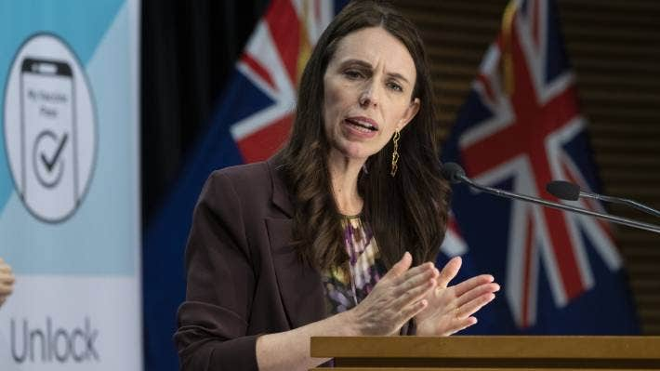

POOL/GETTY IMAGES

Prime Minister Jacinda Ardern would not express a view on possible changes to electoral law for political donations when asked on Monday.

Prime Minister Jacinda Ardern said the Government had not yet determined whether it would support a ban on anonymous donations, among other options on the table.

“We're genuinely interested in what we could do to really shore up people's trust in their democracy,” she said.

ACT party leader David Seymour said the changes would be “constitutionally dangerous”, and only served to aid the Government’s electioneering.

“They are not proposing this change to solve any public problem ... The Labour Party believes rightly or wrongly, that this will make it harder for the opposition to raise money,” he said

“I hear from people that they are afraid to give because they fear political retribution, because of their business is going for government contracts, or because they feel that they'll be ostracised or somehow attacked.

“People are in court. Well, yeah, that shows the law is working.”

He said ACT would likely oppose any electoral law change, including any requirement the party make public its financial returns.

ADVERTISEMENT

[*Advertise with Stuff*](https://advertise.stuff.co.nz/)



BRADEN FASTIER/STUFF

ACT party leader David Seymour said changing the electoral donations regime was “constitutionally dangerous”.

Green Party justice spokeswoman Golriz Ghahraman said the party wanted to see a lower threshold for donations disclosure, but not an outright ban on anonymous donations.

Ghahraman said questions had been raised about foreign countries and big corporations wielding disproportionate influence over elected officials. An example of this, she said, was donations from fishing companies possibly influencing the prior Labour-coalition Government’s decision on installing monitoring cameras on fishing boats.

"There's some practical issues around anonymous donations, you know, for example, people will say, 'Well, when you're fundraising at a bake sale, or in a market, how do you actually really have volunteers verifying very small donations?'

“We probably would support a lower end threshold that allows for that kind of fundraising.”

Ghahraman said the Green Party supported the proposal to have political parties make public their annual reports.

National Party justice spokesman Paul Goldsmith, who took on the justice portfolio for the [party on Monday](https://www.stuff.co.nz/national/politics/127195948/christopher-luxon-demotes-judith-collins-off-front-bench-in-first-reshuffle), said the party's caucus would discuss the issue on Tuesday.

A spokeswoman for the Māori Party said the party would announce its position on the possible changes to electoral law once a bill is introduced to the House.