|[Politics](https://www.nzherald.co.nz/nz/politics/)

National received nearly $3m in large political donations in 2020 - nearly double Labour

6 May, 2021 02:48 PM5 minutes to read

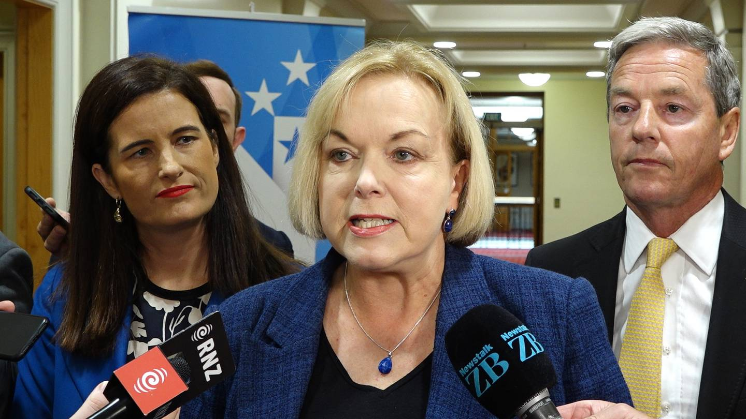

National leader Judith Collins' party received the highest amount of political donations at just over $2.8 million. Photo / Mark Mitchell

NZ Herald

By: [**Michael Neilson**](https://www.nzherald.co.nz/author/michael-neilson/), [**Claire Trevett**](https://www.nzherald.co.nz/author/claire-trevett/) and [**Jason Walls**](https://www.nzherald.co.nz/author/jason-walls/)

The National Party received nearly $3 million in large donations in 2020 - nearly twice the amount donated to Labour.

The Electoral Commission today released the full list of large donations made to political parties for the 2020 calendar year.

Political parties do not have to disclose how much they receive in small donations which are less than $1500.

It shows National on top, taking in just over $2.8m with Labour second with just over $1.5m.

ADVERTISEMENT

[*Advertise with NZME.*](https://advertising.nzme.co.nz/)

It was quite the drop though for National from the previous election year, 2017, when it raked in over $4.6m as it sought a fourth term in government.

Labour has just a slight dip in donations from 2017, when it received $1.6m.

The Act Party received the third-highest amount in 2020, with just over $1.2m - 50 per cent up on 2017, when it took in slightly above $800,000.

The Green Party had the fourth-highest donations in 2020 with just under $860,000.

Read More

* [Election donations: Māori Party referred to police over $320,000 in late declarations - NZ Hera...](https://www.nzherald.co.nz/nz/election-donations-maori-party-referred-to-police-over-320000-in-late-declarations/6ZHXNU36DJ6ZFJTP7E6J3GI5BY/?ref=readmore)
* [Electoral Commission cautions the National Party over tardy donation disclosure - NZ Herald](https://www.nzherald.co.nz/nz/electoral-commission-cautions-the-national-party-over-tardy-donation-disclosure/IPTBPI6PJ5XC2WXFC3PXVMI7GA/?ref=readmore)
* [Electoral Commission lodge appeal over 'Planet Key' song ruling - NZ Herald](https://www.nzherald.co.nz/nz/electoral-commission-lodge-appeal-over-planet-key-song-ruling/5VSJ2AHPNU2YGSPVKD3HGCTJB4/?ref=readmore)
* [Election 2020: Electoral Commission spending on social media for youth vote - is it working? - ...](https://www.nzherald.co.nz/business/election-2020-electoral-commission-spending-on-social-media-for-youth-vote-is-it-working/GHAV47XMJATWEIZLQ3KWQQVT5Y/?ref=readmore)

The Māori Party received just under $390,000.

Donations of more than $30,000 have to be disclosed within 10 working days of receipt, and parties cannot accept anonymous donations of more than $1500, or overseas donations of more than $50.

Related articles

[**NEW ZEALAND**](https://www.nzherald.co.nz/nz/)|[Politics](https://www.nzherald.co.nz/nz/politics/)

[Māori Party donations referred to SFO](https://www.nzherald.co.nz/nz/maori-party-donations-referred-to-serious-fraud-office/PWOJJVKHMYL5HBBOHSFMC4TACI/)

28 Apr, 2021 06:48 PMQuick Read

[**NEW ZEALAND**](https://www.nzherald.co.nz/nz/)|[Politics](https://www.nzherald.co.nz/nz/politics/)

[Electoral Commission cautions National over tardy donation disclosure](https://www.nzherald.co.nz/nz/electoral-commission-cautions-the-national-party-over-tardy-donation-disclosure/IPTBPI6PJ5XC2WXFC3PXVMI7GA/)

28 Apr, 2021 11:34 AMQuick Read

[**NEW ZEALAND**](https://www.nzherald.co.nz/nz/)|[Politics](https://www.nzherald.co.nz/nz/politics/)

[Māori Party co-leaders confident donations above board amid police probe](https://www.nzherald.co.nz/nz/maori-party-co-leaders-are-confident-that-its-donations-are-above-board-amid-police-probe/IT3GETHDZJGQ6A3HXTWCP3ZTZ4/)

14 Apr, 2021 03:02 PMQuick Read

[**BUSINESS**](https://www.nzherald.co.nz/business/)

[NZ First Foundation case: Accused pair slowly edge to 2022 trial](https://www.nzherald.co.nz/business/nz-first-foundation-case-accused-pair-slowly-edge-to-trial-suppression-appeal-to-be-heard-in-june/EK3XYAXW5KRFBR2RW7ROA2PVKA/)

24 Feb, 2021 09:52 AMQuick Read

National's donors

National's election-year haul of $2.8m was much lower than in 2017 when it was campaigning under Bill English, was high in the polls and in government.

The appetite for donations was likely affected by Covid-19, as well as the party's own leadership woes and Labour's dominance in the polls throughout the election year.

ADVERTISEMENT

[*Advertise with NZME.*](https://advertising.nzme.co.nz/)

Its total included donations from party President Peter Goodfellow ($20,000) and Todd Corporation chair and Wellington Phoenix owner Henry Tait ($15,450).

Others included Naomi Ballantyne ($20,600), Gallagher Group ($29,789), Seung Gi Rhi ($18,000), Phillippa Williams ($16,310), Frances Wyborn ($16,831), hotelier Christopher Parkin ($20,999), Clean as a Whistle Ltd ($17,000), rich-lister Peter Huljich ($20,831) and Douglas Pharmaceuticals head Jeffrey Douglas ($16,450).

Larger donations from Garth Barfoot and Doug Catley had already been disclosed as they were above $30,000. The party recently got a warning from the Electoral Commission for disclosing Barfoot's donation late.

National's total of $2.8 million was mainly made up donations less than $15,000 ($2,384,000).

It did not declare any anonymous donations, but declared $71,800 in donations protected from disclosure: a mechanism which allows donors to give money to the party via the Electoral Commission without their identities being disclosed to the party or publicly.

Labour did not use that mechanism at all.

Labour's donors

Of Labour's $1.5m, $731,000 came from donations of less than $15,000 and $770,000 came from donations that were above that figure.

The largest donor was the New Zealand Dairy Workers' Union, which donated $90,000.

A number of other unions, such as the maritime union, the rail union and Etu all donated to Labour, $40,000, $40,200 and $20,000 respectively.

And, among the big-ticket donors is Prime Minister and Labour leader Jacinda Ardern, who donated $17,000 to her party.

The donations are listed as being paid fortnightly through the year and are likely to have been paid through party tithing.

Kelvin Davis, who is a senior minister and Labour Deputy Leader, is also on the list and has donated just over $15,000 in the 2020 year.

Other Labour MPs are likely to have made fortnightly donations to the party as well.

However, donations under $15,000 are anonymous so they would not have come up on the list.

Also on the list is former prime minister Geoffrey Palmer, who donated just over $15,000 to the party in June last year.

NZ First's donors

New Zealand First – which was booted out of Parliament at the elections after it didn't get enough votes – received $514,000 in donations.

Of the donations more than $15,000 – which are required to be disclosed – most have been made through holding companies.

Caniwi Management limited, which according to Companies Office records is owned by Rich Lister Troy Bowker who is estimated to be worth $84m, donated close to $30,000 to NZ First.

The party also received a $20,000 donation from GRL Holdings, which is owned by Greg Loveridge, another rich-lister.

GRL Holdings also donated $25,000 to the Labour Party.

Most of New Zealand First's donations, some $385,000, came from donations less than $15,000, meaning the identity of the donor is not required to be disclosed.

Smaller parties

The majority of Green Party donations came from their own MPs. The party has a policy meaning they have to donate a portion of their salaries to the party coffers.

The largest donations were two individual donations of $50,000 from Phillip Mills of Auckland and Peter Kraus of Kerikeri.

All donations to the Māori Party were over $30,000, meaning they have already been declared.

They include $50,000 from the Whanganui Regional Development Board Trust, $49,000 from the National Urban Māori Authority, $158,000 from John Tamihere, and $120,000 from Aotearoa Te Kahu Limited Partnership.

The latter three were only declared well after the legally required 10 working days and were initially referred to the police "for further investigation".

The police have since referred the donations to the Serious Fraud Office to consider.

Parties outside Parliament

Advance NZ received just over $250,000 and the New Conservative party slightly less than $200,000.

Under electoral laws, only donors who give more than $15,000 in a year have to be publicly disclosed.

ADVERTISEMENT