1. [national](https://www.stuff.co.nz/national)

Log in

ADVERTISEMENT

[*Advertise with Stuff*](https://advertise.stuff.co.nz/)

**National and ACT build $5m election war chest, Labour and Greens trail in fundraising**

Andrea Vance05:00, Oct 23 2022



JULIA GILLARD/TWITTER

Prime Minister Jacinda Ardern hosted former Australian Prime Minister Julia Gillard in an online Labour party fundraiser.

For every dollar raised by Labour and the Greens, National and ACT have raised $6, new figures reveal.

Since the 2020 election, Christopher Luxon’s party has amassed a $3.1m election war chest, and David Seymour has pulled in $1.9m [in declared donations](https://elections.nz/democracy-in-nz/political-parties-in-new-zealand/party-donations-and-loans-by-year/).

On the other side of the House, Jacinda Ardern’s Labour raised a fraction of that: $339,886. They were outstripped by their minor support party: the Greens received $490,639, though their total includes a tithe from MPs.

ADVERTISING

When tallied, both centre-right parties netted $5,098,179, and those on the centre-left got $830,525.

**Judge delivers verdicts in political donations case**

Play Video

STUFF

Judge delivers verdicts in political donations case

ADVERTISEMENT

[*Advertise with Stuff*](https://advertise.stuff.co.nz/)

These figures do not represent a complete picture of the post-election period. Named donations of less than $1500 do not have to be declared – and this is traditionally where much of the money flowing into Labour and the Greens come from – and data on donations under $30,000 is yet to be released.

The figures analysed are strictly party donations, and so do not include money given to candidates to fund their election campaigns, which are disclosed post-election.

And the amounts don’t take into account other fundraising – such as business conferences, dinners or online events such as [the video chat between Ardern and former Australian Prime Minister Julia Gillard last week.](https://www.stuff.co.nz/national/politics/130199533/jacinda-ardern-says-she-hasnt-faced-blatant-sexism-from-other-politicians-like-julia-gillard-did)

Nevertheless, the record of donations does show an imbalance which suggests next year’s election won't be fought on a level playing field, said [researcher Max Rashbrooke](https://www.stuff.co.nz/national/politics/opinion/129418361/max-rashbrooke-undisclosed-money-threatens-next-election).

[Rashbrooke and Lisa Marriott](https://www.stuff.co.nz/national/politics/300633508/new-research-sheds-light-on-what-motivates-political-party-donors-in-new-zealand), of Victoria University’s Institute for Governance and Policy Studies, compiled the figures as part of [their year-long research into New Zealand’s fundraising regime](https://www.doughnation.nz/). Their report will be released next month.

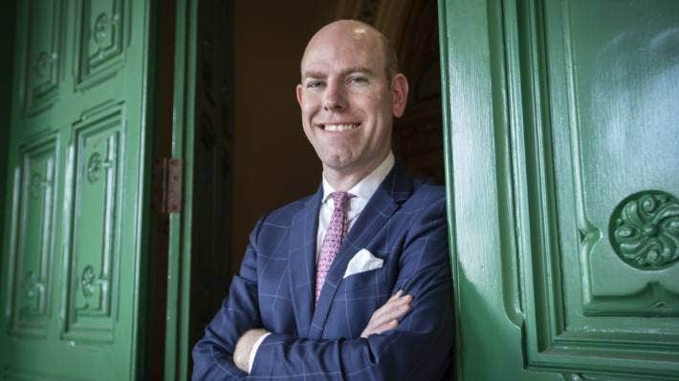

ROSA WOODS/STUFF

Donations researcher Max Rashbrooke is also the author of Too Much Money: How Wealth Disparities are Unbalancing Aotearoa New Zealand.

The greatest disparity is in large donations, those of more than $30,000, where National and ACT outpace Labour and the Greens by 10 to one.

“Money isn't the only thing that matters in politics, but it certainly helps,” Rashbrooke said. “If you have everything else right, then it's the catalyst for being able to get your message across much more effectively than your opponents if they don't have as much money as you do.

“We don't have data on donations yet under $30,000, and we will have no data at all for donations from people who are known to the parties and give less than $1500.

[MORE FROM](https://www.stuff.co.nz/authors/andrea-vance)**[ANDREA VANCE • SENIOR JOURNALIST](https://www.stuff.co.nz/authors/andrea-vance)**

[andrea.vance@stuff.co.nz](mailto:andrea.vance@stuff.co.nz)

“If you included those, the figures will undoubtedly look a little better for the Left. I'm just sceptical that it would make that much of a difference. When I've spoken to people off the record, they don't think that the amount the Left makes in small donations gets close to making up for the disparity created by National and ACT getting so much more in large donations.”

Earlier this year, a fundraising drive spearheaded by former National Party minister Paula Bennett brought in $1.8m from wealthy supporters like Graeme Hart, Murray Bolton and Nick Mowbray. Labour countered that with an email drive, which raised around $80,000.

“The fundraising that Labour and the Greens do at the lower level doesn’t get anywhere near compensation for National and ACT’s rich list fundraising,” Rashbrooke said.

ADVERTISEMENT

[*Advertise with Stuff*](https://advertise.stuff.co.nz/)

The cash is spent on advertising, flyers, billboards, consultants, transport and hosting events. Two elections over a six-month period – [in Tauranga](https://www.stuff.co.nz/bay-of-plenty/129007469/nationals-sam-uffindell-wins-tauranga-byelection-will-be-the-citys-next-mp) and [Hamilton West](https://www.stuff.co.nz/national/politics/300716919/pm-jacinda-ardern-says-hamilton-west-byelection-will-be-held-on-december-10-labour-party-expels-gaurav-sharma) – will also drain funds.

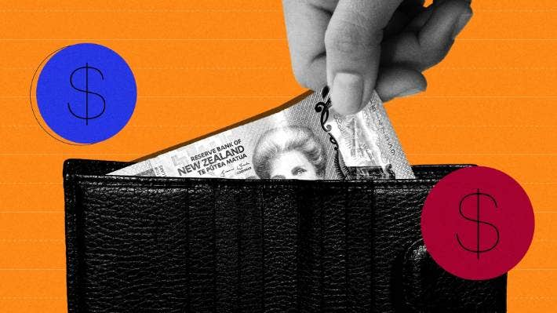

SUNGMI KIM/STUFF

Political donations are under the spotlight, with the three political parties recently embroiled in court action.

**POLITICALLY CORRECT**

Independent, expert political analysis delivered to your inbox

[Sign up now](https://my.stuff.co.nz/register/newsletter?type=politicallyCorrect&cid=politicallyCorrect:editorial:pointer)

National's election campaign chair Chris Bishop said his party is “predominantly funded by ordinary Kiwis”. He added: “It just goes to show the mood for change is building.”

Labour’s general secretary Rob Salmond said published donation returns don’t account for most donations of under $1500. “Labour has a strong focus is on encouraging supporters from all walks of life to give whatever they can afford,” he said. “Despite other parties’ reliance on the wealthiest New Zealand for their funding, we’re confident we’ll be competitive in 2023.”

The donations regime will change before next year’s election. [A shake-up is currently before Parliament](https://www.stuff.co.nz/national/politics/129453287/the-fight-over-political-donations-and-what-the-government-plans-to-change), sparked by prosecutions that embroiled National, Labour and New Zealand First.

[New legislation will cap anonymous donations to parties at $5000](https://www.stuff.co.nz/national/politics/129051604/shakeup-of-political-fundraising-rules-will-limit-secret-donations?cid=app-iPhone). It will also require parties to reveal the number and total value of party donations under $1500, which are not made anonymously.

They must disclose gifts which are ‘in-kind’ or non-cash, like artworks, and declare loans to candidates from unregistered lenders and also publish annual financial statements.

But the new rules won’t tackle[‘cash for access’ schemes – which allow wealthy citizens to pay for an audience with ministers and political figures](https://www.stuff.co.nz/national/politics/128962631/cash-for-access-the-price-tag-to-schmooze-new-zealands-political-leaders).

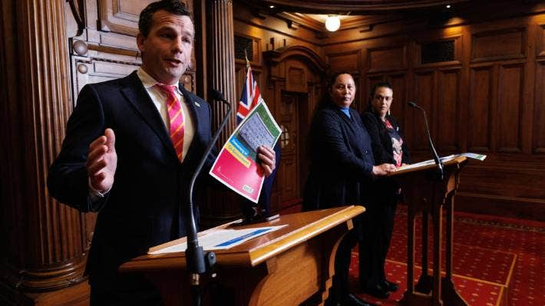

ROBERT KITCHIN/STUFF

ACT leader David Seymour is opposed to new rules covering the disclosure of political donations.

Nor will it impose a limit on donations – an area where New Zealand is out of step with much of the OECD. Seven states have a cap of less than $5000, and a further four of less than $15,000.

Of 32 countries, 17 require publication of a donor’s identity if they give over $5,000. Nine demand disclosure for donations less than $1500; and three require all donor identities to be disclosed.

“It will be interesting to see what difference lowering the disclosure threshold from $15,000 to $5000 will make,” Rashbrooke said. “Between 2011 and 2019, National massively out-fund raised Labour. Where they really had the advantage was in raising donations between $1500 and $15, 000, which are anonymous.

ADVERTISEMENT

[*Advertise with Stuff*](https://advertise.stuff.co.nz/)

“I don't think that will suddenly stop all the people who gave between $1500 and $15,000. But obviously some of them will be put off.”

During that period, National received $14,896,256 below the threshold, Labour got $4,108,852, ACT raised $2,081,581 and the Greens $1,944,703.



SUPPLIED

Paula Bennett – how a television host – was behind a month-long $1.8m fundraising drive for National.

National and ACT are opposed to the changes. Seymour agrees it will have an impact on the Right’s ability to attract cash – and that the overhaul is politically motivated.

He has calculated how much it would cost each party should donors reduce their spend to less than $5000 to protect their identity. “It will cost us $300,000 in foregone donations, the National Party $600,000, the Labour Party [roughly] $140,000 and the Greens $70,000. It would have a disproportionate effect,” he said.

“For many people, the idea of being publicly named is quite terrifying.”