**Contribute to Newsroom and support quality NZ journalism**

BECOME A SUPPORTER

* [Facebook](https://www.facebook.com/newsroomnz)
* [Twitter](https://twitter.com/NewsroomNZ)
* [Linkedin](https://www.linkedin.com/company/newsroom-new-zealand)
* [**Home**](https://www.newsroom.co.nz/)
* [**About**](https://www.newsroom.co.nz/about)
* [**Contact**](https://www.newsroom.co.nz/contact)
* [**Donate**](https://www.newsroom.co.nz/donations)
* [**NEWS**](https://www.newsroom.co.nz/news)
* [**POLITICS**](https://www.newsroom.co.nz/politics)
* [**COVID-19**](https://www.newsroom.co.nz/covid-19)
* [**ENVIRONMENT**](https://www.newsroom.co.nz/environment)
* [**BUSINESS**](https://www.newsroom.co.nz/business)
* [**COMMENT**](https://www.newsroom.co.nz/comment)
* [**TECHNOLOGY**](https://www.newsroom.co.nz/technology)
* [**AUCKLAND**](https://www.newsroom.co.nz/new-auckland)
* [**HEALTH & SCIENCE**](https://www.newsroom.co.nz/health--science)
* [**PODCASTS**](https://www.newsroom.co.nz/podcasts)
* [**PUZZLES**](https://www.newsroom.co.nz/puzzles)

**EXPAND SEARCH**

**SIGN IN TO PRO**[**SUBSCRIBE TO PRO**](https://www.newsroom.co.nz/prosubscribe)

SIGN IN TO PRO[**SUBSCRIBE TO PRO**](https://www.newsroom.co.nz/prosubscribe)

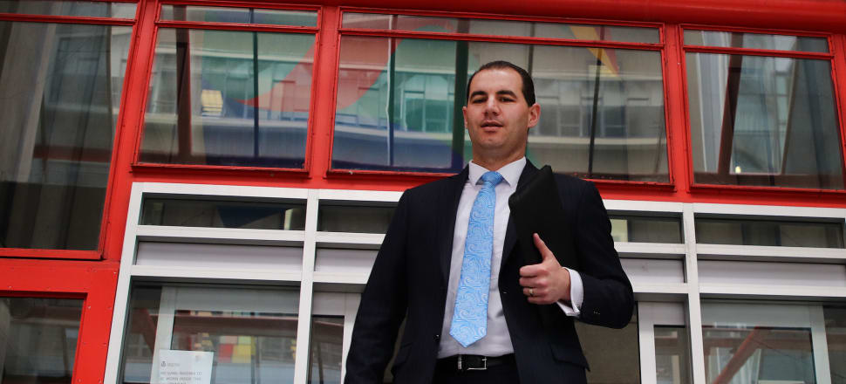

*Jami-Lee Ross after laying his complaint with Wellington police in 2018. Photo: Lynn Grieveson*

FIRST PUBLISHED JUL 27, 2022Updated 7 hours ago



**[Tim Murphy](https://www.newsroom.co.nz/profile/timmurphy/posts)**

Tim Murphy is co-editor of Newsroom. He writes about politics, Auckland, and media. Twitter: @tmurphynz

**POLITICS**

**SFO reveals more covert recordings of Ross and Bridges**

***The MP who first complained to police about secret, broken-up political donations finds himself finally on trial in the High Court, and his SFO accusers say they have more covert tape recordings with his ex leader***

Four years after National MP Jami-Lee Ross publicly released a covert recording of a call with his party leader Simon Bridges - and lit a fuse for a crackdown on concealed political donations - the Serious Fraud Office is about to present content from at least two more such recordings to Ross' criminal trial.

"These are conversations that Mr Ross did not release publicly," the SFO's lawyer John Dixon QC told the High Court on Monday.

Dixon said the taped conversations were from September 2018. In his opening statement in Ross' trial before Justice Ian Gault, he provided brief tasters of content from the tapes. In one, Ross said to Bridges about a $100,000 donation to the party: "That donation has not been declared properly ... those donations have not been handled in a way that's in accordance with the Electoral Act."

In another taped discussion, Ross again spoke of that $100,000 donation from 2018 and said "I was asked to be involved in significant donations and Chinese interests that haven't been declared properly."

Ross has publicly claimed it was Bridges who asked him to do that.

But the Crown instead says Ross' own words on the taped conversations are "evidence of Mr Ross' knowing involvement in the deception".

Now Bridges, a former Crown prosecutor, will be among Crown witnesses giving evidence about Ross and his three co-accused in relation to two $100,000 donations to National. The others are Auckland businessman Yikun Zhang, his right-hand man Colin Zheng and Zheng's twin brother Joe.

Ross' wife, Lucy Schwaner, and assistant Katya Kershaw, will also be called by the Crown to give evidence.

The men have pleaded not guilty to two charges of obtaining with deception over the donations, which came from accounts linked to Zhang, and in one instance possibly Colin Zheng, but were paid to what the Crown calls 'sham donors' from the Chinese community who then paid smaller, non declarable, amounts to National.

Three other defendants, who have name suppression, have also pleaded not guilty to one charge of obtaining by deception over a Labour Party donation of $35,000 paid for artworks in March 2017.

Dixon said the first donation to National was arranged after a dinner Ross had with Zhang and Colin Zheng at the Parnell restaurant Cibo in May 2017.

"The Crown says that at or almost immediately after that meeting an agreement was reached that: Mr Zhang (or both Zhang and Zheng) would donate $100,000 to the National Party; but other persons would be put forward as the nominal donors so that the identity of the true donor(s) would not be disclosed."

The next day Zhang arranged with his sister Shaona in China to send $50,000 to Colin Zheng and, the Crown says, Zheng then used that money to pay the first three lots of $14,000 each to the 'sham donors'' accounts. Colin Zheng then had a further $98,000 sent from his father's bank account in China and broke that up for other sham donors to pass on.

Colin Zheng later wrote to Ross "they will all follow the law" and added a smiling face emoji.

Zheng openly told the sham donors in June 2017 that Zhang, who he called "the association chairman" or "the president" needed to donate money to National but one transaction was too high and "registration would be required". So the money would be sent "through your account to the National Party to make it work".

It was Ross who in May 2018 provided the names of the sham donors to the National Party for its records. As none were above $15,000, donor details were not included in the party's donations return.

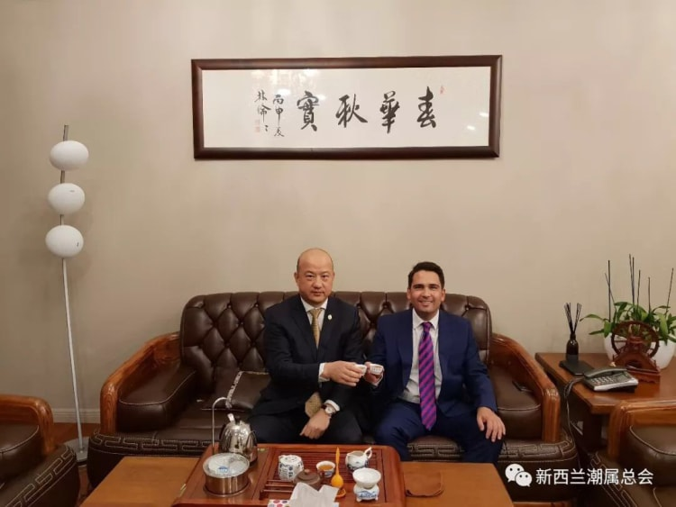Yikun Zhang with Simon Bridges at another, undated, meeting. Photo: Supplied

The second $100,000 donation from Zhang to National, in mid 2018, followed another dinner - this time Ross took Simon Bridges to the Remuera home of Yikun Zhang.

Ross sent Bridges a long text briefing him before the dinner, noting "Mr Zhang is very wealthy, although the exact source of his wealth in China is not well known."

Ross mentions Zhang's angling for a royal honour and his surprise that National had not given him one at New Year. (After references from key National and Labour figures, Zhang was made MNZM at Queen's Birthday 2018 for services to China-NZ relations and the Chinese community.)

"He does support both sides of politics, but he would be closer to us," Ross wrote. "Goodfellow [Peter, National's president] and Jian [Yang, former Chinese spy trainer and ex National MP] and I have invested a lot of time in the relationship."

And Ross has a social tip for his leader: "He will likely want to drink red wine with you. He may say that they're happy to support you at any time and just to let them know."

Dixon QC told the court Bridges would give Crown evidence that one week later he met Zhang and Zheng at another National fundraiser and they offered to make a donation of $100,000.

The SFO alleges Ross, Zhang and Zheng then made another agreement for the $100,000 from Zhang to be put through other nominal donors in smaller amounts.

That money, Dixon says, was raised by the two businessmen sending boxes of New Zealand wine to China, selling it and transferring the money first to Zhang's sister and then back to New Zealand. The sham donors were given the bank account for Ross' Botany electorate of the National Party.

The Crown says Ross gave National the list of sham donors, later telling police he got the names from "an agent" of the real donor who did not speak English. "The Crown says this is a clear acknowledgement that Mr Ross knew or believed that Mr Zhang was the true donor."

At the end of the Crown's opening statement outlining its case, Ross, through his lawyer Hannah Stuart, had a brief chance to put his side to the court.

Stuart said Ross was closely involved with the Chinese community in his Botany electorate, including the Chao Shan General Association, which Zhang led. Ross accepted National's Botany electorate received "eight donations each under the threshold" in 2017 and seven in 2018, but "it was no surprise to Mr Ross as Chao Shan members had indicated they would be giving support."

Ross did not dispute that he would have routinely advised donors that any donation above $15,000 would have to be disclosed.

But Stuart said her client had no discussion with any of the defendants or the Chao Shan association on splitting up a large donation into smaller amounts to avoid disclosure.

When Ross went public in October 2018 against Bridges, revealing details of the donations, he claimed Bridges had instructed him to commit an unlawful act.

In court, Ross distanced himself from any scheme to break up donations. Stuart said such methods had pre-dated Ross' own dealings with Zhang and Zheng. "They had clearly adopted that scheme before - when making a donation to the Labour Party."  (Zhang bought the five artworks as a donation to Labour in March 2017, two months before the first National donation of $100,000 was arranged.)

She said "both men were sophisticated and informed when it came to New Zealand politics" and Ross had no involvement in how they may have structured their donations.

main region

article

Andrew Little is expected to appear in the witness box late next week before the case turns to the National Party donations. Photo: RNZ/Angus Dreaver

Andrew Little is expected to appear in the witness box late next week before the case turns to the National Party donations. Photo: RNZ/Angus Dreaver





FIRST PUBLISHED JUL 26, 2022Updated 10 hours ago

Tim Murphy

Tim Murphy

Tim Murphy is co-editor of Newsroom. He writes about politics, Auckland, and media. Twitter: @tmurphynz

POLITICS

Big political names drawn into donations trial

The Crown outlines its case against six men and a woman charged with deceit in concealing donations to the Labour and National parties, and lines up big

names who will be called to give evidence.

Cabinet ministers Michael Wood and Andrew Little, former National leader Simon Bridges, the Prime Minister's chief press secretary and an official from

her department are among 51 witnesses the Crown is calling in its case against seven people alleged to have concealed political donations.

A former Labour president, Nigel Haworth, New Zealand's ambassador to Jakarta, Trevor Matheson, and National's general manager Greg Hamilton will also

give evidence.

The expected 10-week trial opened on Tuesday with lawyers on behalf of the Serious Fraud Office laying out their case against former National MP Jami-Lee

Ross and three others involved in two $100,000 donations to National in 2017 and 2018, and three people for $35,000 donated to Labour in 2017 as the proceeds

of an art sale.

All of the defendants have pleaded not guilty to the charges of obtaining by deception.

The SFO says in all three of those donations, 'sham' donors were enlisted to pass on small amounts under the declaration threshold for electoral donations

that had been given to them by one or two big donors wanting to conceal their involvement. National and Labour would have had to declare donations over $15,000

and identify the donors to the Electoral Commission, but were given incorrect information.

Crown lawyer John Dixon QC also raised a $100,000 purchase of a Chinese imperial robe at a Labour Party fundraiser by one of the defendants, Auckland businessman

Yikun Zhang, but said because the actual value of the robe was $300,000 when donated by others, Zhang's money could not be considered a party donation.

The Crown noted that Zhang received written support from both National and Labour luminaries (including Ross, outgoing National Party president Peter Goodfellow,

former Labour Party president Nigel Haworth and the Mayor of Auckland Phil Goff) for his nomination for a Queen's Birthday Honour, which he received in

2018, an MNZM  "for services to NZ-China relations and the Chinese community".

"The Royal honour evidence provides a possible justification - a motive - for the defendants to engage in offending that shielded the donation and true

donor from public scrutiny."

Yikun Zhang receiving his MNZM from former Governor General Patsy Reddy.  Photo: Government House

Dixon told Justice Ian Gault: "This case involves the subversion and manipulation of the public process of political party donations."

He said the three donations in question were funded by Yikun Zhang, with the possibility a second defendant, Zhang's right-hand man in a Chinese cultural

association Colin Zheng, contributing as well, in one instance.

"The Crown alleges the true donor(s) wanted to conceal from the public their identity(ies) as donors of these funds. To achieve that, they, and some of

the other defendants, persuaded friends and family members to pretend to be the actual donors and then they split the large donation up into a series of

smaller donations from those persons (sham donors)."

Also charged alongside Ross, Zhang and Colin Zheng, is Joe Zheng, Colin's twin brother, for the National donations. Joe Zheng is charged with lying to

the SFO during its compulsory interview with him over the matter in 2020.

Yikun Zhang is also charged with the two Zhengs and three other defendants, who have name suppression, over the Labour Party artworks donation.

All defendants pleaded not guilty to all charges in court on Tuesday morning.

The hearing is expected to focus first on the Labour Party artworks donation, with politicians including Little and Wood expected to appear in the witness

box late next week, before the case turns to the National Party donations.

Jacinda Ardern's chief press secretary Andrew Campbell and former Labour party officials Andrew Kirton and Hayden Munro will also give evidence of what

they knew from some of the defendants.

Dixon presented the court with diagrams showing how money linked to Yikun Zhang in China was transferred to either Colin or Joe Zheng via an online site

called I.E, and then distributed to the alleged 'sham donors' to send on to either Labour or National.

A number of the donors, including those who supposedly bought the artworks later found at Yikun Zhang's home during an SFO search, will be called, Dixon

said, to say they had not used their own money but had done what was asked of them.

Two of the defendants, Yikun Zhang and one of those with name suppression have had to join proceedings by video after either contracting Covid or becoming

a household contact since Monday morning. The hearing with 20 lawyers, including six QCs, has led to a packed courtroom of more than 40 people at times,

with one bench of 10 lawyers seeking more table space to be added, and media spilling over into the dock.

After the Crown opening statement, defence lawyers made brief remarks in reply.

John Katz, QC, for Yikun Zhang, said the Labour and National elements to the case were quite distinct and Zhang accepted he bought the five artworks as

a donation to Labour in 2017. "The money was clearly his. That's not in dispute." There appeared to have been a mistake in Labour's donations declaration

for that year but that was not Zhang's responsibility.

If Justice Gault was to find that any of the defendants used a stratagem with intent to conceal the true identity of the donor from the Labour Party, Zhang

would argue he was not a party to that. "He had no intent to deceive anyone."

On the National Party donation allegations, Zhang denied paying the $100,000 in 2017 or the same amount in 2018. "It was not money tended by him or on

his behalf."

Marc Corlett, QC for a defendant with name suppression charged over the Labour Party donation, said the SFO investigation had been what he called "rabid",

and a theory looking for evidence that had been reverse engineered to "make some kind of parallel construction between" the National Party issue with funds

raised by Labour.

Corlett also accused the SFO of "euro-centric, cringe-inducing cultural assumptions" of what the Chinese community might think or how it might act. It

had not left open the possibility that if any scheme to deceive had been employed it had been entirely from the "donor side of the table".