[**NEW ZEALAND**](https://www.nzherald.co.nz/nz/)|[Politics](https://www.nzherald.co.nz/nz/politics/)

Controversial businessman Troy Bowker makes $35,000 NZ First donation, Winston Peters says Bowker a 'friend'

8 Feb, 2022 03:48 PM3 minutes to read

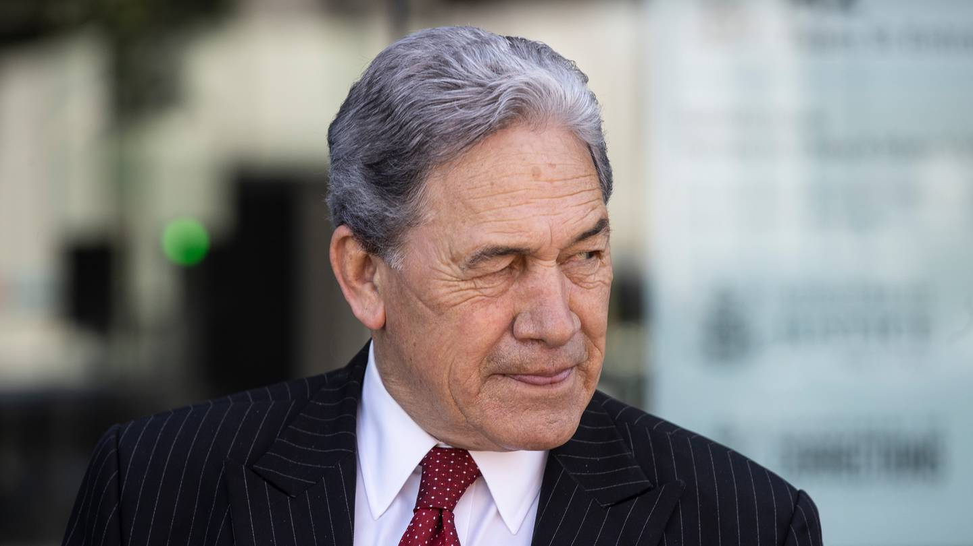

Winston Peters described Troy Bowker as a "friend". Photo / George Heard

By

**Thomas Coughlan**

Senior Political Reporter, NZ Herald

[**VIEW PROFILE**](https://www.nzherald.co.nz/author/thomas-coughlan/)

Controversial businessman Troy Bowker donated $35,000 to NZ First last year, including a $10,000 donation made the [same day he donated $5,000 to the Act Party](https://www.nzherald.co.nz/nz/controversial-businessman-troy-bowker-makes-35000-act-donation/UWOA5743C2CXEEAMQC2JH6XZ2Y/).

Any donations of over $30,000 a year must be declared by political parties to the Electoral Commission.

Bowker, executive chairman of Wellington-based investment company Caniwi Capital, was a topic of controversy last year because of a social media post accusing animation entrepreneur Sir Ian Taylor of "sucking up to the left Māori​-loving agenda".

Read More

* [Thomas Coughlan: Which MPs could lose their jobs in ...](https://www.nzherald.co.nz/nz/politics/thomas-coughlan-which-mps-could-lose-their-jobs-in-2022/BUXVEZ6O7AFTXJ467VXWDYQXKM/?ref=readmore)
* [Thomas Coughlan: Callous MIQ Tweet sets Government ...](https://www.nzherald.co.nz/nz/politics/thomas-coughlan-callous-miq-tweet-sets-government-back-after-victorious-summer/N5DD2ZZKA3KOFAU2WTAHTBBH4Q/?ref=readmore)
* [Thomas Coughlan: Two political fault lines open for ...](https://www.nzherald.co.nz/nz/politics/thomas-coughlan-two-political-fault-lines-open-for-2022/YX4AZ6MZMDKJ7HM3XOH3NSSFBY/?ref=readmore)
* [Thomas Coughlan: Covid strategy in doubt...](https://www.nzherald.co.nz/nz/thomas-coughlan-covid-strategy-in-doubt/AY4BPR34NL3K4EHFR5ICN5ZV2U/?ref=readmore)
* [Thomas Coughlan: The case for Labour](https://www.nzherald.co.nz/nz/politics/thomas-coughlan-the-case-for-labour/ALT6L2FOEPLUNDTN4A7P7RJVCA/?ref=readmore)

He had previously donated to Labour's [Stuart Nash, who received at least $51,000 in direct and indirect donations from Bowker over three election campaigns](https://www.nzherald.co.nz/nz/labour-minister-distances-himself-from-under-fire-donor-troy-bowker/P2NL6OPJ3V5C52623T6JRFUWAQ/), but said last August he would not be taking any more donations from Bowker, as a result of the controversy. Hurricanes halfback TJ Perenara said at the time the comments contained "underlying racism''.

ADVERTISEMENT

[*Advertise with NZME.*](https://advertising.nzme.co.nz/)

Bowker told the Herald he supports "politicians on the political right who oppose Labour and who will play a crucial role in 2023 in removing Labour".

"I'm in the fortunate position to assist and I intend to keep doing so until this Labour Government is gone," he said.

Bowker was particularly enthusiastic about NZ First leader Winston Peters.

Make a beeline for the Beehive

Get weekly politics headlines with commentary from our political experts straight to your inbox.

Top of Form

**Please email me competitions, offers and other updates. You can stop these at any time.**



SIGN UP

Bottom of Form

By signing up for this newsletter, you agree to NZME’s [Terms of Use](https://www.nzme.co.nz/about-us/terms-conditions) and [Privacy Policy.](https://www.nzme.co.nz/media/1737/nzme-privacy-policy.pdf)

Bowker said Peters will be "judged very favourably in years to come for his outstanding contribution to democracy and freedom of speech in New Zealand for many years".

"Winston is a man of principle and is in a unique position to stand up to those on the left of politics who for their own subversive and some would say dishonest reasons wish to silence dissenting voices and keep us divided," he said.

Bowker took aim at New Zealanders of "means and resources" who were "happy to sit back and quietly complain from the safety of their living rooms about the atrocious state of New Zealand and the path to division and poverty Labour are leading us down".

Instead, he called on New Zealanders "with the financial resources to contribute" to "stand up proudly to the lunacy of this socialist woke bunch that are temporarily holding power in Wellington".

The donations comprised $25,000 received on October 19, 2021, and $10,000 received on December 22, 2021.

ADVERTISEMENT

[*Advertise with NZME.*](https://advertising.nzme.co.nz/)

Peters would not talk about Nash's decision to refuse Bowker's donations.

Peters - who is not responsible for declaring the party's donations - told the Herald Bowker was a "friend".

"Mr Bowker is a friend of mine. He happens to believe in free speech," Peters said.

"He happens to believe in one standard of citizenship in our country and - perchance, so have I all my life," he said.

Peters has historically disagreed with the Act party's free-market philosophy. He also has a history of disputes with Act party leaders.

During the last term of Parliament, after a jibe from Act leader David Seymour about Peters' physical health, Peters shot back, "I reckon you'd last 10 seconds in the ring with me."

"There'd be three hits – you hitting me, me hitting you, and the ambulance hitting 100," Peters said.

Peters would not comment on any apparent irony over Bowker donating to both NZ First and Act on the same day.

"That's his business in a first-world democracy - that's the only irony I see," Peters said.

ADVERTISEMENT