[](https://cranmer.substack.com/)

[**Cranmer’s Substack**](https://cranmer.substack.com/)

Subscribe

**Sidestepping Conflicts - Wellington Style**

The best sidestep in town used to be seen at the Cake Tin but the Beehive is now the venue to watch the most electrifying players in the capital sidestep conflicts with consummate ease and panache.

[](https://substack.com/profile/104514607-cranmer?utm_source=author-byline-face)

[**Cranmer**](https://substack.com/profile/104514607-cranmer)

Oct 20

**14**

[[](https://images.unsplash.com/photo-1589871973318-9ca1258faa5d?crop=entropy&cs=tinysrgb&fit=max&fm=jpg&ixid=MnwzMDAzMzh8MHwxfHNlYXJjaHwzfHx3ZWxsaW5ndG9ufGVufDB8fHx8MTY2NjE1NTYwMw&ixlib=rb-4.0.3&q=80&w=1080)](https://images.unsplash.com/photo-1589871973318-9ca1258faa5d?crop=entropy&cs=tinysrgb&fit=max&fm=jpg&ixid=MnwzMDAzMzh8MHwxfHNlYXJjaHwzfHx3ZWxsaW5ndG9ufGVufDB8fHx8MTY2NjE1NTYwMw&ixlib=rb-4.0.3&q=80&w=1080" \t "_blank)

Photo by [Sulthan Auliya](https://unsplash.com/@swafie) on [Unsplash](https://unsplash.com/)

**For many years the best sidestep** in Wellington belonged to Christian Cullen*.*His electrifying change of direction and acceleration are the stuff of legend. Cullen is now long retired and his title has since passed to Doug Martin, the former Deputy State Services Commissioner and founder of Wellington-based consultancy firm, MartinJenkins.

Cranmer’s Substack is a reader-supported publication. To receive new posts and support my work, consider becoming a free or paid subscriber.

Top of Form

Subscribe

Bottom of Form

Martin has a lower profile than Cullen ever had but his frequent changes of direction are no less exhilarating for his fans within government and bewildering to his opponents. Last November, [the Herald reported](https://www.nzherald.co.nz/nz/politics/independence-of-three-waters-review-questioned-after-working-group-chairs-firm-contracted-staffer-to-reforms/6QLBFYYGQW5JSFC64UX6RALV4I/) that opposition parties had questioned Martin’s independence after he had been appointed as the independent chair of the government's working group to review Three Waters.

Christopher Luxon, at the time National’s spokesperson for local government, said:

*It is concerning that the same firm that embedded a consultant in a senior DIA role working on the Three Waters programme has now supplied the independent working group chair. That deserves further questioning.*

Act’s local government spokesman Simon Court said the appointment would not “deliver the kind of robust and independent critique of Three Waters that's sorely needed. Is MartinJenkins really going to criticise the work of MartinJenkins?”.

Then in May [the Herald revealed](https://www.nzherald.co.nz/business/three-waters-spend-up-21m-on-consultants-and-contractors/ANOH3KNNSYHN2YYRBHCIKPX3S4/) that the government had spent $21 million on consultants and contractors for its Three Waters reform in the 20 months to the end of February. More than $2.5 million of that amount went to MartinJenkins.

In response to questions put to the government by the Herald, the Department of Internal Affairs confirmed that on top of the amount of $2.5 million, Martin was also directly paid an additional amount for chairing the working group.

When questioned about the apparent conflict of interest in his role as independent chair of a process intended to reconsider the work of his MartinJenkins colleagues, Martin declined to comment. Instead he referred the Herald to the DIA. A spokesperson for Minister Mahuta said “there is clearly no conflict of interest here. Doug Martin has neither had an ownership interest in, nor been director of MartinJenkins for some years”.

That explanation seems barely credible given that Martin still appears on the MartinJenkins website, complete with MJ contact details, and alongside the firm’s directors. Although best avoided, it is possible of course for two individuals (or teams) within the same organisation to work on different and potentially conflicting roles on one transaction provided that there are robust ethical walls in place that prevent the transfer of information between the two individuals or groups, and provided further that if an actual conflict arises (such as one team reviewing the other’s work) one of teams agrees to stand down.

However in the case of DIA and MartinJenkins, it appears that they cannot recognise the conflict, let alone manage it.

The rationale that there is “clearly no conflict” because Martin is no longer a director or shareholder of MartinJenkins is such a bizarre and arbitrary distinction that it can only make sense if you’re a fully paid-up member of Wellington’s governing class.

As if to demonstrate just how nimble his footwork is, when it was announced a few months ago that Martin had been hired by Wellington Water to conduct an independent inquiry into a fluoridation failure at its water treatment plants, the water utility confirmed to the Herald that the contract was in fact with MartinJenkins. One moment the independent chair able to objectively review the work of his “former firm” and the next, a MartinJenkins consultant. Chapeau!

As with all the greats, they inspire the next generation of players to imitate their strengths. And so it is with Doug Martin.

It’s no surprise therefore that when Minister Henare’s partner, Skye Kimura, set up communications agency Tatou NZ with Henare’s twin brother and other family members, she did not become a shareholder or director. Instead the agency is owned by Greg Partington’s Waitapu Group with Kimura being held out as the leader and CEO. The agency pitches for government contracts and even features Minister Henare in its promotional videos but as if by magic there appears to be no conflict with this arrangement.

The newest proponent of this style of business is former Cabinet Minister, Kris Faafoi. His new firm, Dialogue22, specialises in public and government relations, and is also owned by Waitapu Group. Faafoi is described as the leader and CEO of the new outfit, and like Martin and Kimura, is not a shareholder or director.

Will Faafoi take the view that when Dialogue22 is back in his old Beehive stomping ground lobbying former colleagues on behalf of commercial interests there will be no conflict to declare because, like Martin and Kimura, he is not a shareholder or director of the company he represents?

Unmanaged conflicts are not welcome at the best of times. Christopher Luxon can attest to that after last week’s revelations concerning one of his MPs. But the fact that questions relating to conflicts have been raised that go to the heart of the Three Waters reforms is particularly concerning. The reforms are controversial, wide-ranging and of national significance for our water resources. In the circumstances conflicts should be handled assiduously, and where there is doubt (or appearance risk), the government should err on the side of caution. It’s regrettable that it hasn’t on this occasion as it undermines reforms that are already precariously balanced.



**Read Cranmer’s Substack in the Substack app**

Available for iOS and Android

[Get the app](https://substack.com/app/app-store-redirect?utm_campaign=app-marketing&utm_context=author-post-insert)

Call me old fashioned but I prefer watching Cullen tearing the opposition to ribbons rather than Wellington insiders pulling questionable moves on an unsuspecting public. Ardern has shown herself to be singularly uninterested in this issue so there is no chance of anything being done before the election but perhaps a new government will see the sense in updating some of the laws of the game.

**Subscribe to Cranmer’s Substack**

By Cranmer's Substack  ·  Launched a month ago

Public interest citizen journalism about politics, culture and law in New Zealand

Top of Form

Subscribe

Bottom of Form

[](https://substack.com/profile/32104763-richard-seager?utm_source=post-reactions-face)

[](https://substack.com/profile/4484752-graham-adams?utm_source=post-reactions-face)

**14 likes**

**14**

**Comments**

Top of Form

[[](https://substack.com/profile/74918890-grant-nelson)](https://substack.com/profile/74918890-grant-nelson)



Bottom of Form

**Top**NewCommunity

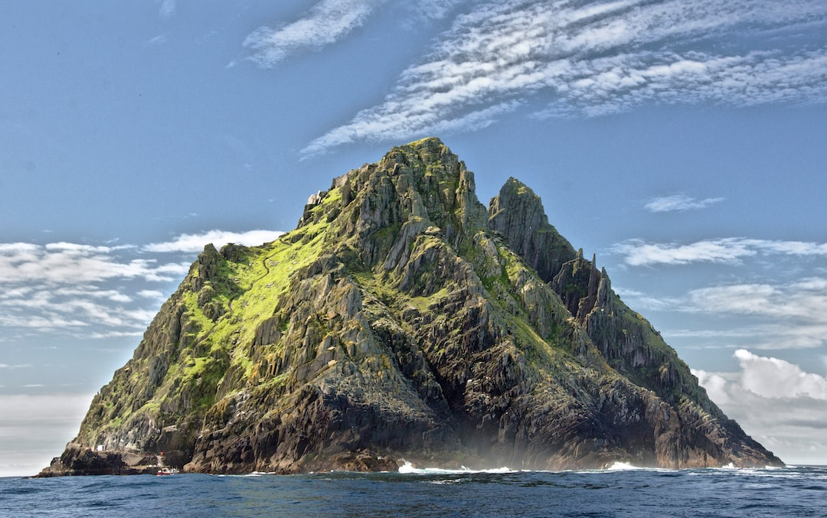

[**Three Waters and One Mountain of Debt**The proposed debt financing of Three Waters has received little coverage in the media but it brings its own set of risks to the reforms which could turn…](https://cranmer.substack.com/p/three-waters-and-one-mountain-of)

[CRANMER](https://substack.com/profile/104514607-cranmer)

OCT 10

34

[4](https://cranmer.substack.com/p/three-waters-and-one-mountain-of/comments)



[**The unbridled power of Te Mana o te Wai**The sheer scale and magnitude of the mechanism that lies at the heart of the Three Waters reforms is mind-boggling and threatens to totally overwhelm…](https://cranmer.substack.com/p/the-unbridled-power-of-te-mana-o)

[CRANMER](https://substack.com/profile/104514607-cranmer)

OCT 14

25



[**Three Waters and the Debt that will tear us apart**According to the government's own projections the Three Waters debt will only grow over time. We will never escape it and eventually it will tear the…](https://cranmer.substack.com/p/three-waters-and-the-debt-that-will)

[CRANMER](https://substack.com/profile/104514607-cranmer)

OCT 17

14

[2](https://cranmer.substack.com/p/three-waters-and-the-debt-that-will/comments)

[See all](https://cranmer.substack.com/archive?sort=top)

© 2022 Cranmer

[Privacy](https://cranmer.substack.com/privacy) ∙ [Terms](https://cranmer.substack.com/tos) ∙ [Collection notice](https://substack.com/ccpa#personal-data-collected)

[**Publish on Substack**](https://substack.com/signup?utm_source=substack&utm_medium=web&utm_content=footer)[**Get the app**](https://substack.com/app/app-store-redirect?utm_campaign=app-marketing&utm_content=web-footer-button)

[Substack](https://substack.com/) is the home for great writing

The Urgent Need to Update The Rules on Political Conflicts of Interests | Newsroom

pcs/click

Unlabeled 1

nr logo

Contribute to Newsroom and support quality NZ journalism

BECOME A SUPPORTER

list of 3 items

Facebook



Twitter



Linkedin



list end

list of 4 items

Home

About

Contact

Donate

list end

newsroom

Home

SIGN IN TO PRO

SUBSCRIBE TO PRO

Newsroom

SIGN IN TO PRO

SUBSCRIBE TO PRO

main region

article

Barbara Kuriger was not a minister, so is not bound by the provisions of the Cabinet Manual. Photo: Lynn Grieveson

Barbara Kuriger was not a minister, so is not bound by the provisions of the Cabinet Manual. Photo: Lynn Grieveson









FIRST PUBLISHED OCT 20, 2022Updated 12 hours ago

Peter Dunne

Peter Dunne

Peter Dunne was the leader of United Future and served as a minister in former National and Labour governments.

POLITICS

Rules on political conflicts of interests must be updated urgently

The Kris Faafoi case raises questions about the adequacy of the rules regarding conflicts of interest for ministers and former ministers, and the Barbara

Kuriger case highlights the absence of any such rules for backbench MPs

Opinion: The curious case of Taranaki-King Country MP Barbara Kuriger, who stood down abruptly last week from her roles as an Opposition spokesperson,

has drawn fresh attention to how MPs manage conflicts of interest. There have already been unresolved questions about the appropriateness of former minister

Kris Faafoi’s move to establish a public relations and political lobbying business just weeks after leaving Parliament.

However, the circumstances of the two situations are quite different. In Faafoi’s case, he has been subject to the provisions of the Cabinet Manual regarding

conflicts of interest. But while those provisions are quite extensive they are silent on what has become the key issue of the Faafoi case, namely the short

time frame between his departure and the establishment of his new business.

Australia and Canada have clear rules requiring former ministers to undergo a stand-down period of up to a year before they can become involved in businesses

drawing on their inside knowledge as a minister. In New Zealand there are no such rules, nor, if the Prime Minister is to be believed, are there likely

to be for some time.

#comment-container

Where the Kuriger case differs is that she was not a minister, so is not bound by the provisions of the Cabinet Manual. For her, the relevant formal guides

to the behaviour and conduct of MPs are Parliament’s Standing Orders, the record of Speakers’ Rulings on the application of those Standing Orders, and

the MPs’ Code of conduct released in 2020.

But there is no reference in the Standing Orders to managing conflicts of interest, or even what may constitute a conflict of interest. MPs are required

to submit an annual declaration of their pecuniary interests, which is made public, and to declare if they have a financial conflict on any piece of legislation

coming before the House, but that is all.

The Speakers’ Rulings are also silent on conflicts of interest. Moreover, McGee’s Parliamentary Practice in New Zealand, the authoritative text on Parliamentary

behaviour and practice in New Zealand, notes “the House has not adopted detailed ethical guidelines for its members, taking the view that advice about

appropriate behaviour is primarily a matter for induction training and internal party discipline”. Erskine May, often referred to as the “Bible of Parliamentary

procedure”, makes a similar point in respect of the British House of Commons. When it comes to conflicts of interest, MPs have been largely left to manage

them themselves.

block quote

It is far from clear the actions that caused Kuriger’s conflict of interest would have ever been identified, were it not for the whistleblower within the

Ministry of Primary Industries contacting her party leader’s office. That is simply not acceptable.

block quote end

The Kuriger incident is another example of the essentially hands-off approach to the management of backbench MPs that has been brought into the public

spotlight by so many lapses in recent years. It raises again whether such an approach is fit for purpose any more, and whether more specific rules and

guidance are now required to prevent repetitions. Leaving things once more to “internal party discipline” is looking more and more inadequate to deal with

today’s circumstances.

In recent years, the House of Commons and our own House of Representatives have adopted codes of conduct for the behaviour of MPs. But their focus has

been on curbing bullying and harassment, and ensuring MPs treat those working alongside them in the Parliamentary environment with respect. They have not

considered the question of conflicts of interest as they apply to ordinary MPs.

The time has surely come to formalise general conflict of interest rules for all MPs, and for the Cabinet Manual to address the specific issues raised

by the Faafoi case.

However, the lack of clear rules cannot be used as an excuse for Kuriger’s conduct. From the few details revealed, she has acted in a manner that, for

whatever reason, was unwise and unprofessional and compromised the integrity of her role as an MP. In the circumstances, by continuing to pursue matters

related to the earlier prosecution of her son by the Ministry of Primary Industries, she overstepped the mark, bringing not only her judgment into question,

but also making her position as a senior Opposition spokesperson untenable.

That makes it unlikely she will ever serve as a minister, which in turn raises the question of whether she will continue as an MP. What makes all this

so remarkable is that up till this point Kuriger had been viewed as a competent person of sound judgment who would perform well in a ministerial role.

The fact Kuriger stood down so quickly once the circumstances of her case became known cannot be an excuse for leaving things as they are. From the moment

the Ministry of Primary Industries began pursuing prosecutions against her husband and son in 2017, Kuriger should have immediately stood aside, for the

period the prosecutions were live, from any situations with the potential to create a conflict of interest or compromise her position as an MP. That she

did not was a poor reflection on her judgment and that of National's leadership at the time.

The telling point is that it is far from clear the actions that caused Kuriger’s conflict of interest would have ever been identified, were it not for

the whistleblower within the Ministry of Primary Industries contacting her party leader’s office. That is simply not acceptable.

Where the Faafoi case has raised questions about the adequacy of the existing Cabinet Manual rules regarding conflicts of interest for ministers and former

ministers, the Kuriger case has highlighted the complete absence of any such rules for backbench MPs. With an election looming and a likely significant

intake of new MPs next year, from a variety of backgrounds, there is now an urgent need for the Cabinet Office, the Speaker and the Standing Orders Committee

to prioritise over the next few months updating the rules and practices regarding managing conflicts of interests for ministers and MPs.

Help us create a sustainable future for independent local journalism

As New Zealand moves from crisis to recovery mode the need to support local industry has been brought into sharp relief.

As our journalists work to ask the hard questions about our recovery, we also look to you, our readers for support. Reader donations are critical to what

we do. If you can help us, please click the button to ensure we can continue to provide quality independent journalism you can trust.

Become a Supporter

JOIN THE CONVERSATION

Post comments with a Newsroom Pro subscription.

Subscribe now to start a free 14-day trial.

SUBSCRIBE TO PRO

SIGN IN TO PRO

View our subscription options

1 comments

SHOW COMMENTS

MOST POPULAR ON NEWSROOM

Newsroom daily quiz, Friday 21 October

Farming's big warming impact needs a fair price

Best-selling books at Labour Weekend

pcs/click

Unlabeled 1

RECOMMENDED READS

Kuriger's increasingly uncertain political future raises questions for Luxon

Mauger denies lobbying mayor over son’s studio plans

Mayoral candidate: I should have disclosed conflict

Demystifying the world of political lobbying

mail

Daily Briefing

Start your day with a curation

of our top stories in your inbox

Email

email-submit

article end

With thanks to our partners

bnz logo

spark logo

beca logo

bell logo

sky logo

catalyst logo

wellington logo

auckland logo

otago logo

women logo

creative logo

main region end

mail

Daily Briefing

Start your day with a curation of our top stories in your inbox

Enter your email

Newsletter subscribe

Newsroom logo

logo

list of 3 items

Facebook



Twitter



Linkedin



list end

list of 7 items

Contact Us

Terms and Conditions

Privacy Policy

Pro FAQ

New Zealand Media Council

Commenting FAQ

Pro Community Rules

list end

DESIGNED AND POWERED BY PAGEMASTERS PUBLISH

list of 7 items

Newsroom Pro link

Ideasroom link

LockerRoom link

Sustainable Future link

Investigations link

ReadingRoom link

Video link

list end