1. [opinion](https://www.stuff.co.nz/opinion)

Log in

ADVERTISEMENT

[*Advertise with Stuff*](https://advertise.stuff.co.nz/)

**Kris Faafoi's unwelcome move into lobbying**

Ernie Newman05:00, Oct 13 2022

* [118](https://www.stuff.co.nz/opinion/130147021/kris-faafois-unwelcome-move-into-lobbying#comments)

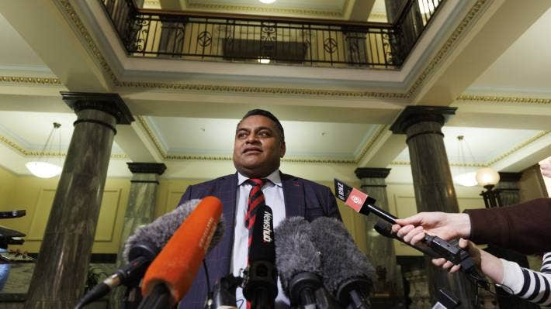

ROBERT KITCHIN/STUFF

Kris Faafoi talks about his decision to leave politics, to journalists at Parliament in June.

***Ernie Newman is a Waikato-based consultant with experience across a range of industries over several decades, including the grocery and telecommunications sectors.***

**OPINION:**I’ve had a bit to do with Kris Faafoi over the years. I like him – who wouldn’t?

But I’m disappointed in him. His decision to [become an unashamed lobbyist](https://www.stuff.co.nz/national/politics/300704791/exminister-kris-faafoi-is-now-a-lobbyist-and-pr-guy) a few months after [leaving Cabinet](https://www.stuff.co.nz/national/politics/300620732/kris-faafoi-comes-good-on-10year-debt-hands-proof-to-the-pm-as-he-says-farewell-to-parliament) casts doubt on his ethics and judgement.

ADVERTISING

Faafoi has worked around Parliament since 2005. He started as a journalist, then led the media team for Phil Goff when he was Opposition leader.

For the past five years he’s been a cabinet minister with numerous portfolios, many of them sensitive ones – commerce, communications, justice, broadcasting and immigration for examples.

ADVERTISEMENT

[*Advertise with Stuff*](https://advertise.stuff.co.nz/)

He’s sat through hundreds of hours of Cabinet meetings. That’s given him access to papers prepared by officials, insights into the views of specific ministers on a vast range of issues, and highly sensitive understandings of the issues on which a specific decision has turned.

To many private interests, those insights are invaluable. Knowing who to target, with which specific angle, in order to influence an outcome is gold dust.

Take telecommunications for a hypothetical example.

**Kris Faafoi fronts media on resignation**

Play Video

ROBERT KITCHIN/STUFF

Kris Faafoi talks to political journalists after announcing his resignation from Parliament in June.

At some point soon, government will decide on future rounds of investment in [improved broadband and mobile connectivity](https://www.stuff.co.nz/business/farming/123935198/broadband-divide-widens-as-data-demand-puts-pressure-on-networks) to the last remaining unconnected farms – or possibly connectivity right across those farms.

One option is to deploy the wide range of smaller regional businesses who have very competently driven the connectivity thus far – initially with their own capital and more recently with government funds.

The other centres on very large businesses such as Chorus, which is already lobbying intensively to that end.

Right now, a deep insight to Cabinet thinking and how to influence it would be of immense value to those competing parties.

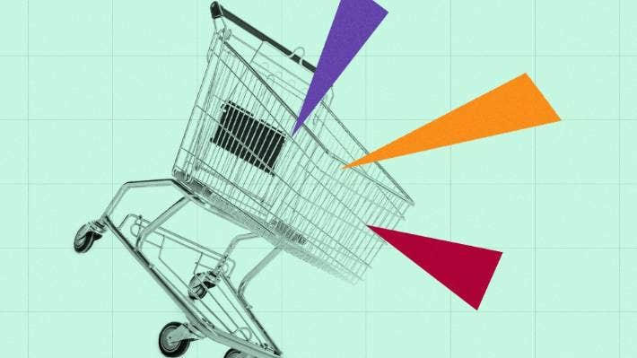

ALEX LIM/STUFF

The behaviour of the supermarket duopoly has been the focus of intense political attention.

Another example is in the grocery sector.

Our [supermarket duopoly](https://www.stuff.co.nz/business/opinion-analysis/129691688/government-yet-to-get-to-the-most-meaty-issue-in-the-supermarket-industry) remains on tenterhooks with a constant threat of more heavy-handed intervention hanging over it.

Faafoi will have sat through many debates over a five year period leading to the current situation. He is privy to valuable insights into the Government’s contingency plan if the duopoly’s behaviour worsens, what might trigger it, and the benefits and risks associated with that.

I’m not implying that the big ends of the grocery or telecommunications business are working with Faafoi – I have no inside knowledge.

ADVERTISEMENT

[*Advertise with Stuff*](https://advertise.stuff.co.nz/)

But “insights” are what he is now taking to market, barely three months after leaving Parliament.

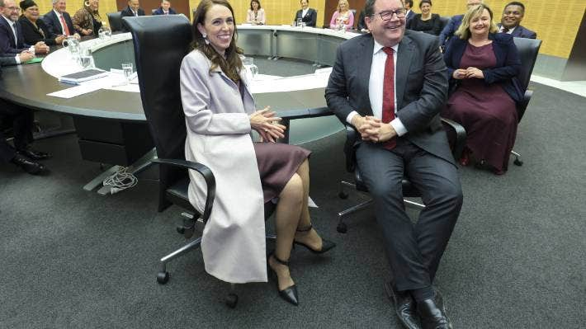

HAGEN HOPKINS/GETTY IMAGES

The Labour Government’s new Cabinet meets for the first time in November 2020, with Kris Faafoi at far right. Insights into the thinking of Cabinet ministers are gold dust to lobbyists, argues Ernie Newman.

This skews the playing field in favour of the large businesses. Smaller businesses, which generally lobby through business associations run on a shoestring, are less likely to sign up - especially to an ex-minister just weeks out of Cabinet, who can charge a premium.

At the end of the day it is the public who potentially lose out through reduced integrity in decision-making and the imbalance of information and influence.

He himself [acknowledged to media](https://thespinoff.co.nz/politics/07-10-2022/kris-faafoi-and-the-revolving-door) that he has already been speaking to “people I’ve had relationships with in the past”. Form your own conclusions.

Kris Faafoi is far from the first person to leave a sensitive role in Parliament, or even a ministerial position, and peddle “insights” to fee-paying clients.

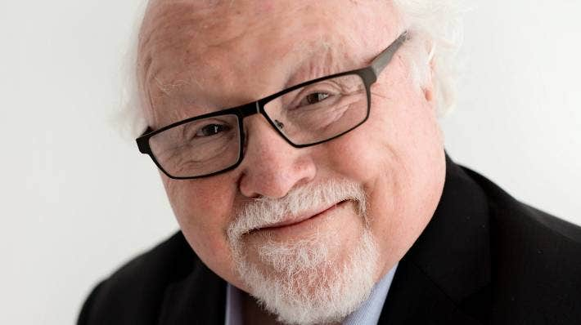

STUFF

Ernie Newman is a Waikato-based consultant who has worked in many business organisations over more than 40 years including within the telecommunications and grocery sectors.

But he has set a new, much lower bar by moving so quickly after resigning mid-term while the rest of his Cabinet colleagues still occupy the seats of power.

People in government – whether Cabinet, Parliament or senior levels of the public service – are in positions of enormous trust. Rules can only go so far, so ethics really matter.

When someone in such a high office pushes such boundaries it can lead to a dangerous, slippery slope.

An unfortunate precedent has been set. As a citizen, my confidence in the integrity of our system has taken a small but significant dive.