Friday October 28, 2022

Log in

Support quality, homegrown journalism.[***DONATE***](https://members.thespinoff.co.nz/?utm_source=thespinoff&utm_medium=header-donate-button&utm_campaign=header)

* ***[NEWS](https://thespinoff.co.nz/live-updates)***
* ***READ***
* ***[WATCH](https://thespinoff.co.nz/videos)***
* ***[LISTEN](https://thespinoff.co.nz/podcasts)***
* ***MORE***

**POLITICS**Yesterday at 9.00am

How to hide a million dollars in politics

[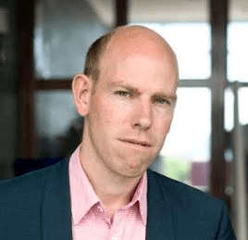](https://thespinoff.co.nz/authors/max-rashbrooke)

[**Max Rashbrooke**](https://thespinoff.co.nz/authors/max-rashbrooke)

Guest writer

SHARE STORY

**MADE POSSIBLE BY**

Illustration: Toby Morris 


Illustration: Toby Morris

**ANALYSIS**

**Two recently-concluded court cases highlight the inadequacies of New Zealand’s political donation laws, writes Max Rashbrooke.**

According to the official records, David Zhang had donated $8,000 to the Labour Party by buying an overpriced piece of art at auction. So it was something of a surprise when he stood up in court and said, “I do not like the Labour Party. I’d rather burn money than give it to Labour.”

Zhang’s comments were just one darkly comic moment in the long winter of cases in which people connected to National, Labour and New Zealand First went on trial for trying to hide the sources of those parties’ funding from the public. And now that the cases have concluded (pending appeals), and some defendants been convicted, it is time to take stock of a political finance system that appears wide open to abuse, and reflect on how it might be reformed.

[The first court case](https://www.newshub.co.nz/home/politics/2022/06/new-zealand-first-foundation-case-trial-underway-against-two-accused-of-electoral-fraud.html), which wound up in July, concerned the New Zealand First Foundation, set up as a fundraising vehicle for Winston Peters’ centrist party. It solicited large sums from wealthy New Zealanders, and took in nearly $700,000 in what were, on the face of it, donations. Most of the sums were over the $15,000 threshold at which, under the Electoral Act, the donor’s identity must be publicly disclosed. Many of the givers thought the money was going to New Zealand First, and the foundation used the cash to pay the party’s bills. These were, in substance, donations: sums the New Zealand public should have known about, so that they could see who was funding the party and be on the lookout for favours being paid in return. This is the basic premise of our transparency laws.

In this case, however, the defendants – who have name suppression – were acquitted, partly on the technicality that, in law, donations are sums given directly to a party or to people “involved in the administration of the affairs of the party”. The defendants, in the judge’s view, were administering the foundation, not the party itself. This ruling suggested that unlimited sums could be anonymously channelled to parties through related entities: a loophole so large you could drive [Winston Peters’ bus](https://www.newsroom.co.nz/sfo-details-not-one-but-two-nzf-secret-funds) right through it.

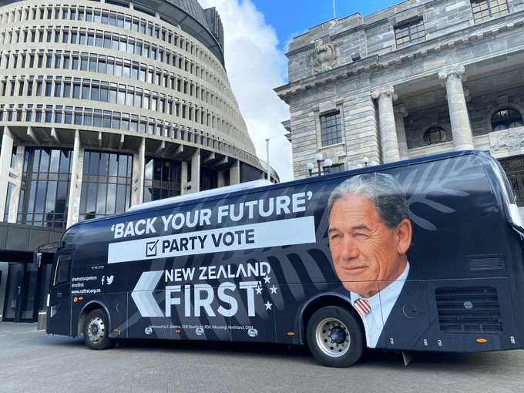The Winston Peters battle bus outside parliament in 2020. (Photo: Justin Gionvannetti)

To further underline the law’s weakness, the defendants weren’t even charged under the Electoral Act, which lacks sufficiently strong penalties and, in some cases, the kind of offences that would cover such activities. Convoluted charges under the Crimes Act were filed instead. What’s more, [many donors admitted](https://www.newsroom.co.nz/millionaires-for-nz-first) to the Serious Fraud Office (SFO) that they had split their very large donations into sub-$15,000 tranches, routing those sums through the bank accounts of friends, family members and companies and trusts they controlled, in order to keep their (the true donor’s) identity secret. (As the foundation wasn’t disclosing the donations anyway, this was an unnecessary precaution.) Yet they weren’t prosecuted, for reasons that remain unclear.

In the winter’s [second big political case](https://thespinoff.co.nz/politics/26-07-2022/sham-donors-and-fairy-dust-on-opening-day-of-donations-fraud-trial), the judgement in which [landed earlier this month](https://thespinoff.co.nz/politics/05-10-2022/jami-lee-ross-acquitted-as-three-found-guilty-over-national-party-donations), the SFO finally got a conviction.  The trial revolved around three Aucklanders: wealthy businessman Yikun Zhang and his associates, twin brothers Colin and Joe Zheng. All three were found guilty of concealing a $100,000 donation from Zhang to National by splitting it into sub-$15,000 tranches and routing them through other people’s bank accounts. Colin Zheng was also found guilty of concealing Zhang’s identity as the donor of another $100,000 to National, and Joe Zheng was convicted of lying to the Serious Fraud Office (SFO).

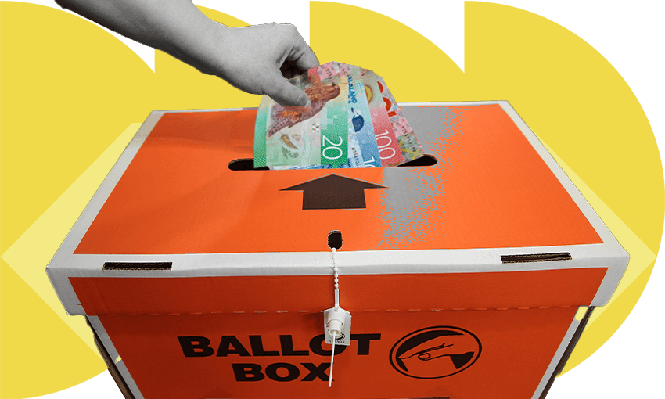Image: Tina Tiller

Why they so badly wanted to conceal Zhang’s identity was never fully explained, though the SFO did note that he had eagerly sought, and received, an official Honour (MNZM) from the National government of the time. Ironically, the disgraced former National MP Jami-Lee Ross, who had solicited donations from Zhang and whose allegations of wrongdoing sparked the whole trial, was cleared of all charges, owing to the state of his mental health at the time.

When the SFO had been following up Ross’s allegations, though, they found that Zhang had also donated to Labour. Following that trail led to charges against him and the Zheng brothers – heard in court simultaneously with the National charges – of conspiring to conceal another $35,000 donation. Zhang had paid $60,000 for five artworks that Labour had valued at $25,000, the balance counting, the SFO argued, as a donation.

The payment was again disguised, this time by the Zheng brothers falsely claiming that five members of Auckland’s Chinese community had bought one artwork each at a silent auction. One of them was the above-mentioned David Zhang, whose anti-Labour views – and insistence that he had never bought a painting in his life – underscored the SFO’s case.

For all that, the defendants were cleared of the Labour-related charges, essentially because of an SFO mistake. The agency had failed to independently value the artworks, raising the (very slim) prospect that the paintings might actually have been worth over $45,000 and therefore Zhang’s donation (the difference between his payment and the artworks’ market value) would have been less than the $15,000 that needed to be declared. Two Labour Party defendants were also cleared of charges, on the basis that, although they had clearly provided false statements about the donations, they might simply have been misled by Zhang and the Zheng brothers.

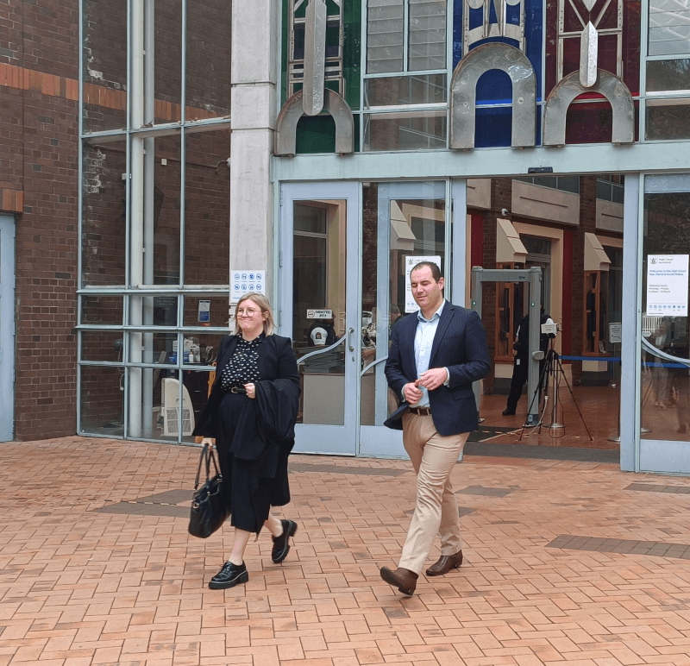Jami-Lee Ross, accompanied by Heather Stewart, walks free from the High Court in Auckland. (Photo: Toby Manhire)

What can we conclude from these two cases? Clearly the law is inadequate. The government has said it will [close the New Zealand First Foundation loophole](https://thespinoff.co.nz/politics/28-07-2022/how-to-close-the-donation-loopholes-exposed-by-the-nz-first-foundation-judgment), but it may need to go further. Penalties for breaches may need to be strengthened, and the law may need a general “anti-collusion” offence to catch donation subterfuges the law can’t specifically anticipate.

It is clear, too, that the concealment of donors’ identities, via donation-splitting, is widespread. Stopping it altogether is difficult, but greater transparency would help. So the government may need to go beyond [its current plan](https://www.parliament.nz/en/pb/bills-and-laws/bills-proposed-laws/document/BILL_125504/tab/hansard) to lower the threshold for disclosing a donor’s identity from $15,000 to $5,000. Even at that level, a donor of $60,000 could hide their identity by splitting the sum among 12 people; at, say, $1,500, they would have to involve 40 people in the conspiracy, significantly raising the chances of being ratted out or otherwise detected.

**MORE READING**

**Jami-Lee Ross acquitted as three found guilty over National Party donations** Outside the court the man who launched a 'kamikaze' mission littered with lies said it was time to move on after four long years.

**Christopher Luxon’s everyman campaign has begun** The leader of the opposition would like you to know he's just a regular bloke.

It is also worrying that these cases were brought to light only by whistleblowers – albeit strange ones, in Ross’s case – and not by tough, systematic inspections by regulators. Such haphazard methods of discovery leave ample room for more offending to go undetected.

And indeed the trials remind us of just how weak our regulatory agencies are. The SFO, though basically in the right, made rookie mistakes. The police appear to be generally reluctant to take donations-related cases, perhaps because those cases are so intensely politicised. Meanwhile the Electoral Commission, which should be the first agency to detect wrongdoing, has almost no ability to do so. It receives donation summaries from political parties, but cannot check whether the summaries match the party’s own internal records, nor whether those records themselves are reliable. It can compel neither documents nor witnesses.

The consequence is that party funding often remains opaque; the public is kept in the dark. Across the two cases, something close to $1m was given to political parties from people whose identities would, absent whistle-blowers, have remained secret forever. And this winter’s cases are just two in [a long line of donations scandals](https://thespinoff.co.nz/politics/04-03-2020/a-brief-history-of-new-zealand-donations-scandals) that have, until the National-related convictions, resulted in precisely zero successful prosecutions. One partial success does not greatly change the overall impression that the country’s electoral laws, and its system of enforcement, are both in need of serious repair.

