**Rich list donors are great for political parties but not for democracy**

Max Rashbrooke05:00, Apr 09 2022

Pause

Unmute

Current Time 8:13

/

Duration 23:04

Loaded: 40.12%

Fullscreen

RNZ

RNZ podcast The Detail explores the techniques used by political parties to maintain anonymity for people who donate large sums of money.

***Max Rashbrooke is a senior associate at the Institute for Governance and Policy Studies, Victoria University of Wellington-Te Herenga Waka.***

**OPINION:**In a democracy, government is supposed to be “of the people, by the people, for the people”, in Abraham Lincoln’s famous phrase. The recent flood of donations to National and ACT, though, suggests we risk getting a government of the Rich List, by the Rich List, for the Rich List.

National has reportedly, in just one month, raised $1.8m in large donations, and [ACT](https://www.stuff.co.nz/national/politics/300550443/mori-party-calls-for-xero-boycott-over-its-founders-ties-to-act-party) $850,000. These are extraordinary sums, roughly ten times the normal amount for a non-election year. And what no-one seems to have noticed is that, in National’s case, all bar one of their 17 donors are on the Rich List.

ADVERTISING

Graeme Hart, worth $11b and New Zealand’s richest man, reportedly gave a quarter of a million, as did toy entrepreneur Nick Mowbray (family net worth: $2.5b) and former Brierleys chief executive [Murray Bolton](https://www.stuff.co.nz/national/health/coronavirus/126796850/covid19-richlister-murray-bolton-challenges-mbie-decision-to-refuse-him-home-miq#:~:text=Bolton%2C%20who%20is%20worth%20about,Justice%20Geoffrey%20Venning%20on%20Wednesday.) ($400m). Other mega-donors reportedly include former strip-club owners the Chow brothers ([a reported](https://businessdesk.co.nz/article/property/from-sex-to-the-suburbs-the-chow-bros-latest-money-grab#:~:text=Just%20a%20roomful%20of%20influential,growth%20in%20a%20short%20time.) $500m) and property investor [Trevor Farmer](https://autofile.co.nz/nbr-lists-wealthy-kiwis-#:~:text=Trevor%20Farmer%20%E2%80%93%20%24750%20million) ($750m).

The only apparent non-Rich-Lister is Mike Thorburn, who, news reports suggest, is the inheritor of the ECC lighting empire. ACT’s donors, meanwhile, include Hart (again), and billionaires Rod Drury and Stephen Jennings.

**READ MORE:  
\***[**Election 2020: Rich-listers spreading cash across NZ's political spectrum**](https://www.stuff.co.nz/national/politics/300091062/election-2020-richlisters-spreading-cash-across-nzs-political-spectrum?rm=a) **\***[**It's time to end the secrecy over political donations**](https://www.stuff.co.nz/national/politics/119894608/its-time-to-end-the-secrecy-over-political-donations?rm=a) **\***[**NZ First donations scandal threatens to upend election year**](https://www.stuff.co.nz/national/politics/119268201/nz-first-donations-scandal-threatens-to-upend-election-year?rm=a) **\***[**New Zealand politics: foreign donations and political influence**](https://www.stuff.co.nz/national/politics/108096827/new-zealand-politics-foreign-donations-and-political-influence?rm=a)

ADVERTISEMENT

[*Advertise with Stuff*](https://advertise.stuff.co.nz/)

The issues raised by such donations go well beyond the Right, however. A number of individuals face charges relating to allegations of concealing or improperly reporting donations to the Labour and National parties while two people are facing charges relating to allegations of fraudulently depositing money into a New Zealand First Foundation account and Te Pati Māori is being investigated over its reporting of donations.

Donations cause our parties recurring problems because they revive the age-old concern about the confluence of politics and money. Liberal democracies insist that every citizen should have an equal chance to influence politics, even while allowing concentrations of wealth that are often translated into excess power.

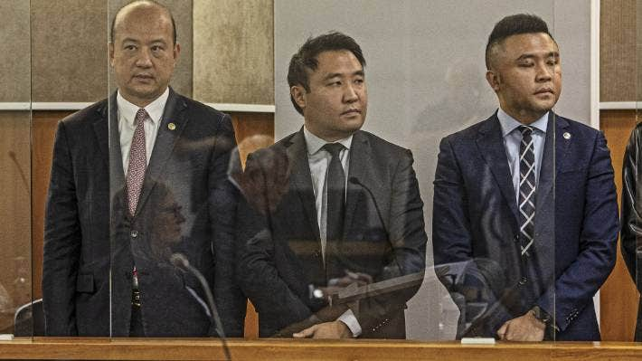

LAWRENCE SMITH/STUFF

Yikun Zhang, Shijia (Colin) Zheng and Hengjia (Joe) Zheng face charges in relation to both the Labour and National party donations cases.

This can take the form of a quid pro quo: a donation buys a favourable decision. Such instances, thankfully, are rare here. But one of the most concerning aspects of [the NZ First](https://www.stuff.co.nz/national/politics/117509589/nz-first-foundation-dodging-electoral-rules-records-suggest-breaches) case is that, allegedly, the party's fundraising foundation hid thousands of dollars in donations from industries directly affected by its MPs' decisions.

Perhaps nothing untoward happened. But if so, why the apparent effort to hide the donations? The appearance of misbehaviour should, by itself, concern us: even just a suspicion of corruption can corrode people’s faith in politics and stop them voting.

Donations can also have a subtler influence, biasing politicians not towards specific individuals but towards the wealthy as a whole. The Rich List donors represent not even the 1% but rather the 0.01%. (Almost all, moreover, are Pākehā men.) And the $1.8m they have given National is a large sum, domestically speaking, worth nearly half what the party spent contesting [the last election](https://elections.nz/democracy-in-nz/historical-events/2020-general-election-and-referendums/party-expenses-for-the-2020-general-election/).

[Research](https://www.wgtn.ac.nz/__data/assets/pdf_file/0010/1908226/WP-20-05-patterns-of-political-donations-in-New-Zealand-under-MMP.pdf) by Victoria University’s Thomas Anderson and Simon Chapple shows that, between 1996 and 2019, big donations from businesses outweighed those from trade unions by four to one. If political parties become dependent on large donors for the cash needed to contest elections, how will they not also become, subtly and over time, biased towards those donors’ interests and worldviews? As the *Stuff* columnist and former National Party staffer Ben Thomas [has observed](https://www.newsroom.co.nz/pete-mckenzie-politics-rife-with-dark-money), donor relationships can, in a given policy area, “change your idea of what’s possible or desirable”.

Several of the donors, Hart and Farmer among them, founded their fortunes in the heady, hyper- individualistic 1980s, when state assets were sold at fire-sale prices and inequality and child poverty soared. If, as [ACT leader David Seymour says](https://www.nzherald.co.nz/nz/politics/act-party-donations-drive-nets-almost-1-million-from-rich-listers/TC65IND7DIGN6GIMQAK3IGYTQ4/), such donors are dissatisfied with “New Zealand’s long-term direction”, and want other values “cemented in a more serious way”, we might reasonably suspect they seek a 1980s revival entirely out of step with the public’s desires.

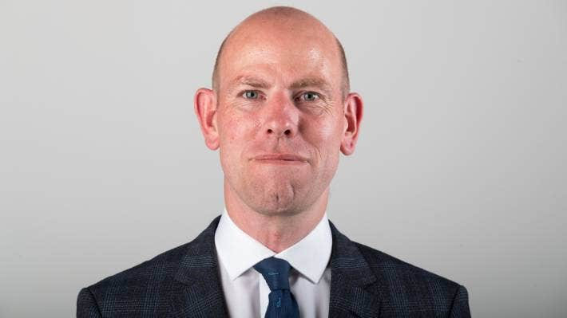

JERICHO ROCK-ARCHER/STUFF

Max Rashbrooke: “Donations can also have a subtler influence, biasing politicians not towards specific individuals but towards the wealthy as a whole.”

The counter-argument is that wealthy donors are nobly disinterested individuals who simply “care about democracy”, to quote National fundraiser (and former Cabinet minister) Paula Bennett. But this seems inconsistent with what we know about money and politics, which is that the former tends to corrupt the latter. We make politicians [declare every gift](https://www.parliament.nz/en/pb/parliamentary-rules/standing-orders-2017-by-chapter/appendix-b-pecuniary-and-other-specified-interests/) they receive over $500, on the basis that these things typically lead to bias; why would we suddenly abandon such suspicions when it comes to donations of $250,000?

Donations can, finally, create imbalances between parties, allowing the richer ones to buy more advertising and employ more campaigners. National’s advertising expenses will be capped next year, during the official three-month election campaign, but no restrictions apply before then. It could spend large sums on a “permanent campaign” for the next year or so, in a manner that other parties, except its soulmate ACT, may not be able to match.

The party expects the money to keep flowing: “I’m not finished here,” Bennett told reporters. That would be good news for National, but by no means for democracy.

A