* [Login](javascript:void(0))

MARCH 4, 2020

[**MADE POSSIBLE BY**](http://thespinoff.co.nz/commercial-content/)**[](https://www.flickelectric.co.nz/?source=spinoff&placement=header)**

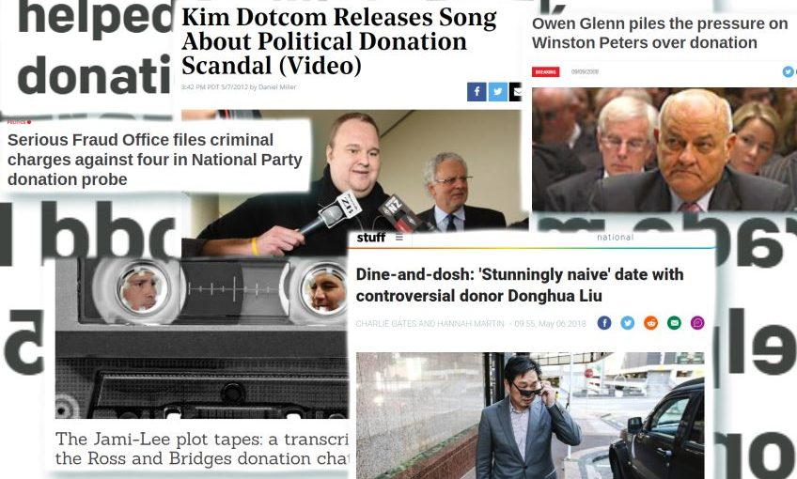

A brief history of New Zealand donations scandals

[**Max Rashbrooke**](https://thespinoff.co.nz/author/max-rashbrooke/) | Guest writer  
Commentary

**We live, supposedly, in the most open era in New Zealand history. Yet right now scandal swirls around donations to National and New Zealand First. The other large party, Labour, also has form. As part of our**[**week-long series on electoral funding, Money Talks**](https://thespinoff.co.nz/tag/money-talks/)**, Max Rashbrooke asks: how has it come to this?**

***This series is made possible thanks to Spinoff Members.***[***Join Members to support more of this sort of thing***](https://thespinoff.co.nz/members/?utm=mtk-4march)***.***

The reason that donations to political parties matter so much, and are the subject of so much current debate, is simple: money talks. Or, at least, it can. Election campaigns cost a lot of cash to run, often in the millions of dollars. Communicating with voters outside of elections also costs money. So politicians need funders.

If political parties rely on very large numbers of very small donations, none of those donations is likely to buy undue influence. But if parties, conversely, rely on very large donations from a very small number of people, the obvious danger is that those donations allow the giver an influence over politicians not open to the rest of us.

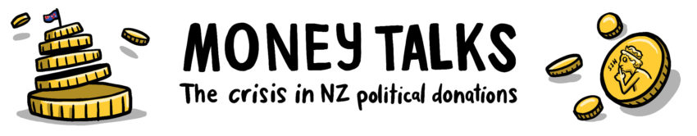

Of course one has to be careful here. Unlike in other countries, where bags of cash clearly buy favours, it is rare that an individual New Zealand donation can be connected to a particular policy or decision. But it does happen. And the wider concern is that reliance on a small group of wealthy individuals, even if it does not influence one specific law, will still orient policy in their general direction.

And it is noteworthy that the two current national scandals concern alleged attempts to conceal the identity of donors, in the case of donations to National by pretending that the funds from one person came from several, and in New Zealand First’s case by questionable use of a foundation to gain anonymity. (In both cases the alleged perpetrators deny wrongdoing.)

Like many stories, this one is partly old, partly new. The pace of the scandals appears to be accelerating, like a train running downhill and out of control. But the scandals themselves are hardly unique to this century.

What we know about donations to political parties is, of course, a function of how much scrutiny they receive – which until the 1980s was very little. [The 1956 Electoral Act](http://www.nzlii.org/nz/legis/hist_act/ea19561956n107130/), for instance, asked only candidates, not parties, to disclose their spending and donations – and in practice the donations disclosure was often dodged. So it is entirely possible that the old establishment subtly exerted undue influence over New Zealand political parties. Nonetheless, [the 1986 Royal Commission on the Electoral System](https://web.archive.org/web/20170509091840/http:/www.elections.org.nz/sites/default/files/bulk-upload/documents/Chapter%208%20political%20finance.pdf) felt able to claim that the system “shows no sign of corruption … and no excessive reliance by parties on a few special interest groups or institutions.”

But this rosy picture soon grew bleak. In 1987, as the pro-business fourth Labour government sought re-election, corporate donations poured into the party. Totalling [around $3 million](https://liberation.typepad.com/liberation/2007/04/myth_2_corporat.html), they represented a colossal sum at the time, far greater than donations from unions or members. Businessman Allan Hawkins openly acknowledged that he alone had given Labour $250,000. (Hawkins has recently been in the news again after receiving his second jail sentence.) While a controversial 1990 *Frontline* documentary went far too far in implying that such donations directly bought favourable policies and discounted asset sales, there were certainly legitimate questions to be raised about such donations and the relative lack of any controls, or indeed transparency, around them.

These concerns also existed against a wider backdrop. Though sanguine about donations, the Royal Commission had noted the increasing cost and complexity of election campaigns. Meanwhile membership of political parties, which in all likelihood had been an important source of funds, was dwindling.

Since then, both trends have only intensified: the need for more cash, combined with having fewer members to tap, has led to greater reliance on wealthy individuals. “The thing that makes concerns about the donations model greater,” says Otago law professor Andrew Geddis, “is the fact that parties have to some extent been hollowed out. With the membership falling away, the question is, what goes in its place?” The increasing professionalisation of parties only exacerbates these issues. “Things that used to be done by volunteers, you are now hiring companies to do for you. So you need to have more money.”

Responding to such concerns, the 1993 Electoral Act required parties to disclose every donation over $10,000 and the identity of its donor. (Anything under that threshold was the party’s business alone.) Although the law did not seek to curb how much could be given, it did enshrine a belief that the public had a right to know about large donations, in order to check whether they were leading to undue influence.

The threshold was, however, easily circumvented. Most famously, National used the Waitemata Trust, [described by the *Herald*](https://www.nzherald.co.nz/nz/news/article.cfm?c_id=1&objectid=10507261) as “a secretive organisation which has showered [the party] in cash”, to channel hundreds of thousands of dollars in donations from figures who wished to remain anonymous. Labour also received significant sums from “undisclosed clients” channelled through law firms.

These concerns were addressed in the 2007 Electoral Finance Act, although the donation provisions were largely overshadowed by enormous controversy about the parts of the law that sought to restrict campaigning by third-party organisations. After National won office in 2008, the law was repealed, but a compromise between the major parties largely preserved the restrictions on donations, including the crackdown on the anonymous channelling of large sums and the introduction of real-time reporting of the very largest ones.

What we have now is essentially a result of that compromise. Parties do not have to declare donations worth less than $1,500. They do have to report donations – but not the identities of their donors – that are worth between $1,500 and $15,000. Above $15,000, they have to declare the donations *and* the identities of donors. And above $30,000, they have to declare the donations and the identities of the donors *in real time* on the Electoral Commission website.

[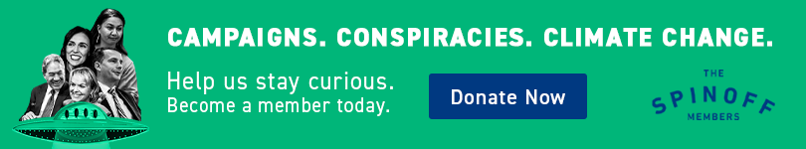](https://thespinoff.co.nz/members?utm_campaign=members-interruptive-web)

None of the post-1993 reforms, however, has halted the growing pace of donations scandals. Any list of the scandals in this millennium alone would have to include the following:

* Late 2000s – Labour ministers lobby for, and approve, citizenship for Bill Liu, a donor, against the advice of officials
* 2008 – New Zealand First’s Winston Peters is censured by parliament for failing to declare a $100,000 donation from Owen Glenn, following a firestorm of controversy
* 2010s – Both National and Labour develop schemes (named the Cabinet Club and the President’s Club, respectively) in which donors gain access to ministers
* 2014 – National minister Maurice Williamson loses his portfolios after intervening in the police investigation into party donor Donghua Liu
* 2018 – National MP Jami-Lee Ross alleges a $100,000 donation to the party was split into a series of smaller donations to illegally avoid disclosure, sparking an investigation in which four people, including Ross himself, have now been charged by the Serious Fraud Office
* 2019 – Chinese citizen Lin Lang avoids curbs on donations by non-residents by (legally) routing a $150,000 donation to National through a New Zealand-based firm, the Inner Mongolian Rider Horse Industry
* 2020 – The operation of the New Zealand First Foundation, which, as above, appears designed to avoid donor disclosure requirements, is now under investigation by the SFO.

(Meanwhile, at the local level, the SFO is also investigating donations to the Labour mayor of Christchurch, Lianne Dalziel, as well as Auckland Mayor Phil Goff’s expenses.)

These scandals persist partly because nothing in the law curbs the amounts that can be given or – as a result – the potential for influence. At best, the law provides some transparency, and frequently it does not even do that. Because the threshold for disclosing a donor’s identity is set as high at $15,000, a donor can donate $45,000 over a parliamentary term. And they can straightforwardly split, say, $60,000 into four chunks of $15,000, pass those chunks onto friends to donate on their behalf, and thus give a huge sum in complete secrecy. The fact that this is illegal does not mean it doesn’t happen. Nor does it help that the supposed watchdog, the Electoral Commission, has to rely on parties’ declarations and cannot meaningfully investigate their donation records.

Past reformers have contemplated fixing all these weaknesses, but have ultimately shrunk back from the task. In the light of the accelerating pace of scandals, that stance is increasingly untenable.