* [Weather](https://www.rnz.co.nz/news/weather)[**POLITICS**](https://www.rnz.co.nz/news/political)[**COMMENT & ANALYSIS**](https://www.rnz.co.nz/news/on-the-inside)

20 Feb 2020

**Cat MacLennan: Time for state-funded political parties to replace donations**

1:05 pm on 20 February 2020

Share this

* [Share on Twitter](https://twitter.com/intent/tweet?text=Opinion%3A%20Time%20for%20state-funded%20political%20parties%20to%20replace%20donations&url=https://www.rnz.co.nz/news/on-the-inside/409959/cat-maclennan-time-for-state-funded-political-parties-to-replace-donations)
* [Share on Facebook](https://www.facebook.com/sharer/sharer.php?u=https%3A%2F%2Fwww.rnz.co.nz%2Fnews%2Fon-the-inside%2F409959%2Fcat-maclennan-time-for-state-funded-political-parties-to-replace-donations)
* [Share via email](mailto:%20?subject=Opinion%3A%20Time%20for%20state-funded%20political%20parties%20to%20replace%20donations&body=I%20thought%20you%20might%20be%20interested%20in%20this%20page%20https%3A%2F%2Fwww.rnz.co.nz%2Fnews%2Fon-the-inside%2F409959%2Fcat-maclennan-time-for-state-funded-political-parties-to-replace-donations%20from%20RNZ.)
* [Share on Reddit](https://www.reddit.com/submit?url=https://www.rnz.co.nz/news/on-the-inside/409959/cat-maclennan-time-for-state-funded-political-parties-to-replace-donations)
* [Share on Linked In](https://www.linkedin.com/shareArticle?mini=true&url=https://www.rnz.co.nz/news/on-the-inside/409959/cat-maclennan-time-for-state-funded-political-parties-to-replace-donations)

***By Cat MacLennan\****

*Opinion -*For donations to two of New Zealand's largest political parties to be investigated by the Serious Fraud Office in the same year appears to be more than an unfortunate coincidence. Rather, it seems like a clear signal that something is seriously wrong with our political party funding rules.

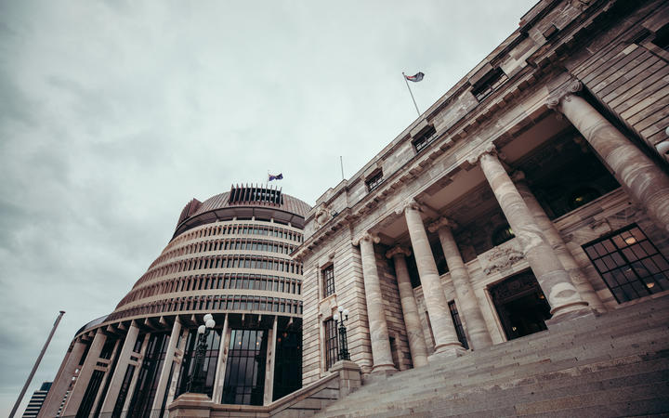

Photo: RNZ / Dom Thomas

The Serious Fraud Office's investigation of large donations to the National Party has resulted in [four men being charged](https://www.rnz.co.nz/news/political/409878/national-party-donations-case-jami-lee-ross-named-as-suppressions-lifted). The regulator's [probe of issues relating to New Zealand First](https://www.rnz.co.nz/news/political/409780/new-zealand-first-foundation-serious-fraud-office-confirms-investigation) is only just beginning, so an outcome is some time away.

However, what is plain is that our political party funding rules are not fit for purpose. And politicians cannot be trusted to fix them.

Political parties tell the public that money buys neither influence nor policy and that MPs - and particularly party leaders - are kept insulated from donations and do not know who contributes. That has always seemed difficult to believe, since it is obvious that a common reward for donations is access to dinner or meet-and-greets with party leaders or Ministers.

The [tape released by Botany MP Jami-Lee Ross](https://www.rnz.co.nz/news/political/370217/simon-bridges-defends-jami-lee-ross-promotion-offer-in-leaked-recording) of his conversation with National Party leader Simon Bridges showed that Bridges knew not only the names of donors, but amounts. The donors had dined once with Bridges and another meal was planned.

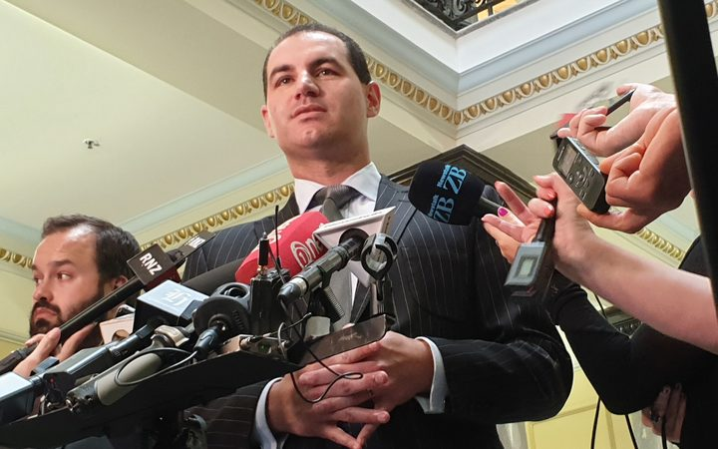

Jami-Lee Ross talks to media after it was revealed the Serious Fraud Office was investigating his complaint about disclosure of political donations. Photo: RNZ / Craig McCulloch

The corrosive influence of money on politics is clearly apparent in other countries. In the United States, gun control and action to address climate changed are stymied by politicians' fear of upsetting large donors. The United States' 2018 mid-term elections were calculated to have cost close to $6 billion.

In the December 2019 British election, the Conservative Party in the first two weeks of the campaign broke the record for the most money raised in an election, with large, pro-Brexit donors pouring £12m into the party's coffers. The Conservatives' Leader's Group rewards people who donate at least £50,000 a year with dinner with the Prime Minister.

In Australia, a 2018 Grattan Institute report showed that up to 40 percent of donations to political parties in the preceding decade came from untraceable sources, with $AU62.8m in party funding - in 2017 alone - being hidden.

It would be nice to believe that all these donors give money simply to support the democratic process, which is their common explanation. However, the clear correlation between large donations and parties with business-friendly policies suggests a less benign motivation.

It does not have to be like this. New Zealand should accept that there is a problem with our political party funding and remedy it by introducing state funding of political parties. This would place parties on an even footing and make elections a contest of ideas, not dollars.

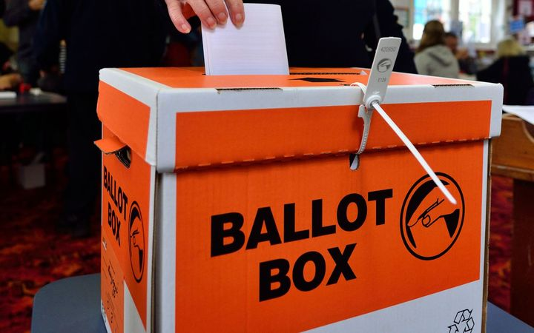

Photo: 123rf.com

Many other countries have already done this. Public financing of political parties takes place in Canada, Sweden, Germany, Australia, Spain, Austria, Israel, the Netherlands, Poland, France, Japan and Mexico.

The ACE Electoral Knowledge Network says that, out of a sample of 180 nations, 25 percent provide no direct or indirect funding to political parties, while 58 percent give direct public funding. However, the fact that so much secret money still pours into Australian political parties demonstrates that it is not enough merely to introduce public funding. Other safeguards must also be put in place.

It is the public that must demand this. MPs have made numerous changes to donation laws over the years, but their common characteristic has been that they have effectively amounted only to tinkering. They have failed utterly to address key concerns, or to prevent parties from doing their best to hide donors' identities.

New Zealand political parties have always been reluctant to support state funding as they believe it will be unpopular with the public. That is a poor excuse.

Politicians - and others - need to explain to the public that state funding of political parties is not feathering the nests of already well-paid MPs. Rather, it is an investment in protecting and strengthening our democracy.

***\* Cat MacLennan is a barrister and former political reporter.***

Share this