STUFF

BusinessNZ's top members include several public sector organisations.

Public sector organisations including ACC and Auckland Council have spent more than $1 million on memberships of business advocacy group BusinessNZ in total over the past several years, research by *Stuff* shows.

BusinessNZ has advocated on controversial issues such as [opposing a broad-based capital gains tax](https://www.stuff.co.nz/business/opinion-analysis/112123207/capital-gains-tax-would-have-been-a-loss-for-kiwis) and the [curtailing of 90-day employment trials](https://www.stuff.co.nz/business/107038995/kirk-hope-lack-of-change-to-employment-bill-deeply-disappointing).

It has also voiced concerns about [tightening some visa rules for immigrants](https://www.stuff.co.nz/business/opinion-analysis/83813483/kirk-hope-migration-provides-important-skills-for-business) and the Government banning new petroleum and gas exploration ["without industry consultation"](https://www.stuff.co.nz/business/104872423/kirk-hope-reality-is-positive-but-fears-of-heavyhanded-regulation-is-hurting-confidence).

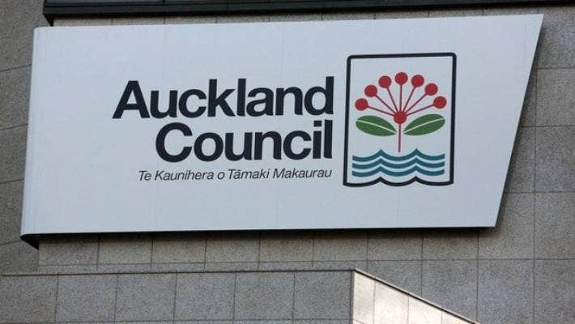

SUPPLIED

Auckland Council is the only council that subscribes to BusinessNZ's major companies group top tier, and pays for two memberships to cover council-controlled organisations.

ACC has paid $285,000 since 2009 to belong to BusinessNZ's 80-plus strong major companies group (MCG).

**READ MORE:  
\***[**Capital gains tax polling is pointless when you set leading questions**](https://www.stuff.co.nz/business/111909096/capital-gains-tax-polling-is-pointless-when-you-set-leading-questions?rm=m)  
**\* [BusinessNZ considering an international challenge to labour law changes](https://www.stuff.co.nz/business/106973865/businessnz-considering-an-international-challenge-to-labour-law-changes?rm=m)  
* [BusinessNZ admits error in business confidence survey that 'lacked validity'](https://www.stuff.co.nz/business/industries/106996366/businessnz-admits-error-in-business-confidence-survey-that-lacked-validity?rm=a)  
\***[**Kirk Hope: idea NZ is a 'low-wage economy' is a myth**](https://www.stuff.co.nz/business/105627756/new-zealand-has-issues-but-the-idea-it-is-a-lowwage-economy-is-a-myth?rm=m)

But Auckland Council has been the biggest contributor, with the council and organisations it controls such as economic development agency Panuku contributing $300,000 in membership fees since 2011.

ADVERTISEMENT

[*Advertise with Stuff*](https://advertise.stuff.co.nz/)

The council currently pays $60,000 a year for full or associate membership for the council and five council-owned businesses including Auckland Tourism, Events and Economic Development, and Auckland Transport, under a package deal it renegotiated in 2017.

[](https://www.linkedin.com/company/business-stuff)

The other public sector organisations that pay for membership of BusinesNZ's major companies group are:

* Callaghan Innovation: $50,000 in total since 2016.

* KiwiRail: member since 2009 and unable to provide total but currently paying $30,000 a year.

* Niwa: $200,000 in total since 2012.

* New Zealand Racing Board (TAB): $90,000 in total since 2015.

* New Zealand Superannuation Fund: $90,000 in total since 2016.

In most, if not all cases, the figures exclude GST.

BusinessNZ promises to help ensure members of the group are heard in policy, business and economic debate.

Specific benefits of membership are [listed on BusinessNZ's website](https://www.businessnz.org.nz/major-companies-group) as including specialist independent policy advice, access to specialised policy forums including ministers and MPs, and an opportunity to engage in influencing the political and regulatory business framework.

ADVERTISEMENT

[*Advertise with Stuff*](https://advertise.stuff.co.nz/)

BusinessNZ's networking events include an annual cocktail party in February billed as the "biggest annual networking/connecting event held in Wellington" where more than 500 business people meet with "MPs and key officials over drinks and canapes".

It also holds a lunch in December attended by the prime minister that attracts "an 'A' list business audience plus movers and shakers in Auckland".

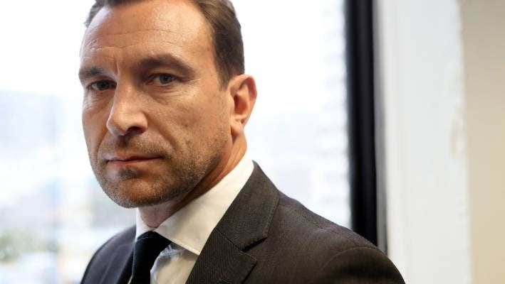

CAMERON BURNELL/STUFF

BusinessNZ chief executive Kirk Hope says it is also common overseas for public sector organisations to belong to business groups.

Jordan Williams, chief executive of the Taxpayers Union lobby group, said it was opposed to public sector organisations paying to belong to BusinessNZ, saying it was "not constitutionally appropriate for government agencies to be funding lobby groups".

The Taxpayers Union did not believe membership could be justified on the grounds it provided networking opportunities, he said.

"Auckland Council does not need networking opportunities." Others such as ACC were not in a competitive market, he said.

BusinessNZ chief executive Kirk Hope said the Taxpayers Union was entitled to its views, but said public sector organisations would not choose to "spend their valuable taxpayers dollars with us" if they did not get value from that.



CAMERON BURNELL/STUFF

Taxpayers Union lobby group chief executive believed Jordan Williams memberships were not justifiable.

"Our view is state-owned enterprises are engaged in large-scale commercial, industrial and managerial activities and they are entitled to engage in policy and advocacy and advice around that."

Lobbying was only one part of BusinessNZ's activities, he said.

Organisations might also choose membership because they wanted more information and deep insights into what the private sector was thinking about particular issues, he said.

Auckland Council was involved in the Climate Leaders Coalition and was a big entity and employer with a range of commercial activities, he said.

ADVERTISEMENT

[*Advertise with Stuff*](https://advertise.stuff.co.nz/)

The Climate Leaders Coalition receives support from the Sustainable Business Council which is associated with BusinessNZ.

[MORE FROM  
**TOM PULLAR-STRECKER • SENIOR BUSINESS REPORTER**](https://www.stuff.co.nz/authors/tom-pullar-strecker)  
[tom.pullar-strecker@stuff.co.nz](mailto:tom.pullar-strecker@stuff.co.nz)

There was nothing unusual about public sector organisation belonging to business groups, Hope suggested.

"We are connected to an international network of employer and business organisations all over the world," he said.

"We know from our experience from those organisations that state-owned enterprises and other large-scale employers, including councils, belong to peak business bodies in those jurisdictions.

"We do our best to add as much value as we can for all of our members. We have a mixed economy in which government plays a huge role in the business community," he said.

State Services Minister Chris Hipkins said it was up to individual chief executives to decide whether their agency was a member of a private organisation.

"Without the details of any individual cases it's difficult to offer a particular view, but I expect chief executives to have regard to public service principles around conflicts of interest, impartiality and expenditure," he said.



ILLYA MCLELLAN/STUFF

KiwiRail says it doesn't always agree with BusinessNZ's views but membership is important for business planning and strategy.

ACC spokesman James Funnell said membership ensured ACC was "connected to both large and small organisations and focused on how we can improve our services".

Auckland Council chief operating officer Dean Kimpton said it provided "useful networking opportunities with senior business leaders across the Auckland region, connecting us with major employers and facilitating invaluable insights into the issues that they are experiencing and the opportunities being explored".

It is the only council listed by BusinessNZ as belonging to the MCG, though Palmerston North City Council is in the process of signing up to its "MCG Gold" category for mid-sized organisations.

ADVERTISEMENT

[*Advertise with Stuff*](https://advertise.stuff.co.nz/)

Super Fund spokesman Conor Roberts said membership provided it with an efficient way to engage with businesses and understand "the myriad of policy and regulatory issues affecting them and the broader investment environment".

KiwiRail, which posted an annual loss of $105 million this year, listed benefits as "information, analysis, forums and briefings which are important for business planning and strategy".

But spokeswoman Faith Thumath said it did "not always support BusinessNZ's views".

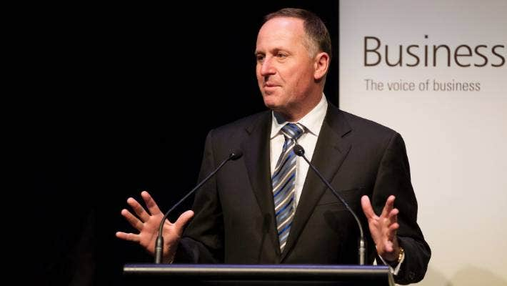

MAARTEN HOLL/STUFF

John Key addresses a Deloitte-BusinessNZ election conference ahead of the 2014 election.

Niwa spokeswoman Susan Pepperell said benefits included access to business forums to share and discuss matters impacting the business community, as well insights, networking opportunities and "briefings and discussions with ministers".

Racing Board spokeswoman spokeswoman Kate Gourdie said membership provided "access to valuable services, support and connections which have benefited our industry".

All of the organisations said their memberships were reviewed annually, with the exception of Auckland Council which said it constantly reviewed its professional memberships.

Kathy Errington, executive director of the newly-launched Helen Clark Foundation think-tank, would not comment on whether it had received approaches from public sector organisations seeking membership, or whether it would accept them, saying that would be a matter for its board.

*\* Comments on this story are now closed*

* [0](https://www.stuff.co.nz/business/112369158/more-than-1m-spent-by-public-sector-on-businessnz-memberships?rm=a#comments)

[COMMENTS0](https://www.stuff.co.nz/business/112369158/more-than-1m-spent-by-public-sector-on-businessnz-memberships?rm=a#comments)

**paid content**[**about this content**](https://www.stuff.co.nz/about-stuff/99824934/about-the-paid-content-panel-on-stuffs-article-pages)